MINISTRY OF EDUCATION, SPORT AND YOUTH
0 1 0 0 1 1 0 1 0 1  1 0 1 1 0 0 1 0 1 0  COMPUTER  SCIENCE  A' LYCEUM | WORKBOOK  (WORKSHEETS)
CYPRUS PEDAGOGICAL INSTITUTE
CURRICULUM DEVELOPMENT SERVICE

Informatics and Computer Science
1st Grade
Workbook (Worksheets)
Author:
The Support Team of the Curriculum and the Advisors
of Professors of Informatics and Computer Science:
1st Edition 2nd and 3rd Edition 4th and 5th Edition
Socrates Mylonas (NW)
Nikolas Zangoulos (NW)
Michalis Dionysiou (NW)
Pavlos Pavlikkas
Paula Makkoula
Nikolas Stratis
Dimitris Mavrovouniotis
Xenios Xenophontos
Ioannis Ioannou
Miltiadis Charilaou
Ilias Theodorou
Pavlos Pavlikkas Paula Makkoula
Paula Makkoula Dimitris Hatzipandelis Dimitris Hatzipandelis Nikos Stratis
Nikos Stratis
Dimitris Mavrovouniotis
Panagiotis Irakleous
Electronic Paula Makkoula
pagination: Professor of Informatics and Computer Science
Supervision: Marios Miltiadou
Michalis Tortouris
Socrates Mylonas
Michalis Farazis
Informatics and Computer Science Supervisors
Linguistic Areti Stylianou
Editor: Development Service Officer Programs
Cover Socrates Mylonas
Design: Inspector of Informatics and Computer Science
Coordination Petros Georgiadis
of Publication: Coordinator of Program Development Service
1st Edition 2014
Reprint 2016 (With minor corrections)
Reprint 2017 (With minor corrections)
B’ - C’ Edition 2018
D’ Edition 2019
F’ Edition 2023
Printed by: RPM LITHOGRAPHICA LTD
© MINISTRY OF EDUCATION, SPORTS AND YOUTH
CYPRUS EDUCATIONAL INSTITUTE
PROGRAM DEVELOPMENT SERVICE
ISBN: 978-9963-54-342-7
 The cover uses recycled paper of at least 50%, originating from waste paper management. The remaining percentage comes from responsible forest management.

Preface
It is with great pleasure and satisfaction that I preface the printed material to support the teaching of the Informatics and Computer Science course in the First Grade of the Lyceum.
The creation of this material was deemed necessary to serve three main objectives:
the smooth transition of students from Middle School to High School, by providing the supplementary knowledge and skills required by the High School Curriculum, which are no longer covered in High School.
the limitation of the overlap of objectives which in the old Curriculum
were developed in the First Year of High School, but in the new Curriculum were transferred to the High School, by providing activities for consolidation and deepening.
the bridging of methodological differences by introducing student-centered approaches, in accordance with the principles of the new Curriculum.
As in the Gymnasium, the material is divided into two volumes, Notes and a Notebook. The volumes are organized in the sections with which the students have become familiar since the Gymnasium. The material covers the range of knowledge, abilities, skills and attitudes that arise from the general purpose of the course, namely to prepare the students for their integration into the Information Society, cultivating the responsible, conscious, safe, efficient and creative use of modern technologies of Information Technology and Computer Science.
The Notes are not a teaching manual but reference material, which contains examples, explanations and additional information and is used as a source of information.
The Notebook consists of indicative worksheets, divided into activities for the development of new knowledge, abilities and skills, activities for the assessment of the degree of acquisition of this knowledge, additional activities for the deepening and broadening of knowledge, abilities and skills and, finally,
homework activities. Activities with a differentiated difficulty index are also included, so that the course can be adapted to the abilities, demands and needs of all students.
I would like to express my thanks to the training and support team of the Curriculum and the consulting teachers of Informatics and Computer Science for the creation of this material, as well as the electronic material that accompanies it. I also thank the relevant inspectors as well as the officers of the Program Development Service for their coordination and, more generally, for their contribution to the development of this material.
Dr. Kyprianos D. Louis
Director of Secondary General Education

CONTENTS
Introduction ............................................................................................................................ 7
SECTION A2
The Hardware/Architecture of Computers. 9
WORKSHEET A.2.M1 The computer system as a whole ................................... 11
WORKSHEET A.2.M2 The computer system as a whole ..................................... 15
WORKSHEET A.2.M3 Problems Related to Hardware .............................................. 19
WORKSHEET A.2.M4 Problems Related to Software ..................................... 25
WORKSHEET A.2.M5 Problems Related to the User ..................................... 29
UNOTHTA A3
Operating Systems ..............................................................33
WORKSHEET A.3.M1 Using Operating Systems ..................................................... 35
WORKSHEET A.3.M2 Role and Functions of an Operating System ............................... 39
UNIT A4
Application Software - Multimedia ..................................43
WORKSHEET A.4.M1 Multimedia - Introduction ..................................................................... 45
WORKSHEET A.4.M2 Multimedia - Audio.................................................................................. 49
SHEET WORKSHEET A.4.M3 Multimedia - Audio................................................................................ 51
WORKSHEET A.4.M4 Multimedia - Audio................................................................................ 53
WORKSHEET A.4.M5 Multimedia - Image ......................................................................... 57
WORKSHEET A.4.M6 Multimedia - Image .............................................................................. 59
WORKSHEET A.4.M7 Multimedia - Image .............................................................................. 63
WORKSHEET A.4.M8 Multimedia - Video ........................................................................... 69
WORKSHEET A.4.M9 Multimedia - Video ........................................................................... 71
WORKSHEET A.4.M10 Multimedia - Video ......................................................................... 75
UNIT A5
Computer Networks and the Internet ..................................79
Worksheet A.5.M1 Introduction ..................................................................................... 81
Worksheet A.5.M2 Network Operation Check ............................................................... 87
Worksheet A.5.M3 Creating a Simple Network ..................................................... 91
WORKSHEET A.5.M4 Wireless Networks ........................................................................... 99
WORKSHEET A5.M5 Security, Interactive Communication Applications and Social
Networks ................................................................................................................... 105
UNIT A7
Algorithmic Thinking, Programming and Modern
Informatics Applications ............................................... 109
WORKSHEET A.7.M1 The Development Cycle of an Application ............................................... 111
WORKSHEET A.7.M2 Python's Integrated Environment (IDLE).................................................. 115
WORKSHEET A.7.M3 Variables ................................................................................................ 117
WORKSHEET A.7.M4 Sequential Structure ............................................................................... 121
WORKSHEET A.7.M5 Sequential Structure – Arithmetic Operators ..................................... 125
WORKSHEET A.7.M6 Sequential Structure – Arithmetic Operators ..................................................... 127
WORKSHEET A.7.M7 Sequential Structure .............................................................................. 129
WORKSHEET A.7.M8 Branching Structure ...................................................................... 131

CONTENTS
WORKSHEET A.7.M9 Branching Structure .............................................................................. 133 WORKSHEET A.7.M10 Branching Structure ....................................................................... 137 WORKSHEET A.7.M11 Branching Structure – Logical Operators ............................................... 139 WORKSHEET A.7.M12 Branching Structure – Independent Conditions ................................ 143 WORKSHEET A.7.M13 Branching Structure – if…elif…else .................................................. 147 WORKSHEET A.7.M14 Branching Structure – if…elif…else .................................................. 151 WORKSHEET A.7.M15 Repetition Structure ....................................................................... 153 WORKSHEET A.7.M16 Repetition Structure ....................................................................... 157 SHEET WORKSHEET A.7.M17 Repetition Structure ...................................................................... 161 WORKSHEET A.7.M18 Programming with App Inventor–Introduction ........................ 165 WORKSHEET A.7.M19 Programming with App Inventor–Variables.................................. 171 WORKSHEET A.7.M20 Programming with App Inventor–Branching Structure ................ 175 WORKSHEET A.7.M21 Programming with App Inventor–Nested Structure
Branching ........................................................................................................................... 179

Introduction
When the effort to develop the New Curriculum for the Informatics and Computer Science course began in March 2009, a priority was given to considering the course through the prism of the three pillars of educational reform. That is, through the prism of the acquisition of an adequate body of knowledge by students, the cultivation of values ​and the manifestation of behaviors that are consistent with the modern concept of democratic citizenship, and the cultivation of key abilities and skills by students, so that they can function in the emerging society of the 21st century.
The committee for the preparation of the Syllabus included academician Andreas Andreou (Associate Professor at the Cyprus University of Technology), the Informatics inspectors Marios Miltiadou and Michalis Tortouris and the Informatics professors Nikolaos Zangoulos, Ioannis Ioannou, Minas Karaolis, Theodoulos Konstantinou, Maria Marda, Socrates Mylonas and Panagiotis Papettas. The result of the effort is the Syllabus that you already have in your hands.
The new Syllabus does not contain a large number of new topics. The subject matter has been restructured to include seven modules, which are developed in parallel from one grade to the next and reflect key thematic axes of Computer Science and Information Technology:
Basic Concepts
Computer Hardware/Architecture
Operating Systems
Application Software
Networks and the Internet
Databases and Systems Analysis
Algorithms, Programming and Modern Computer Applications.
These units are developed gradually through graded objectives/success indicators from one grade to the next, providing additional opportunities for students who were unable to master them in one grade to do so in the next, with parallel deepening. It should be emphasized here that each unit is developed to a
different extent in each grade, based on the general level of readiness of the students in the specific age group. An important element of the new approach is the interdependence of the units, as well as the concretization and limitation of the concepts that students should know, with an emphasis on their application in practice.
The new Curriculum is implemented in the three grades of the Gymnasium, but its implementation in the A’ Lyceum has been suspended, in order to complete the evaluation of its implementation so far. This publication aims to maintain coherence between the Gymnasium
and the Lyceum.
The indicative worksheets that follow were based on teaching proposals that were prepared by the supporters of the implementation of the new Curriculum, and by the consultants of Informatics and Computer Science.
Through them, guidance is provided both for the breadth and depth of the knowledge and skills that students need to develop, as well as for the proposed methodological approaches. Emphasis is placed on the practical application of students' knowledge and

skills and on the use of tools and software by students
on
electronic
computers,
promoting
student-centered
approaches
and
limiting
frontal teaching. Teachers are encouraged to
adapt them or even create others that better respond, both
to the specific characteristics of their students and
to their own
teaching approach to each lesson.

UNIT A2 The Material/
Architecture
of
Electronic
Computers
The following
Professors of Informatics and Computer Science who attended the
training program for combat instructors for the New Curriculum worked on the preparation and writing of the material of this unit:
Valanos Cyprus
Georgiou George
Zangoulos Nikolaos (Advisor)
Captain Rhea
Kareklas Christos
Kettiris George
Kleanthos Cleanthis
Kofteros Xenios
Michael Michalis
Mylonas Socrates (Advisor)
Xanthou Andreas
Xeni Koulla
Papadouris George
Charalambous Charalambos
Chimaridou Christina



WORKSHEET A.2.M1
The computer system as a single whole What will we learn today:
Describe the data processing cycle (Input / Processing / Output /
Storage, program)
Associate the parts of the data processing cycle with the various units / devices
of hardware
Mention and identify basic units / devices of hardware, the basic characteristics
them and compare examples in terms of their characteristics.
Reinforcement Activities
1. What are the four basic functions performed by a computer?
(a) ......................................................................................................................... (b) ........................................................................................................................ (c) ........................................................................................................................ (d) ..............................................................................................................................
2. The multiples of the units of measurement of information are given mixed up: GB, MB, KB, Byte, TB, PB. Put them in order, starting with the one with the smallest capacity.
................................................................................................................................
3. The unit of measurement of information is (circle the correct answer): (a) GHz
(b) bit
(c) ppm
(d) dpi
4. Circle the units of measurement of the resolution of a scanner: (a) dpi
(b) ppm
(c) bps
(d) Mpixels

A.2.M1
A.2 Computer Hardware/Architecture
5. Write the name of each device next to it and to which type of hardware
(Input Unit, Output Unit or Storage Unit) does each belong:
Device
Device Name
Hardware Type

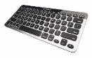

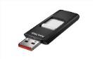
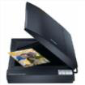
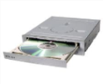
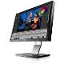
6. Next to each description, note the name of the corresponding part of the
Central Processing Unit (CPU):
(a) Performing operations and comparisons ...............................................................
(b) Storing intermediate results ...............................................................
(c) Controlling and coordinating the operation of the hardware ..............................................
7. Note two types of Main Memory (Main Memory):
(a) ..............................................................................................................................
(b) ..............................................................................................................................
8. Name three types of printers:
(a) ..............................................................................................................................
(b) ..............................................................................................................................
(c) ..............................................................................................................................
9. We have the following printers:
E1: Inkjet printer (color), 9 ppm, 600 dpi
E2: Laser printer (color), 16 ppm, 1200 dpi
E3: Laser printer (black and white), 20 ppm, 600 dpi
E4: Dot matrix printer (black and white), 10 ppm, 120 dpi

A.2 Computer Hardware/Architecture
A.2.M1
Answer the following questions:
(a) Which has the highest resolution and what is it? ..................................................
(b) Which prints at the highest speed and what is it? ...................................
(c) Which can print duplicates? .....................................................................
(d) Which can accept continuous paper? ..................................................................
10. We have the following CPUs:
CPU1: Intel Core i5 Duo, 2.4 GHz, 22 W
CPU2: ARM 10, Dual Core, 1.8 GHz, 3 W
CPU3: Intel Core i5 Duo, 2.1 GHz, 19 W
Answer the following questions:
(a) Which one executes instructions faster and how do you conclude this?
..........................................................................................................................
(b) Which has the lowest power consumption and how do you know this? ...........
(c) Which is most suitable for a desktop computer? ..................................
(d) Which is most suitable for a tablet computer? ..........................
Assessment Activities
11. List three types of Secondary Memory:
................................................................................................................................
12. Make the conversions:
(a) 5 MB corresponds to how many bytes (approximately)? ..............................................
(b) 3,200,000,000
bytes
correspond
to
how
many
GB
(approximately);
..........................................................................................................................
..........................................................................................................................
13. Read the following example and fill in the blanks.
To calculate a person's body mass index (BMI), we divide their weight in kg by the square of their height in m.
(a) Data:..........................................................................................................
(b) Processing:
..........................................................................................................................
..........................................................................................................................
(c) Information:
..........................................................................................................................
..........................................................................................................................

A.2.M1
A.2 Computer Hardware/Architecture
14. The role of the timer is:
(a) To keep accurate time
(b) To determine the rate of execution of instructions by the CPU
(c) To measure the time it takes the computer to execute a program (d) To determine the speed rotation of a hard disk.
15. We have the following monitors:
M1: TFT monitor 19’’, 1024×768, 100 Hz, 2ms refresh rate
M2: TFT monitor 17’’, 1200×800, 70 Hz, 4ms refresh rate
M3: CRT monitor 19’’, 1024×768, 50 Hz, 3ms refresh rate M4: TFT monitor 22’’, 1600×900, 75 Hz, 3ms refresh rate
Answer the following questions:
(a) Which has the highest resolution and how much is it? .................................................. (b) Which has the smallest size and how much is it?................................................................ (c) Which is the most voluminous? ..................................................................................... (d) Which is more relaxing and why? ....................................................................... (e) Which is more suitable for action games and why? ...............................................
16. Answer the questions in A2.M1-quiz.htm. In this way, you will self-test your knowledge. Once you have completed it, inform your teacher.
+Additional Activities
17. Answer the following questions:
(a) What device would an architect use to print his
architectural plans? ..................................................................................
(b) In order to record a song via a PC, apart from an
audio processing program, what other peripheral devices are needed? ...................... ......................................................................................................................... .........................................................................................................................
Homework
18. Search the internet and note down one input unit, one output unit and a storage unit that have not been mentioned in today's lesson:
...............................................................................................................................
...............................................................................................................................

WORKSHEET A.2.M2
The computer system as a whole
What will we learn today:
Describe the role of the program in the processing cycle
Relate the processing performed by a program (functional
system/application software) to the phases of the processing cycle and to the related units/devices in examples
we describe the role of the user as a provider/receiver of data/information in the most above process
To mention/recognize in examples the interdependence of Hardware, Software and User.
Consolidation Activities
1. List three examples of application software:
(a) .......................................................................................................................... (b) .......................................................................................................................... (c) ..........................................................................................................................
2. List three examples of different operating systems that
you know:
(a) .......................................................................................................................... (b) .......................................................................................................................... (c) ..........................................................................................................................
3. List three mechanisms provided by the operating system to
the user:
(a) .......................................................................................................................... (b) .......................................................................................................................... (c) ..........................................................................................................................
4. The operating system manages (controls / coordinates):
(a) .......................................................................................................................... (b) .......................................................................................................................... (c) .......................................................................................................................... (d) .......................................................................................................................... (e) .......................................................................................................................... (f) ..........................................................................................................................
5. To which category of software does the operating system belong?
................................................................................................................................
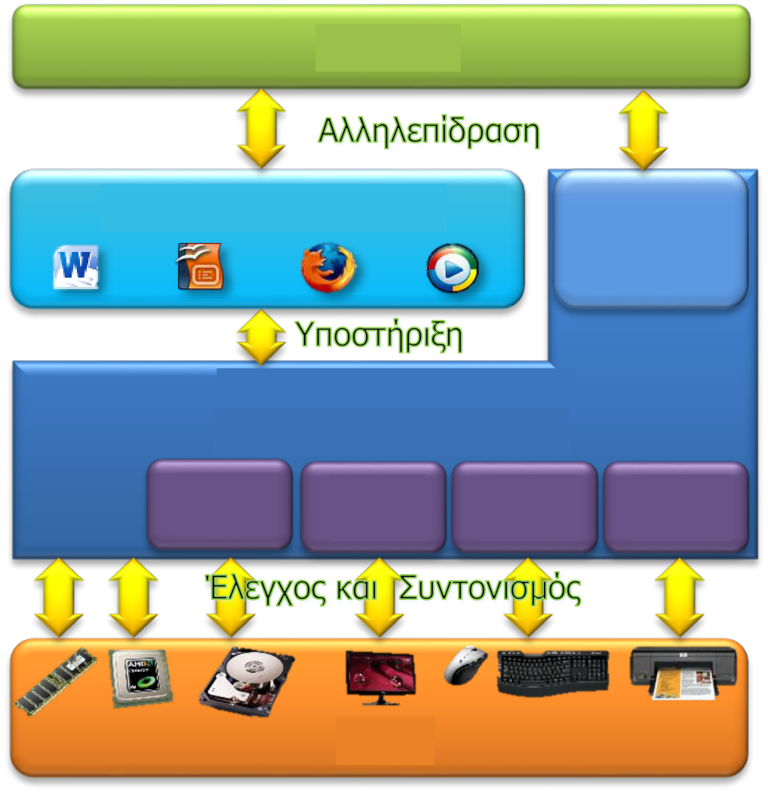



A.2.M2
A.2 Computer Hardware/Architecture
6. Study the diagram below and answer the three sentences that in your opinion best describe this diagram:
User
Application Software
Communication Environment
System Software
(Operating System)
Hardwar
e
(a) The user interacts with the system software
(b) The system software supports the application software (c) The hardware is controlled/coordinated by the system software
(d) The operating system is part of the application software (e) The application software controls the hardware
(f) The user controls/coordinates the hardware
(g) Application software supports the system software
7. Which part of the diagram in the previous question (apart from the users) do you believe is the most important and why?
...............................................................................................................................
...............................................................................................................................
...............................................................................................................................
...............................................................................................................................
8. Complete the equation below:
Computer System = ……………………………………………………………………………………………………….

A.2 Computer Hardware/Architecture
A.2.M2
Assessment Activities
9. Perform the activities below and answer the questions that
follows (the activities could be assigned to groups of three, one for each member of the group).
Activity A: Search the Internet for an image of the ENIAC computer, save it to your computer's hard drive and print it.
Activity B: Write a short greeting in a new text, add an image, save it to your computer's hard drive and email it to your group
members/some of your classmates.
Activity C: Locate the video file named system.mpg on your computer and copy it to your desktop. Then open it and watch it.
(a) What computer hardware has been used to perform the above activities?
............................................................................................................................
............................................................................................................................
............................................................................................................................
(b) What application software have you used to perform the above activities?
............................................................................................................................
............................................................................................................................
............................................................................................................................
(c) What operating system functions were used by the user?
............................................................................................................................
............................................................................................................................
............................................................................................................................ (d) What other coordinating operating system functions were required?
............................................................................................................................
............................................................................................................................
............................................................................................................................

A.2.M2
A.2 Computer Hardware/Architecture
+Additional Activities
10. Open the file A.2.M2-Quiz.htm from your folder and answer
all the questions. This way, you will self-test your knowledge. Once you have completed it, inform your teacher.
11. What parts does the computer system consist of?
(a) Hardware, system software, operating system, and user
(b) Hardware, system software, operating system, and application software (c) System software, operating system, application software, and user (d) Hardware, system software, application software, and user
12. Which two of the following statements are correct?
(a) The user interacts with the system software
(b) The system software supports the application software (c) The hardware controls/coordinates the operating system
(d) The operating system is part of the application software (e) The application software controls the hardware


WORKSHEET A.2.M3
Hardware-Related Problems
What we will learn today:
List common problems related to hardware malfunction and
identify them with examples
To mention ways of protecting/dealing with problems related to hardware
and to suggest the appropriate ones in examples.
Reinforcement Activities
Study the images and scenarios given below and identify in each case the risks that the hardware part of the
computer system may be exposed to. Then, suggest ways in which you could
deal with these risks. You may be asked to work in groups.
1. 
(a) Risks:
................................................................................................................................
................................................................................................................................
(b) Responses:
................................................................................................................................
................................................................................................................................
2. Andrea, a 3rd grade student, lives in a mountain village in the
Troodos region. During the winter months, due to climatic conditions, there are fluctuations in the power and frequency of the electricity.
Additionally, in some cases, the electricity supply is interrupted without warning.
(a) Hazards:
................................................................................................................................
................................................................................................................................
(b) Countermeasures:
................................................................................................................................
................................................................................................................................

A.2.M3
A.2 Computer Hardware/Architecture
3.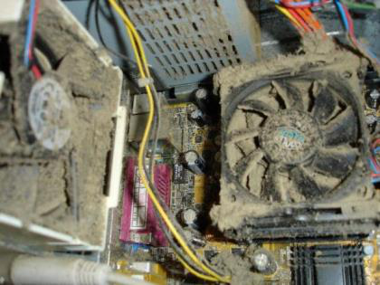
(a) Hazards:
...............................................................................................................................
...............................................................................................................................
(b) Countermeasures:
...............................................................................................................................
...............................................................................................................................
4.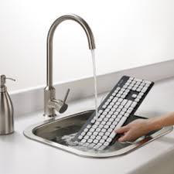
(a) Hazards:
...............................................................................................................................
...............................................................................................................................
(b) Countermeasures:
...............................................................................................................................
...............................................................................................................................

A.2 Computer Hardware/Architecture Computer
A.2.M3
5. 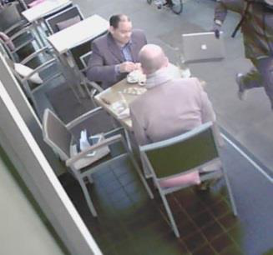
(a) Risks:
................................................................................................................................
................................................................................................................................ (b) Ways to deal with them:
................................................................................................................................
................................................................................................................................ 6. Kostas' computer is already four years old. The computer has started to is experiencing some problems related to its hard drive.
(a) Risks:
................................................................................................................................
................................................................................................................................ (b) Solutions:
................................................................................................................................
................................................................................................................................ 7. Maria, a first-year student in the multimedia and graphic arts department of TE.PA.K., has a computer that she bought two years ago with the following specifications: 512 GB HDD, 4 GB RAM, 512 MB Graphic Card and Windows XP.
(a) Risks:
................................................................................................................................
................................................................................................................................ (b) Responses:
................................................................................................................................
................................................................................................................................

A.2.M3
A.2 Computer Hardware/Architecture
Assessment Activities
8. Select the correct answers below or you can open the file
A.2.M3-Quiz.htm from your folder and answer all the questions. This will
self-test your knowledge. Once you have completed it, inform your
teacher.
The performance and “health” of our computer and
(a) its individual units have nothing to do with □ □
climatic conditions.
(b)
The best cleaner for computers and
peripheral units is water.
The UPS (Uninterruptible Power Supply) is a device that
(c) protects □ □
our computer from dust.
The UPS (Uninterruptible Power Supply) also protects
(d) our computer from fluctuations in input voltage. □ □
Especially for storage units such as the hard disk,
always bearing in mind the possibility of losing
(e) important data in the event of damage from physical
wear and tear, it is very important to always have an □ □
up-to-date backup copy.
(f)
Once we buy a computer, we cannot upgrade it.
One way to meet new computing needs
(g) is to upgrade the hardware of our computer□ □
system.
To decide whether it is possible to upgrade the
memory of our computer, we should subtract the size of
the
(h) installed memory from the □ □
size of the supported memory and then examine our
options taking into account the number of
memory slots that our computer's motherboard has.
If we have to leave our computer
(i) inside the car, we should place it in a place that will not □ □
be visible to passersby.
Recording the serial number of our computer is not
(j) something we should do because it will not help us in □ □
anything.

A.2 Computer Hardware/Architecture
A.2.M3
+Additional Activities
9. List below another problem that may be related to the
malfunction of the hardware of your computer system, as well as the way to deal with it that has not been discussed in class.
Problem
................................................................................................................................ ................................................................................................................................
How to Solve the Problem
................................................................................................................................ ................................................................................................................................
Homework
10. Describe how you could upgrade your computer (or the computer of a relative of yours) by referring to specific devices.
................................................................................................................................ ................................................................................................................................ ................................................................................................................................ ................................................................................................................................ ................................................................................................................................ ................................................................................................................................ ................................................................................................................................
Use a design application to create a poster that will
provide a message about one of the rules for correctly dealing with a problem related to the malfunctioning of your computer system hardware. Then,
post the poster either on your blog or on your personal page on a social networking site.



WORKSHEET A.2.M4
Software-Related Problems
What we will learn today:
List common problems related to software malfunction and
data storage and identify them with examples
Mention ways of protecting/dealing with problems related to
software and suggest the appropriate one with examples.
Reinforcement Activities
Study the images and scenarios given below and identify in each case the risks that the software part of the
computer system may be exposed to. Then, suggest ways in which you could
deal with these risks. You may be asked to work in groups.
1. Maria, a student in the 3rd grade of high school, decided that for this school year she will
save all the assignments she will do in the different subjects on the hard drive of her computer, which is three years old.
(a) Risks:
................................................................................................................................
................................................................................................................................
(b) Solutions:
................................................................................................................................
................................................................................................................................
2. Copy the file A2M4.exe from your folder to the desktop of
your computer and activate it.
(a) Risks:
................................................................................................................................
................................................................................................................................
(b) Solutions:
................................................................................................................................
................................................................................................................................

A.2.M4
A.2 Computer Hardware/Architecture
3. Your aunt Julia, who is a designer and has an Apple computer,
has asked you to help her install the LibreOffice program on her computer. You went to the program's website and selected the first of the three options shown below.
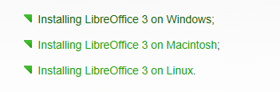
(a) Risks:
............................................................................................................................... ...............................................................................................................................
(b) Solutions:
............................................................................................................................... ...............................................................................................................................
4. Andreas bought a new impressive game but when he installed it on his computer, the game did not respond as it did on the computer of the store where he tried it.
(a) Risks:
............................................................................................................................... ...............................................................................................................................
(b) Solutions:
............................................................................................................................... ...............................................................................................................................
5. Marios, out of carelessness, deleted all the photos from the parade of March 25 that were stored on his computer.
(a) Risks:
............................................................................................................................... ...............................................................................................................................
(b) Countermeasures:
............................................................................................................................... ...............................................................................................................................

A.2 Computer Hardware/Architecture
A.2.M4
Assessment Activities
6. Select the correct answers below or you can open the file
A.2.M4-Quiz.htm from your folder and answer all the questions. This will
self-test your knowledge. Once you have completed it, inform your
teacher.
Removing the flash memory from the USB port of our
computer system, without following the
(a) normal disconnection procedure, is likely to cause □ □
data loss.
Backups can only be stored on websites on the
(b) internet, such as Dropbox and □ □
Google Drive.
Simply by installing an antivirus application on our
(d) computer, its protection is ensured forever. □ □
Before copying a file from a storage unit, we must
make sure to check the storage unit by scanning it with
(e) our antivirus program. □ □
(f)
All application programs are compatible with all different operating systems.
Software manufacturers usually prepare different
(g) versions of an application for different operating □□
systems.
Both upgrading existing programs to new versions and
installing new programs that meet our new computing
(h) needs are considered to be upgrading our computer □ □
software.
(i)
A file that has been deleted from the Recycle Bin cannot be restored.

A.2.M4
A.2 Computer Hardware/Architecture
7. Malware includes various categories such as:
(3 correct answers)
(a) Viruses
(b) Mammals
(c) Trojan Horses
(d) Amphibians
(e) Mycenaeans
(f) Worms
+Additional Activities
8. List one more problem below that has not been discussed in the classroom and which may be related to the malfunction of your computer system software, as well as how to deal with it.
Problem
............................................................................................................................... ...............................................................................................................................
How to Deal with the Problem
............................................................................................................................... ...............................................................................................................................
Homework
9. Describe how you could upgrade your electronic
computer (or the computer of a relative of yours) by referring to specific programs.
............................................................................................................................... ............................................................................................................................... ............................................................................................................................... ...............................................................................................................................


WORKSHEET A.2.M5
User-Related Problems
What will we learn today:
List common problems that occur to the user when using the
computer system and identify them with examples List ways to protect/deal with problems related to the
user and suggest the appropriate one with examples.
Reinforcement Activities
Open the four video files below from your folder, watch them
carefully
and
recognize
in
each
case
the
risks that the user of the computer system may run.
Then,
suggest ways in which you could deal with these
risks. You may be asked to work in groups.
1. Video: A2.M5_1.wmv
(a) Hazards:
................................................................................................................................
................................................................................................................................
(b) Countermeasures:
................................................................................................................................
................................................................................................................................
2. Video: A2.M5_2.wmv
(a) Hazards:
................................................................................................................................
................................................................................................................................
(b) Countermeasures:
................................................................................................................................
................................................................................................................................

A.2.M5
A.2 Computer Hardware/Architecture
3. Video: A2.M5_3.wmv
(a) Hazards:
............................................................................................................................... ...............................................................................................................................
(b) Responses:
............................................................................................................................... ...............................................................................................................................
4. Video: A2.M5_4.wmv
(a) Hazards:
............................................................................................................................... ...............................................................................................................................
(b) Responses:
............................................................................................................................... ...............................................................................................................................
Assessment Activities
5. Select the correct answers below or you can open the file
A.2.M5-Quiz.htm from your folder and answer all the questions. This will self-test your knowledge. Once you have completed it, inform your teacher.
The prolonged use of the computer, without taking
(a) protective measures, poses risks to our □ □ health.
(b)
When working in front of the computer, the presence of a back on the chair we use is not necessary.
Addiction to computers or the Internet is a
(c) condition that causes a significant impairment in the social
and professional or academic functioning of the individual. □ □
(d) □ □

A.2 Computer Hardware/Architecture
A.2.M5
The theft of personal data is always related to the
(e) misleading of a user via electronic message (e- □□ mail).
Passwords should be at least 20 to 30 characters long,
(f) and should only contain letters. □ □
6. Which four of the following physical ailments are likely to be related to the misuse of our computer system?
(a) Osteoporosis
(b) Cervical Syndrome
(c) Chronic Respiratory Insufficiency
(d) Carpal Tunnel Syndrome
(e) Eye Disorders
(f) Incontinence
(g) Burnt Skin Syndrome
7. During typing, the elbows touch the desk and form an angle with the arm:
(a) 30 – 50 (degrees)
(b) 45 – 65 (degrees)
(c) 90 – 120 (degrees)
(d) 180 – 200 (degrees)
8. The science of ergonomics attempts to determine which body positions: (a) Increase the pressure exerted on it and reduce the productivity
(b) Increase the pressure exerted on it and increase productivity
(c) Reduce the pressure exerted on it and decrease productivity
(d) Reduce the pressure exerted on it and increase productivity
9. Addicted users exhibit various symptoms such as the following: (4 correct answers)
(a) Feeling euphoric only when they are in front of the computer
(b) Thirst
(c) Nervousness
(d) Neglect of their personal life and their obligations
(e) Nightmares
(f) Eating disorders

A.2.M5
A.2 Computer Hardware/Architecture
+Additional Activities
10. The term "Nomophobia" refers to a specific "disease" which
has been spreading in recent years. After researching the topic, give a brief description of nomophobia and list ways to deal with it.
Nomophobia - Description
...............................................................................................................................
...............................................................................................................................
...............................................................................................................................
...............................................................................................................................
Nomophobia - Ways to Deal
...............................................................................................................................
...............................................................................................................................
...............................................................................................................................
...............................................................................................................................
Activities for the Home
11. The terms “electronic waste” or “electronic waste” or “e-scrap”
(e-waste or e-scrap) have become internationally accepted to describe those electronic devices (including computers, monitors, printers, etc.) that are no longer used, regardless of whether they are thrown into a landfill or forgotten in a warehouse. The rapid growth rate of "useless" electronic devices (computers, monitors, printers) and the hazardous substances
(lead, cadmium, mercury) that some of them contain, threaten the
environment
and by extension health. Do you agree or disagree with the above
statement? Please provide suggestions for addressing the above problem.

UNIT A3 Operating
Systems



WORKSHEET A.3.M1
Using Operating Systems
What we will learn today:
Check and select the country (location) of our computer Add/remove keyboard languages
Create and remove a user account (User Account)
Locate applications from the World Wide Web
Install an application
Uninstall an application.
Caution:
Note 1: To complete the following activities in Windows 10, you will need
to log on to the computer as an Administrator.
Note 2: Before proceeding with the following activities, check with
your teacher that the computer is configured in a way that will not cause any problems in its operation after
completing the activities.
Reinforcement Activities
1. Why is it important to choose the correct country (location) for our computer?
................................................................................................................................
................................................................................................................................
2. Check and record the country where the computer is located and the keyboard languages
.
................................................................................................................................
................................................................................................................................
3. Add a new keyboard language.
4. Check and record in the table below the names of the user accounts
that your computer has, as well as the type of rights that each account has.
User Account Standard User
(Standard user).
1. ………….………………………………………
2. ……………………………………………………….………………. ……………….
………………. ……………….
3. ………………………………………………. ………………. ……………….

A.3.M1
A.3 Operating Systems
5. Use a search engine and locate the website from which you can download the Simple Sticky Notes application.
6. Install the Simple Sticky Notes application on your computer.
Note: To install any program on your computer, you must
have Administrator rights. If the user account you are using does not have Administrator rights,
ask your teacher for help.
7. Uninstall the Simple Sticky Notes application from your computer.
Assessment Activities
8. If Cyprus is not selected as the computer's country, select it.
9. Remove the keyboard language you added in question 3.
10. Create two new User Accounts on your computer
. The first one should be named Marios and have Administrator rights
and the second one should be named Maria and have Standard user rights.
11. Remove the two new user accounts that you created in the previous exercise.
12. Use a search engine and locate the website, from where you can download the LightShot application.
13. Install the LightShot application on your computer.
Note: To install any program on your computer, you must
have Administrator rights. If the user account you are using does not have Administrator rights,
ask your teacher for help.
14. Uninstall the LightShot application from your computer.
Additional Activities
15. Change only the date and time display format.

A.3 Operating Systems
A.3.M1
Home Activities
16. Can we create different User Accounts on
a mobile device that has the Android operating system? Explain your answer.
................................................................................................................................ ................................................................................................................................ ................................................................................................................................ ................................................................................................................................ ................................................................................................................................



WORKSHEET A.3.M2
Role and Functions of an Operating System
What we will learn today:
Activate the Control Panel
State what happens during the formatting of a peripheral
memory unit
State and perform basic maintenance functions (optimize, defrag) of a peripheral
memory unit
Use the Task Manager to identify which programs are activated
and to stop a program
Use the Task Manager to identify the role of the operating system system
as a manager of the resources (CPU, memory, etc.) of the Computer.
Reinforcement Activities
1. Activate the Control Panel.
2. Use the Programs and Features category and
locate five programs that are installed on your computer and list them below:
................................................................................................................................
................................................................................................................................
................................................................................................................................
................................................................................................................................
................................................................................................................................
3. Close all windows on your computer.
4. Select the peripheral memory unit (hard disk, CD, portable memory, etc.)
that your teacher indicated to you and activate the
Format dialog box. WARNING!: If you proceed to format the peripheral memory unit you selected by clicking on Start, its contents will
be deleted.
5. What do you think will happen if you apply the formatting process to the hard disk
of your computer?
................................................................................................................................
................................................................................................................................

A.3.M2
A.3 Operating Systems
6.
Select the peripheral memory unit (hard disk, CD, floppy disk, portable memory etc.) that your teacher indicated and check it for possible errors,
using the Error Detection tool (chkdsk).
7.
Activate and run the Defragmentation (Optimize) process on your
computer's
hard disk. (Because the defragmentation process usually
takes a long time to complete, follow your teacher's instructions to stop it.)
8.
Activate the Internet Explorer, Word and Paint programs.
9.
Use Task Manager to identify which programs are currently running on your computer
and record them in the space provided below:
...............................................................................................................................
...............................................................................................................................
...............................................................................................................................
...............................................................................................................................
10. Use Task Manager to stop
the Paint program.
11. Close all windows on your computer.
12. Use the Task Manager, locate the
percentage (%) of the CPU capacity currently being used and record it in the space provided below:
...............................................................................................................................
13. Use the Task Manager, locate the
size of Main Memory currently being used and record it in the space provided below:
...............................................................................................................................
14. Activate the Internet Explorer, Word and Paint programs.
15. Using the Task Manager, locate the
percentage (%) of the CPU capabilities currently being used and record it in the space provided below:
...............................................................................................................................

A.3 Operating Systems
A.3.M2
16. Using the Task Manager, locate the
size of Main Memory currently being used and record it in the space provided below:
................................................................................................................................
17. Compare the answers you recorded in questions 12 to 15 and
13 to 16 and record your
conclusions in the space provided below:
................................................................................................................................ ................................................................................................................................ ................................................................................................................................ ................................................................................................................................ ................................................................................................................................
+Additional Activities
18. “After completing the defragmentation process on a Flash Memory unit (Flash Memory), uploading information from that Flash Memory unit
will be noticeably faster.” Do you agree or disagree with the above statement? Explain your answer.
................................................................................................................................ ................................................................................................................................ ................................................................................................................................ ................................................................................................................................ ................................................................................................................................ ................................................................................................................................ ................................................................................................................................ ................................................................................................................................ ................................................................................................................................

A.3.M2
A.3 Operating Systems
Home Activities
19. Explain the usefulness of the Control Panel.
............................................................................................................................... ............................................................................................................................... ............................................................................................................................... 20. Explain the usefulness of the Optimize process.
............................................................................................................................... ............................................................................................................................... ...............................................................................................................................

UNIT A4 Application Software- Multimedia



WORKSHEET A.4.M1
Multimedia – Introduction
What we will learn today:
What is sound
The lossless and lossless compression algorithms
How is sound digitized and what are the basic characteristics of this
process
The Wav, Mp3 and MIDI standards
What is an image
What are the categories of images and what are their characteristics
The ways of capturing a video
What are the characteristics of a video and how do they affect its quality and its size
The methods of video compression
What tools do we use for video editing.
Consolidation Activities
1. What does the image below describe?
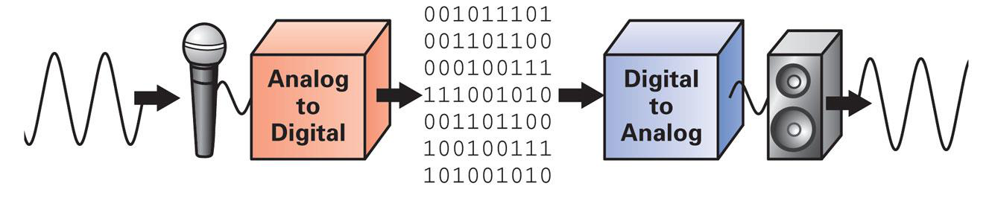
.................................................................................................................................
.................................................................................................................................
.................................................................................................................................
2. List 2 image editing tools.
................................................................................................................................
................................................................................................................................
3. You are given the following monochrome image:

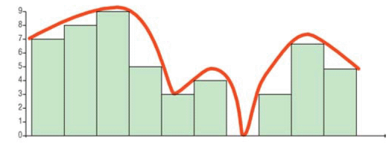
A.4.M1
A.4 Application Software - Multimedia
(a) Write the bit values ​of the above image:
(b) What is the color depth of the image?
...............................................................................................................................
4. List ways in which a video can be captured.
...............................................................................................................................
...............................................................................................................................
Assessment Activities
5.
What is the difference between the two images below?
Image A
Image B 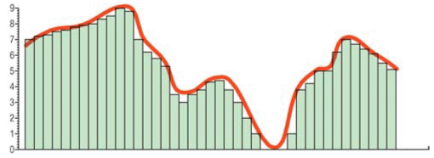
............................................................................................................................. ...
................................................................................................................................

A.4 Application Software-Multimedia
A.4.M1
6. Put √ in the options that represent digitized audio standards.
WAV
Gif
Mp3
Mp4
AVI
JPEG
BMP
MIDI
OGG
7. Open the file A4.1.M1.swf and go to page 2.
(a) What is the fps value, resolution, color depth and which method
of compression that gives us the largest file size?
................................................................................................................................
................................................................................................................................
(b) How does the fps value affect the quality of the video?
................................................................................................................................
+Additional Activities
8. Put a tick in the options that represent image representation standards..
WAV
Gif
Mp3
Mp4
AVI
JPEG
BMP
MIDI
OGG
9. A video editing tool allows …
................................................................................................................................
................................................................................................................................
................................................................................................................................
Homework Activities
10. Describe the MIDI audio standard.
11. At http://pixlr.com/express/ you can find an online photo editor.
(a) Select Browse to upload a photo.
(b) Apply one of the available effects to it.
(c) Save the photo to your computer.
12. Visit http://www.powtoon.com/ to create an
animation.



WORKSHEET A.4.M2
Multimedia - Audio
What we will learn today:
Import an audio file stored on the computer into Audacity
Select, copy, paste and delete a piece of audio
Export the audio to mp3.
Reinforcement Activities
1. Open Audacity. From the File menu, select Open
and open the music1.wav file. The screen should look like this:
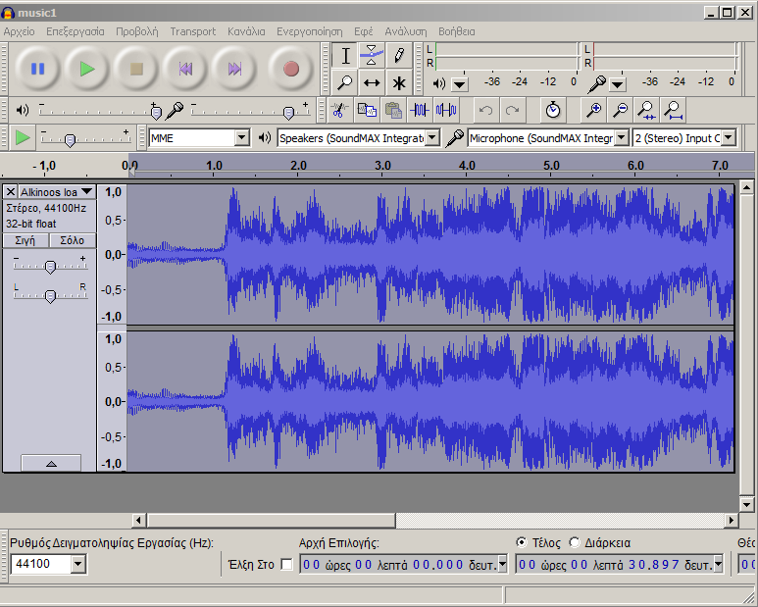
Figure 1: Audacity Screen
2. At the end of the song, the phrase “it was a dream” is heard. Use the
selection tool to select it 
. Make sure the audio is stopped
3. Copy your selection (Ctrl +C ) and paste it
at the end (Ctrl +V), so that the specific phrase is heard twice.
4. Create a new file in Audacity (File New or Ctrl+N or File New).
From the File menu, select Open and open the file music2.wav.
5. The selection tool we used in question 2 is useful, but it
does not give us precision. If we want to select a specific track based on time, we can use the selection bar located at the bottom
of the Audacity window. If the selection bar is not displayed in your window, you can enable it (View Toolbars Selection Bar)
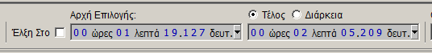
Figure 2: Selection Bar

A.4.M2
A.4 Application Software - Multimedia
Using the selection bar, delete the first 8.8 seconds of the song.
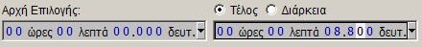
Figure 3: Selecting 8.8 seconds
Repeat the process and delete the track from the 27th second up to the 37.3rd (end of the song).
6. Select the remaining part (Ctrl – A) and copy it. Go
to the original Audacity file (the one with music1 in it) and paste it at the end of the song.
7. Save your file with the name example1.aup. This file
is an Audacity project and you cannot listen to the sound you have created in another program, e.g. a media player.
8. You can, however, convert it to mp3. (File Export Select mp3 type).
Name it example1.
Assessment Activities
9. Inside the example2 folder there are 2 song excerpts named
song1 and song2. Create an mp3 file named example2.mp3 that will contain the part from the 37th second to the 56th
second of song1 and the first 16 seconds of song2.
+Additional Activities
10. Using excerpts from songs in the songs folder,
create a new mp3 file named example3.mp3.
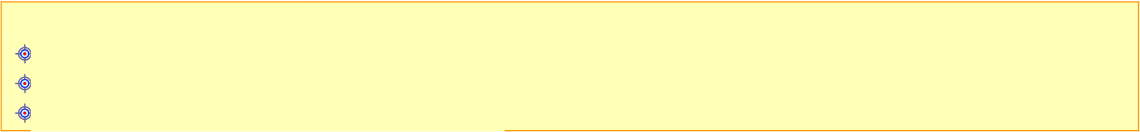
WORKSHEET A.4.M3 Multimedia - Audio What we will learn today:
Using the microphone to record sounds
Applying silence and trimming to a sound
Importing new channels into Audacity.
Consolidation Activities
1. Connect your microphone to the computer.
2. Open Audacity. Make sure the microphone is not muted.
Figure 1: Microphone Volume
3. We will now record the words “YES” and your name. To do this
press the record button
to start.
first say the word “YES” and then press stop
.
Save your audio as yes.aup
4. Create a new file in audacity and repeat the process
recording your name. Save your audio as name.aup
5. Open the exampleM3_1.aup file. Insert a new track (Channels (Tracks) Add NewStereo Track).
6. Copy the sound you have in the file yes.aup to the new track.
7. Using the move tool
, move the sound yes.aup
to the right, so that it answers the question “Do you speak English?”. Also, move the question “What is your name?” so that it starts after the answer “yes”.
8. Insert a new track and copy the sound name.aup into it.
move the sound name so that it is at the end, after the question “What is your name?”. Save the file.
9. Convert the project to mp3 with the name exampleM3_1.mp3
10. Open the theme.aup file. Select the first 8 seconds of the audio located on the 2nd channel (Lord) and apply silence to them (Edit (Edit) Remove Audio Silence Audio).

A.4.M3
A.4 Application Software - Multimedia
11. From the 1st channel (Game), select the seconds from the 8th to the 16th and apply silence to them.
12. From the 2nd channel (Lord) select the seconds from the 16th to the end and apply silence to it.
13. Save the file and convert it to mp3 with the name theme.mp3
14. Open the file ucanttouchthis.aup.
15. Select the seconds from the 20th to the 22nd second. Apply trim (Edit Remove Audio Trim).
16. Save the file and convert it to mp3 with the name ucanttouchthis.mp3
Assessment Activities
17. Inside your folder is the file interview.aup. Record your answers and create a single file of questions and answers.
Export the result to mp3 with the name interview.
+Additional Activities
18. Using excerpts from films in the films folder and your own recordings, create your own mp3.


WORKSHEET A.4.M4
Multimedia - Audio
What we will learn today:
Split and duplicate a selected part of the audio
Use the Fade In/Out effects
Change the speed and rhythm of an audio
Apply time reversal
Download audio from Youtube.
Reinforcement Activities
1. Open the file mpaglamadakia.aup.
2. Apply a split at the 34th second (Edit Clip Boundaries Split).
3. Using the shift tool, move the 2nd track so that it starts at the 1st minute.
4. Open the file beat.aup. Copy the audio in to the file and then close it.
5. Insert a new stereo channel into the mpaglamadakia.aup file. Paste
the audio you copied into the new channel. Move the audio so that it starts at the 34th second.
6. Save the file and close it.
7. Open your browser (e.g. Firefox) and go to youtube.com.
8. Select a song of your choice. Once the song starts, you can press pause.
9. Open a new tab in the browser and go to the page
http://www.youtube-mp3.org/. Through this page you can convert the youtube video to mp3. There are other similar pages. You can
find them by searching for the word video2mp3.
10. Copy the address from the youtube tab to the page
http://www.youtube-mp3.org/ and press the convert button.

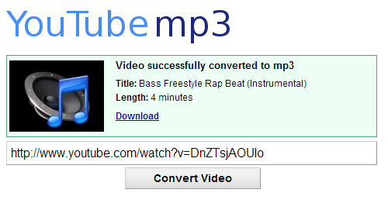Figure 1: Downloading audio from Youtube

A.4.M4
A.4 Application Software - Multimedia
11. Click on the Download hyperlink to convert and download the song.
12. Open the song using Audacity.
13. Select the entire (Ctrl+A) song or a part of it and duplicate it (Edit Duplicate).
14. Now select the sound in one of the two channels in front of you and apply time reversal to it (Effect Time Reversal). What do you notice?
................................................................................................................................
15. Save your file with the name reverse.aup and then close it.
16. Open the file kamila.aup. Press play and listen to the sound. After you finish, press stop.
17. Select the sound in the 1st channel and reduce its speed (Effect Change speed (change speed)).
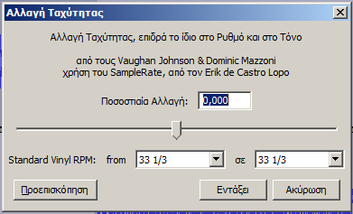
Figure 2: Change Speed
18. Select the sound in the 2nd channel and increase its tempo (Effect Change tempo).
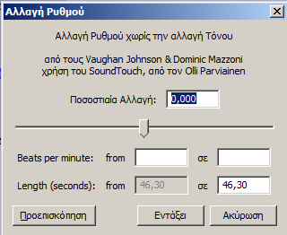
Figure 3: Change Tempo
19. Listen to the result again. Save your changes and close the file.

A.4 Application Software-Multimedia
A.4.M4
20. Open the mix.aup file. You will notice that the songs on the two channels
cover each other for a few seconds. We will try to gradually reduce the volume on the 1st song (fade out) and gradually increase it on the 2nd
(fade in).
21. Select the part from the 1st song that you want to fade out and
apply the effect (Effect Fade out). Apply fade in on the 2nd.
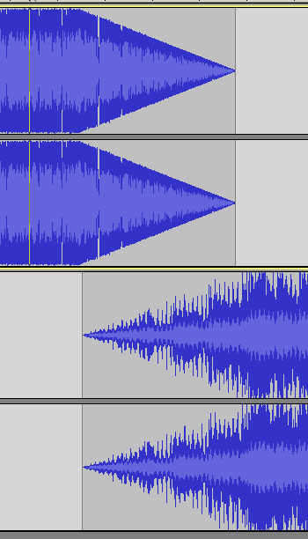
Figure 3: Fade Out – Fade In
22. Save the file and convert it to mp3 with the name mix.mp3
Assessment Activities
23. Create your own mix using songs of your choice from
YouTube.
+Additional Activities
24. Experiment with the effects available in Audacity.



WORKSHEET A.4.M5
Multimedia - Image
What will we learn today:
Create a new image in GIMP
Recognize the basic tools of GIMP
Insert layers into the image and explain their usefulness Remove the background from an image
Export our result to a jpeg or gif image.
Reinforcement Activities
1. Create the image below by composing the images found in
folder ask1. Save the image in your folder with the name image1.jpg
Steps 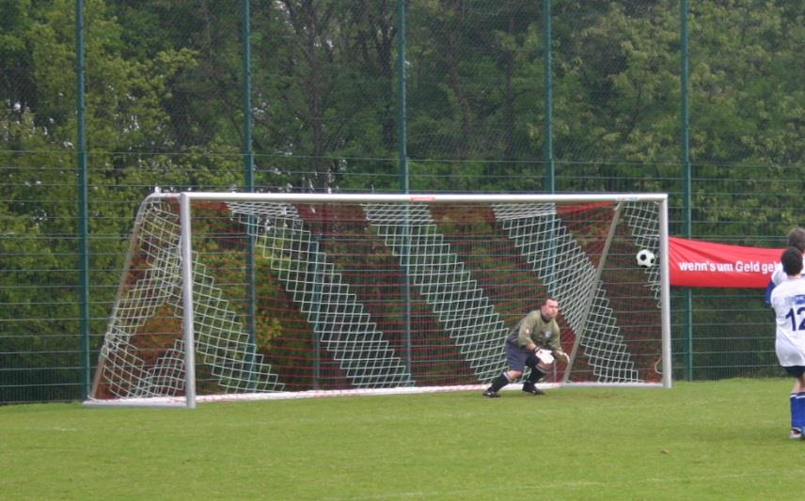
(a) Open GIMP.
(b) Open the image Football_goal.jpg found in the folder ask1 (File
Open).
(c) Open the image Football.jpg found in the folder ask1 (File Open).
(d) Use one of the selection tools to select the ball
.
(e) Copy your selection.
(f) Return to the Football_goal.jpg image and add a new layer
of type transparent (Layer New Layer).
(g) Paste the ball into the new layer.
(h) Change the size of the ball using the tool .
(i) Move the ball to the desired location using the tool
.

A.4.M5
A.4 Application Software - Multimedia
(j) Save your image (Save as) with the name ask1.xcf
(k) Export the image in jpeg format to your folder with the name ask1.jpg (File Export To)
Assessment Activities
2. Create the image below by combining the images found in
folder ask2. Save the image in your folder with the name image2.jpg
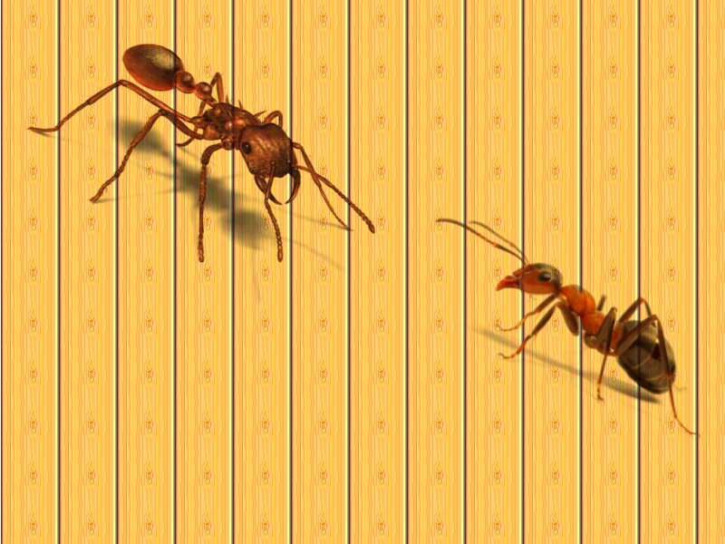
Notes
(a) To remove the white background from the ants Colors Colors to Alpha.
(b) To add the wooden background, drag and drop the background from the pattern to the background layer.
+Additional Activities
3. Create the image below by combining the images found in
the ask3 folder. Save the image in your folder with the name image3.jpg
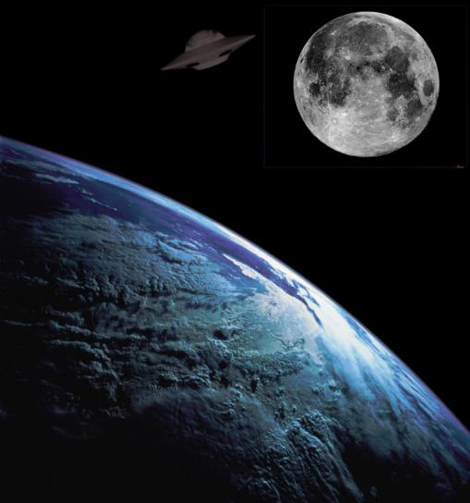

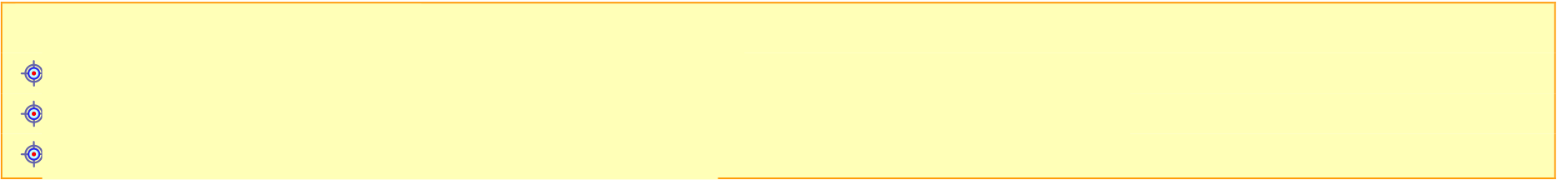
WORKSHEET A.4.M6
Multimedia - Image
What will we learn today:
Converting an image to black and white
Highlighting an area of ​an image using the desaturation method Changing the hues of an image.
Reinforcement Activities
Activity A
1. Open the image Ronaldo.jpg located in your folder.
2. Duplicate the image layer (Layer Duplicate Layer).
3. Convert the new layer to black and white (Colors Desaturate).
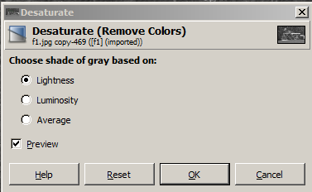
4. Add an Alpha Channel to the black and white layer (Layer Transparency Add
Alpha Channel.
5. Use the eraser
to erase the gray above the football player's jersey. 6. Remove the selection line (Select None).
7. Save the image to your folder.
8. The image should look like below:


A.4.M6
A.4 Application Software - Multimedia
Activity B
9. Open the image audi.jpg.
10. With the Foreground Select tool
to draw a rough outline
around the car.
11. In the second step of the same tool, brush over the colors of
the car that we want to change.
12. Press Enter on your keyboard.
13. Select the new color of the car (Colors Hue – Saturation).
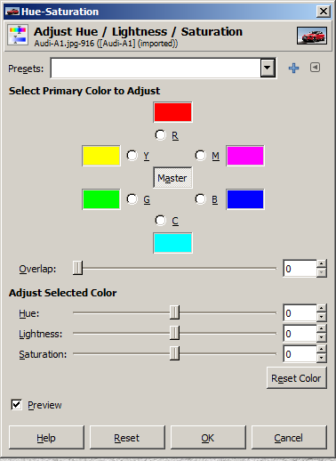
14. Select Select None.
15. Save the image to your folder.
Initial Image
Final Image


A.4 Software Applications-Multimedia
A.4.M6
Assessment Activities
Activity C
16. Open the image face.jpg.
17. Convert the original image to the final one.
Initial Image

Final Image


A.4.M6
A.4 Application Software - Multimedia
Activity D
18. Open the image liberty.jpg.
19. Convert the original image to the final image.
Original Image
Final Image

+Additional Activities
Activity E
20. Open the image umbrella.jpg.
21. Convert the original image to the final one.
Original Image
Final Image

WORKSHEET A.4.M7 Multimedia - Image What will we learn today:
Apply filters to an image.
Activity A – Face Distortion
1. Open the image lena.jpg located in your folder.
2. Using the tool 
select the face.
3. Distort the face using the Pixelize filter (Filters Blur Pixelize).
4. Choose from the menu Select None
5. Save your image in your folder with the name fe7_1.jpg Initial Image
Final Image


A.4.M7
A.4 Application Software - Multimedia
Activity B – Colorify
6. Open Gimp.
7. Create a new image (File New)
with a size of 1000x738, as shown in the dialog box on the right.
8. Open the image Rihanna.png and apply color to it (Colors
Colorify).
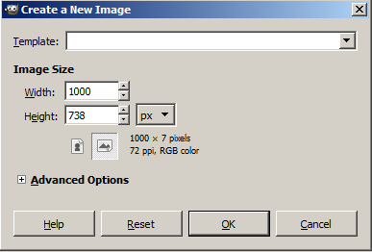
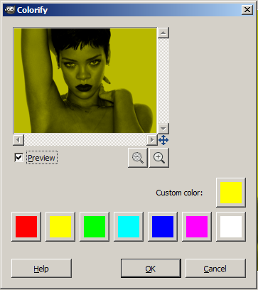
9. Copy the Rihanna image to your empty image. Repeat this step 4 times to create the image below.

A.4 Application Software-Multimedia
A.4.M7

10. Save your image in your folder with the name fe7_2.jpg
Activity C – Converting an image to a painting
11. Open the Scarlett image.
12. Select the Van Gogh filter (Filters Artistic Van Gogh).
13. Select Saturation and play with the other settings.
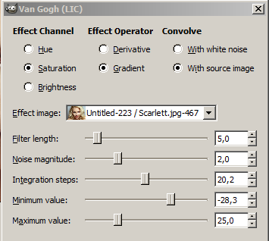

A.4.M7
A.4 Application Software - Multimedia
14. Apply the canvas filter (Filters Artistic Apply Canvas).
15. Save your image with the name fe7_3.jpg
Original Image

Final Image


A.4 Application Software - Multimedia
Activity D – Red Eye Removal
16. Open the redeye image.
17. Zoom in on your image 3 times.
18. Select the ellipse selection tool.
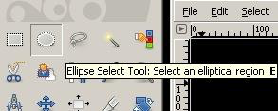
19. Hold down the shift key and select both eyes.
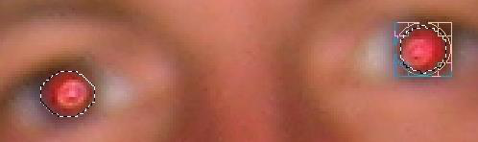
20. Select Filters Enhance Red Eye Removal
21. Save your photo.
Initial Image


A.4.M7
A.4 Application Software - Multimedia
Final Image



WORKSHEET A.4.M8
Multimedia - Video
What we will learn today:
Import image and sound into Movie Maker
Change settings for switching images
Apply transition effects to images
Save the project and video.
Reinforcement Activities
Activity A
In this activity we will create an animation by displaying 38 frames, which represent the movement of a cartoon.
1. Open Windows Live Movie Maker.
2. Import the frames found in the Felix folder.
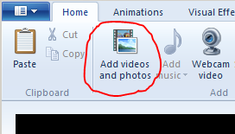
3. Press Play to see the video you have created. You will notice
that the movement is not very smooth. Why do you think this is happening?
................................................................................................................................
4. Select all the frames (Ctrl+A). Go to the Edit tab and change
the duration to 0.03. Press play. What do you notice?
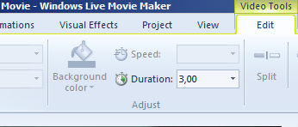
................................................................................................................................
5. Save your animation as Felix.wlmp and as Felix.wmv. What is
the difference
between them?
................................................................................................................................

A.4.M8
A.4 Application Software - Multimedia
Activity B
6. Open Windows Live Movie Maker.
7. Import the video countdown.mp4.
8. Import the images from the ask2 folder.
9. Set the duration for each image to 5 seconds. 10. Insert the song we are the champions.mp3.
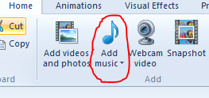
11. Apply a transition effect to each image.
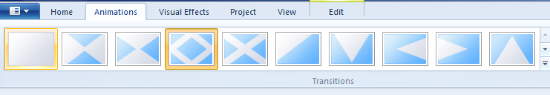
12. Save your movie with the name M8_askB.wmv
Assessment Activities
13. Create a video that:
(a) Starts with the video start.mp4
(b) Contains the images found in the ask3 folder (c) Each image will be 5 seconds long
(d) Each image will have a transition effect
(e) Contains the song song.mp3
(f) Save it with the name M8_askC.wmv.
+Additional Activities
14. Create a video about the European Union. It should
include images of the capitals of the 28 member states, as well as the anthem
of the European Union (Ode to Joy). Save your video with the name M8_askD.wmv.


WORKSHEET A.4.M9
Multimedia - Video
What we will learn today:
Adding visual effects to video
Adding titles and text to video
Editing a video (trim)
Saving the project and the video.
Reinforcement Activities
Activity A
1. Open Windows Live Movie Maker.
2. Import the video ask1.wmv
3. Add the title Mickey Mouse at the
beginning.
4. In the Text Tools tab, we can format the title.

(a) Change the background to blue.
(b) Apply the stretch effect to the title.
5. Add Credits at the end with your name and department. (a) Change the background to blue.
(b) Apply the scroll effect to the title.
6. Select the cartoon video and apply a sepia visual effect to it.
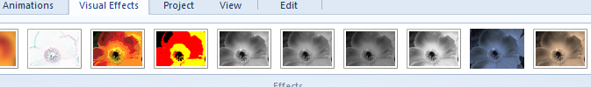
7. Save your movie with the name M9_askA.wmv
Activity B
8. Open Windows Live Movie Maker.
9. Import the video magician.mp4.
10. Select the video and
go to the Edit tab
where
you
will
use
the
Split and Trim tools.
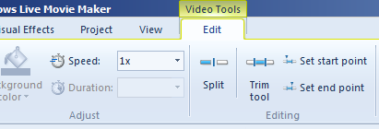

A.4.M9
A.4 Application Software - Multimedia
11. Advance the video to point 1:19 and press split. In this way you will split the video in two.
12. Select the first track and press trim, in order to remove tracks from the beginning and the end. Set the start point to 6 s and the end point to 78 s and press save.
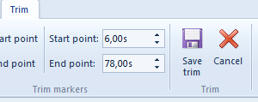
13. Select the second track and press trim. Set the start point to 84 s and the end point to 230 s and press save.
14. Save your movie with the name M9_askB.wmv
Activity C
15. Open Windows Live Movie Maker.
16. Add a title with the name Fears of the Prince.
17. Insert the song song3.mp3.
18. Change the duration of the first frame to 12 s.
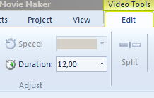
19. Insert the image img1.jpg.
20. Add a caption. In the text, write:
Even if I changed everything, I wouldn't change the path
Even if I lost everything again 21. Change the duration of the second frame to 13 s.
22. Select an effect for the caption from the Text Tools tab.
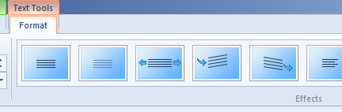

A.4 Application Software-Multimedia
A.4.M9
23. Insert the image img2.jpg.
24. Add a caption. In the text, write:
Even if I changed everything, I wouldn't change the path
Even if I lost everything again from the beginning
25. Change the duration of the second frame to 13 s.
26. Select an effect for the caption from the Text Tools tab.
27. Save your movie with the name M9_askC.wmv
Assessment Activities
Activity D
28. Create a video dedicated to quotes from scientists:
(a) Start with the video start4.mp4. From this video, use only the
section from 10s to 15s.
(b) Contain the images found in the ask4 folder.
(c) Each image must be 10 seconds long.
(d) Each image must have a caption that states the following information:
Image Name
Quote
Only two things are infinite: the universe and
Albert human stupidity, and about the universe I have some Einstein
doubts.
2
Certainty is more often the product of ignorance than of knowledge.
3
Isaac We build many walls but not enough bridges.
Newton
You can't teach a person anything. All
Galileo you can do is help them discover Galileo
what they have inside.
5
I've noticed that even people who
claim that everything is predetermined and that there is nothing we can do to change it, look left and right before crossing the street.
(e) Contain the song song4.mp3.
(f) Save it as M9_askD.wmv
+Additional Activities
Activity E
29. Create a video that presents the lyrics of a
song with images. Save your video as M9_askE.wmv.


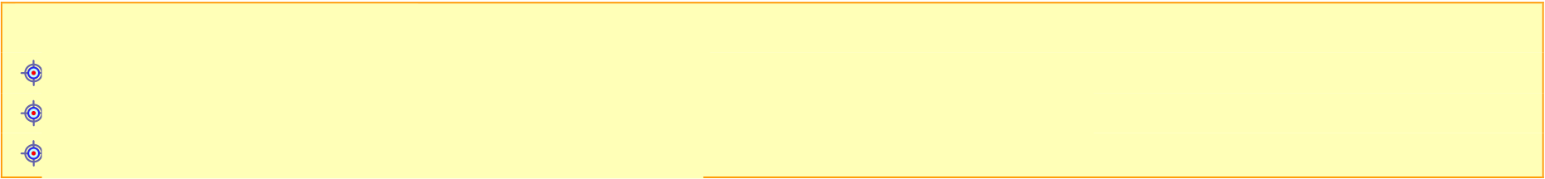
WORKSHEET A.4.M10
Multimedia - Video
What we will learn today:
Downloading a video from Youtube
Publishing a video we have created on Youtube
Adding subtitles to a video.
Reinforcement Activities
Activity A
In this activity we will see how to download a video from Youtube. The method presented is not the only one.
1. Go to the page http://www.youtube.com/ and select a video that
you want to download.
2. Change the address (url) of the video from
www.youtube.com/....... to ssyoutube.com/….. and press enter.
3. You will be taken to the page savefrom.net.
Select the quality of the video that you want from the
options given when you
download it. Once you have selected it, the
download of the video will start.
Activity B
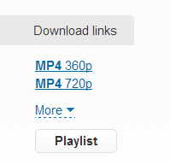
In this activity we will see how we can Publish a video on Youtube. And in this case the method is not the only one.
4. Go to the page http://www.youtube.com/ and log in with
your Google account. If you do not have one, please mention it to your teacher so that he/she can advise you on how to proceed.
5. Press the Upload button.


A.4.M10
A.4 Application Software - Multimedia
6. Select the type of publicity that
7. When the upload is finished
press the Publish button. 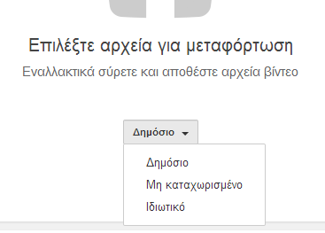
you want your video to have (Public,
Unlisted, Private) and
select the video to upload.
Activity C
The subtitles in a video are usually a separate file with the extension .srt.
This is a text file that contains the subtitles of the video, as well as the time when they should appear. You can create an srt file using Notepad.
The name of the srt file must be the same as that of the video and be in the same folder.
Although it is possible to create subtitles with Notepad, this would be very time-consuming. For this reason, special programs are used. One of them is Subtitle Edit which you can find in the Other_Material folder.
8. Open the video ask3.wmv ​and watch the video.
9. Open the file ask3.srt.
10. Change the subtitle text as shown in the table below:
Number
Text
1
Did you put sugar in my frappe?
2
Don't answer. It's a trap.
3
I will answer. Did you tell me with sugar?
4
I think I was clear.
5
Did you tell me with sugar?
6
I said without sugar.
7
You told me WITH sugar, you old man.
11. Save the file and watch the video again.

A.4 Application Software-Multimedia
A.4.M10
Assessment Activities
Activity D
12. Download two or more videos from Youtube and create your own using excerpts from the ones you downloaded. Save your
video with the name M10_askD.wmv.
13. Publish the video you created on Youtube.
Activity E
14. Select one of the videos in the ask14 folder and create subtitles for it.

UNIT A5 Computer Networks and Internet



Worksheet A.5.M1
Introduction
What will we learn today:
Explain what a network is and what its categories are
Mention the necessary equipment for connecting a device to a network
Mention and distinguish the various media (cables, fiber optics, wireless connection) and
their characteristics
Mention and distinguish the basic network devices (switch, router, access point) and
describe their role
Mention the advantages and disadvantages of wireless networks Name and briefly describe services that may be provided in a network
(e.g. file sharing, printing to a shared printer, e-mail, World Wide Web, etc.) Briefly describe the client-server communication model and distinguish in examples
the client and the server.
Reinforcement/Assessment Activities
1. Determine which of the following statements are true and which are false:
A computer network is a group of two or
(a) more computers and other devices that □ □ are connected to each other to exchange data.
(b)
Our school network is a wide area network.
(c)
Our home network is a local area network.
To create a network with computers, we need to
provide networking materials, such as cables,
(d) network cards, switches and network routers. □ □
To connect the computers in a laboratory
(e) to each other, we need at least one switch. □ □
To connect the network of a bank branch with the
(f) central office network, the use of a router is □ □ necessary.
In order for all computers on a network to be able
(g) to print, it is necessary for each computer to have □ □ a printer.
Through a local network, it is not possible to
(h) access files, folders and programs that may be on □ □ other computers.
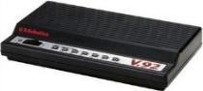
A.5.M1
A.5 Computer Networks and the Internet
In the process of reading your e-mail, your
computer is involved as the server and the
(i) computer of the e-mail service provider as the client. □□
2.
List devices (other than computers), e.g. alarm systems, that are connected to a network.
......................................................................................................................................
......................................................................................................................................
3.
Identify the following network devices and connections by placing the number of the image that represents each next to its name:
(a) Fiber Optics
............
(b) Switch
............
(c) Network Cables (Cat 5, Cat 6)
............
(d) Modem
............
(e) Router
............
(f) Ethernet Card
............
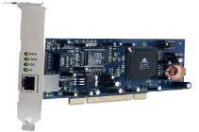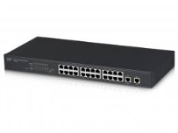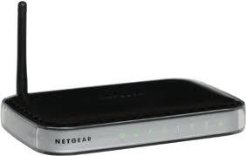
(1)
(2)
(3)
(4)
(5)
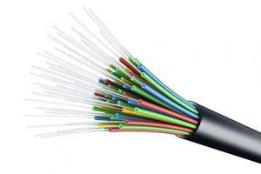
(6)
4.
The following cases are given. For each of them, indicate the connection method (fiber optics, network cables, wireless connection) that you consider to be the most appropriate.
(a) Connecting the home network to the provider …………………………………………………
(b) Connecting the computers of the IT laboratory to the switch located
in the room …………………………………………………………………………………………………………
(c) Connecting a tablet to the home network ………………………………………………………
(d) Connecting a desktop computer to the office network …………………
(e) Connecting the IT laboratory to the router ………………………………………
(f) Submarine connection between countries
…………………………………………………………………

A.5 Computer Networks and Internet
A.5.M1
5. List two advantages and two disadvantages of wireless networks.
...................................................................................................................................... ...................................................................................................................................... ......................................................................................................................................
6. List two Internet services.
...................................................................................................................................... ......................................................................................................................................
+Additional Activities
7. Solve the crossword puzzle below.
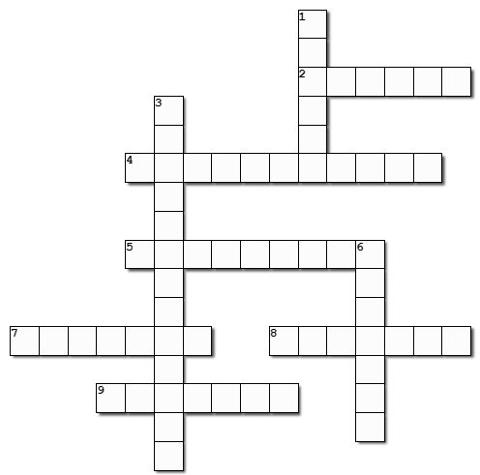

A.5.M1
A.5 Computer Networks and the Internet
HORIZONTAL
2. The ........................... of optical fibers is greater than that of simple network cables (Cat 5, Cat 6).
4. To connect our home network to the Internet, it is necessary to use a .............................
5. Using ............................, two or more computers are connected to a network for information exchange.
7. Cat 5 or Cat 6 are special ........................... that connect the network card of the
PC to another computer or to a switch.
8. One of the categories of networks is the ................... area network.
9. The PC must have a ........................... card in order to be able to connect to a
network.
VERTICAL
1. .................. is a group of two or more computers that are connected to each other.
3. One of the main advantages of using networks is the ability to share .................... devices.
6. One of the main advantages of using networks is the ability to share .....................
8.
Name the additional devices you need to create a
network with five computers and a printer that you already have. Justify your answer.
............................................................................................................................... ............................................................................................................................... ............................................................................................................................... ...............................................................................................................................
Home Activities
9.
What is a Network?
............................................................................................................................... ............................................................................................................................... ...............................................................................................................................

A.5 Computer Networks and the Internet
A.5.M1
10. Mrs. Maria is the director of an architectural office. The office employs three architects and one decorator. To carry out their work
they use computers, printers and a draftsman every day. In
many cases it is necessary to exchange various files with each other.
(a) Explain to Mrs. Maria why installing a network could improve the quality and speed of the work of the
architectural office.
..........................................................................................................................
..........................................................................................................................
..........................................................................................................................
(b) Explain to Mrs. Maria the additional devices that are necessary to create the network.
..........................................................................................................................
..........................................................................................................................
..........................................................................................................................



Worksheet A.5.M2
Network Operation Check
What will we learn today:
Display useful network information
Use IP Addresses
Identify problems in small networks and propose and implement ways to
solve these problems
Check network speed.
Reinforcement/Assessment Activities
1. For each combination of IPv4 address and Subnet Mask for computer PC 1,
determine whether the IPv4 address of computer PC 2 belongs to the same network as computer PC 1.
N/A IPv4 Address Subnet Mask IPv4 Address Yes/No
PC 1 PC 1 PC 2
2. For cases 1-5 of the previous exercise, indicate those for which
the use of the Default Gateway is mandatory, so that computers PC 1 and PC 2 can communicate with each other.
................................................................................................................................
The commands we will see below require the use of the Windows Command Prompt. To open the command prompt window, click in the Search box, type Command, and select Command Prompt.
3. Type ipconfig at the command prompt and press Enter.
Note the following network information for your computer:
(a) IPv4 Address:
________ . ________ . ________ . ________ . ________
(b) Subnet Mask:
________ . ________ . ________ . ________
(c) Default Gateway:
________ . ________ . ________ . ________ . ________

A.5.M2
A.5 Computer Networks and the Internet
4. Type the command ipconfig /all at the command prompt and press
Enter. Note the following additional network information for your PC:
(a) MAC/Physical Address:
____- ____- ____- ____- ____- ____
(b) DNS Servers:
________ . ________ . ________ . ________
________ . ________ . ________ . ________
5. Type the command nslookup at the command prompt and press
Enter.
(a) Type the website www.moec.gov.cy and note the IP
Its address: ________ . ________ . ________ . ________
(b) Type the website google.com and note the IP Address
Its: ________ . ________ . ________ . ________
To terminate the nslookup command, you must type exit.
6. What is the role of the DNS Server?
(a) We send it the IP Address and it returns the name of a computer. (b) We send it the name of a computer and it returns the IP Address
it.
(c) We send it the IP Address and it returns the country in which
the computer is located.
(d) We send it the name of a computer and it returns its MAC/Physical
Address.
7. Open the web browser and type in the address line
8. Type in the command line ping 142.250.201.46 and
press Enter. What can we check with the above command?
(a) If our computer is connected to the Internet.
(b) If there is communication between our computer and the computer that has
address 142.250.201.46.
(c) If our computer belongs to the same network as the computer that has
142.250.201.46.
(d) If our computer is connected to the local network.
9. Type the command tracert 142.250.201.46 in the command line and
press Enter. How many routers (hops) are there to reach the destination? ________
10. Repeat the procedure for the tracert command www.moec.gov.cy. How many
routers (hops) are there to reach the destination? ________

A.5 Computer Networks and the Internet
A.5.M2
11. Go to the website www.speedtest.net and select GO.
(a) What is the download speed?
_______________
(b) What is the upload speed? _______________
12. Match the Check/Problem with the corresponding Action, by putting the
letter from Column A in the empty boxes in Column B:
Column A
Check/Problem
Column B
Action
To check the communication of (1)
our computer with the router Restart the
we can … computer and/or router.
(b) To check if the computer (2)
sends/receives data via the Check the light
cable we can … indicator on the network card.
(c) To check if the computer Use the
has received a logical address from the router we can … (3) Network troubleshooter tool.
(d) To check and (4)
repair the problem through Use the ipconfig
Windows we can … command.
Ping the IP (e) If the computer has not received an IP address from the router we can … Address of the (5) Default Gateway.
+Additional Activities
13. For each combination of IPv4 address and Subnet Mask for computer PC 1,
fill in the IPv4 address of computer PC 2, so that it belongs or not to the same network as computer PC 1.
N/A IPv4 Address Subnet Mask IPv4 Address Yes/No
PC 1 PC 1 PC 2

A.5.M2
A.5 Computer Networks and the Internet
Homework
14. Write down the following network information for your computer:
(a) IPv4 Address:
________ . ________ . ________ . ________
(b) Subnet Mask:
________ . ________ . ________ . ________
(c) Default Gateway:
________ . ________ . ________ . ________ . ________


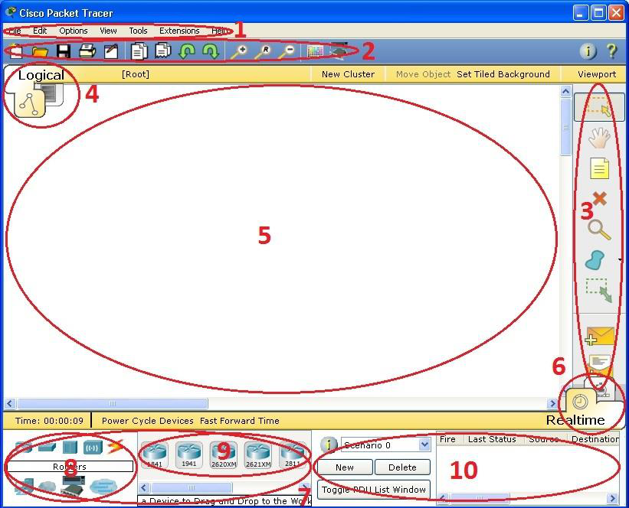
Worksheet A.5.M3
Creating a Simple Network
What we will learn today:
Implement a network
Identify problems in small networks and propose and implement ways to
solve these problems.
Reinforcement Activities
1. Launch the Cisco Packet Tracer program.
This home screen/interface contains ten components. If you are unsure of what an element does, move your mouse over the element and help will appear. The most important
parts are 1, 3, 5, and 7.
Brief description of the elements:
1. Menu Bar - Menu bar. This bar contains the File, Edit, Options, View, Tools, Extensions, and Help menus. You will find the basic commands such as Open, Save, Print, and Preferences.
In the help there are videos on how to use packet tracer.
2. Main Tool Bar - Toolbar. Includes the Copy, Paste, Undo, Redo, Zoom, Drawing Palette, and Devices Dialog buttons.
3. Common Tools Bar - Common toolbar. This line provides access to tools commonly used in the workspace: Select, Move Layout, Place Note, Delete, Inspect, Resize Shape, Add Simple PDU, and Add Complex PDU
4. Logical/Physical Workspace – Logical/Physical workspace.
5. Workspace – Main workspace. In this area you can create your network, watch simulations, and view many types of information and statistics.
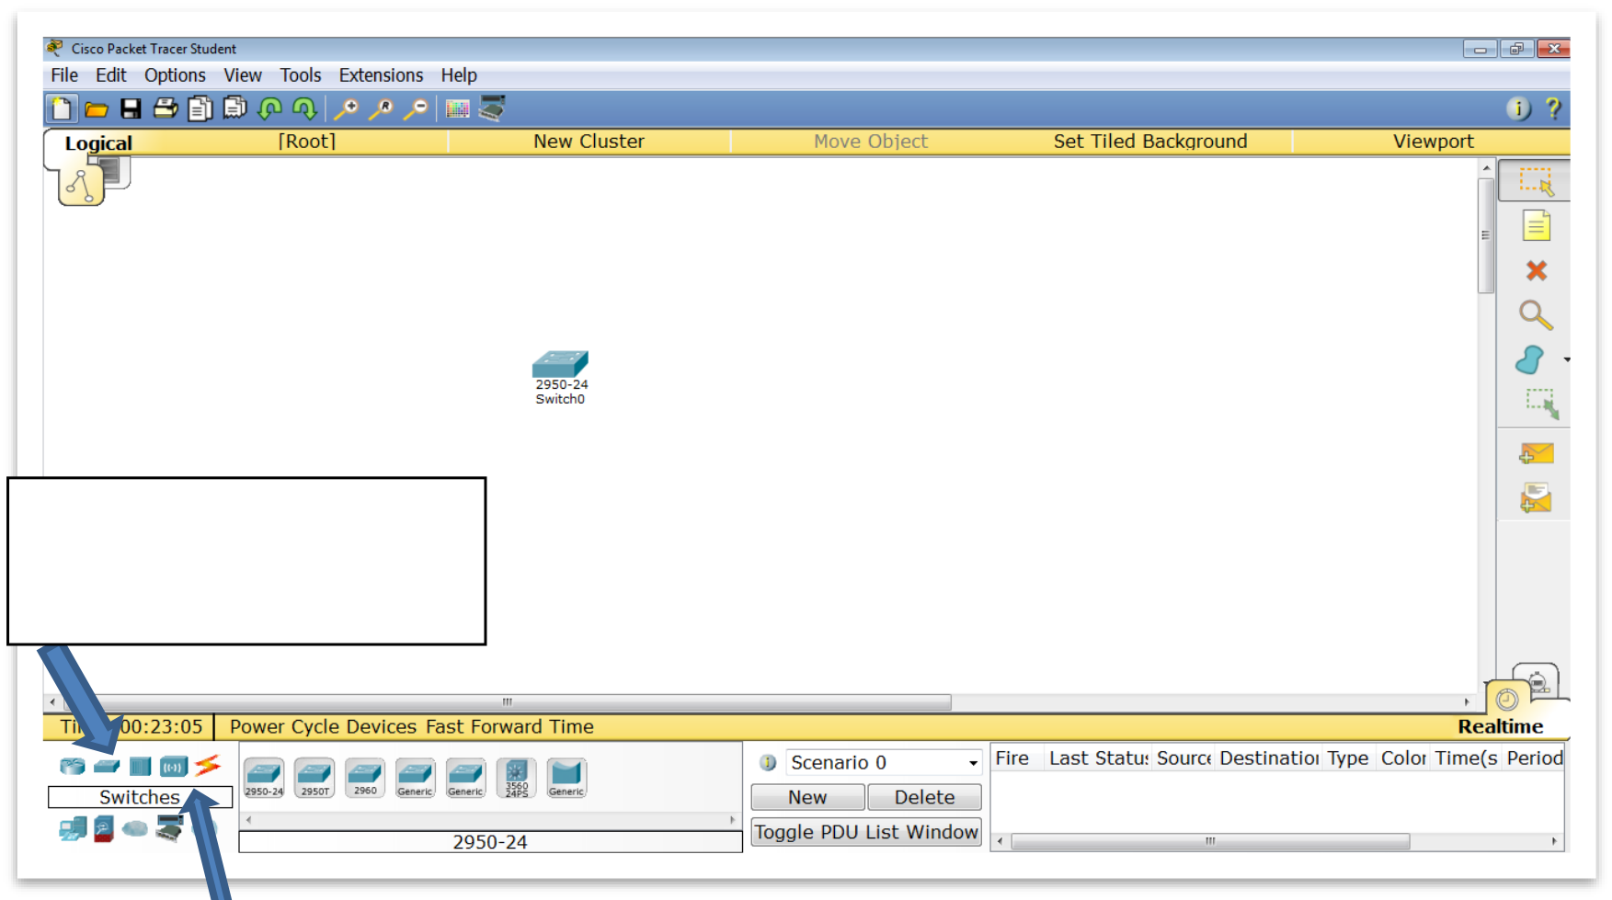
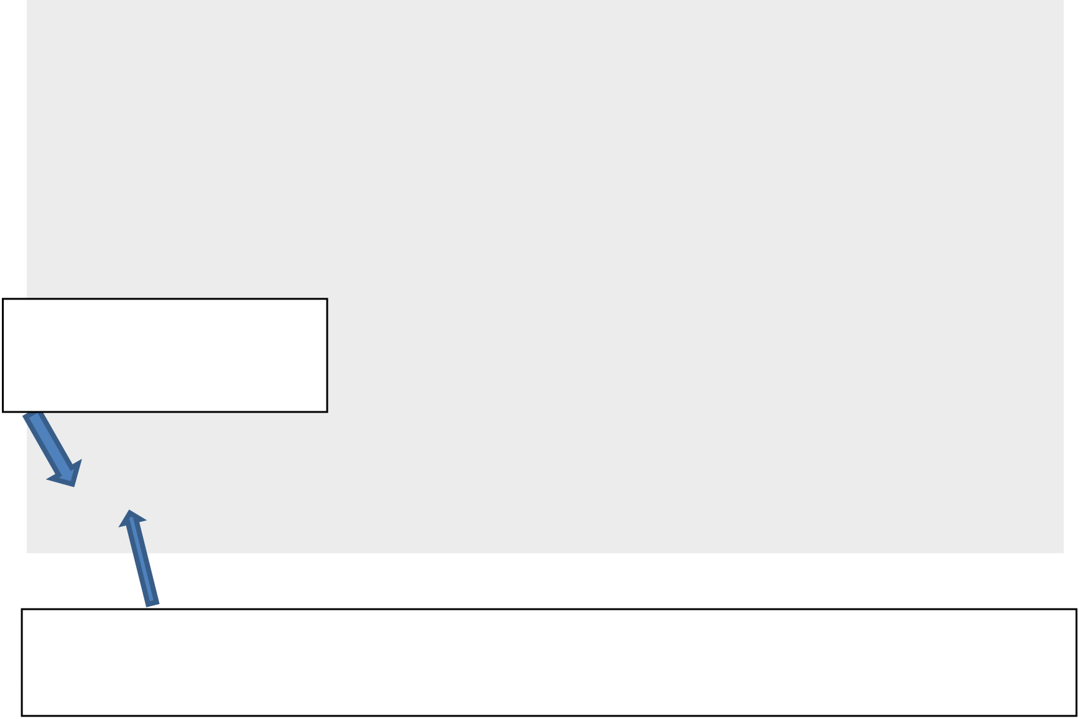
A.5.M3
A.5 Computer Networks and the Internet
6. Realtime/Simulation Bar
7.Network Component Box (8 and 9) – Network Component Box. In this box you will select the devices and connections that you will put in your diagram.
8. Device-Type Selection Box – Device-Type Selection Box. Here you will find the type of network devices and connections. Selecting a specific type changes the box next to
a specific device (9)
9. Device-Specific Selection Box – Device-Specific Selection Box.
10. User Created Packet Window – Packet sending control window.
2. It is time to design your first network. The basic components that you will
use are:
(a) Switch Network Device. A switch has the ability to connect
two or more computers at the same time (b) Two computers and
(c) Cables.
3. Using the mouse, drag and drop a Switch Network Device to the center of the main
workspace as shown in the figure below:
Select the Switch
device type
Select a specific device (model) Switch 2950-24. The 2950 is
the model and the 24 indicates that up to 24 PCs can be connected
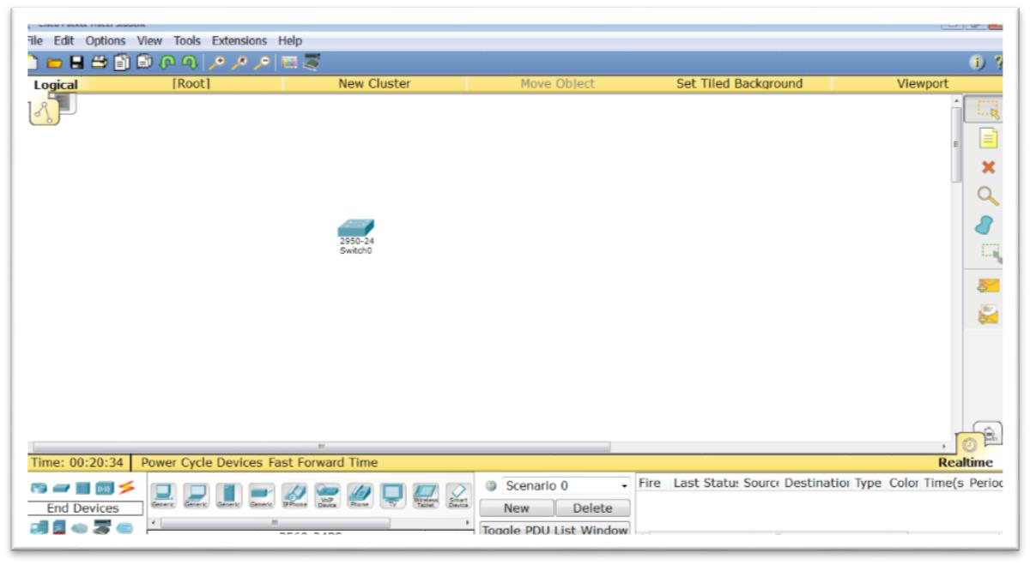
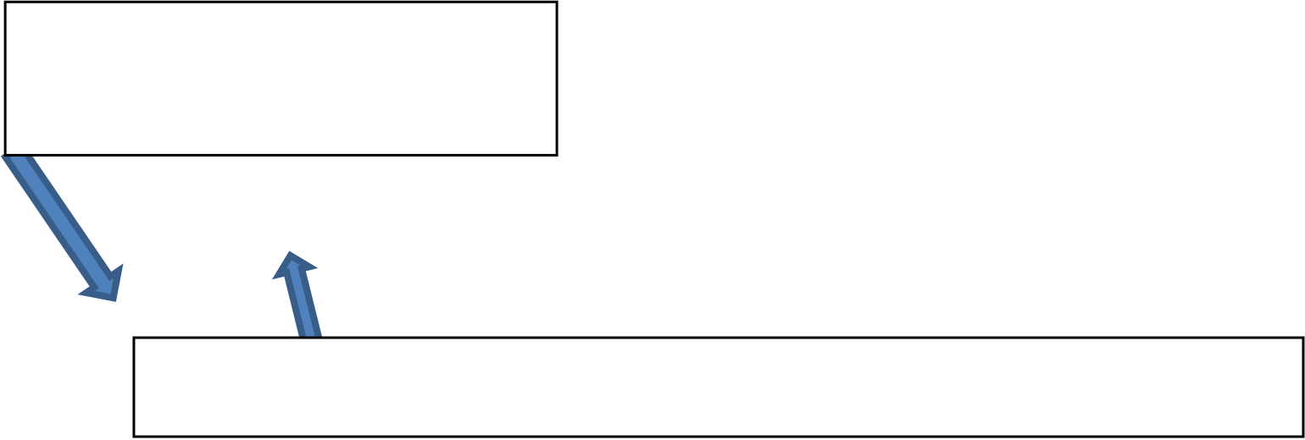
A.5 Computer Networks and the Internet
A.5.M3
The result is shown in the figure below:
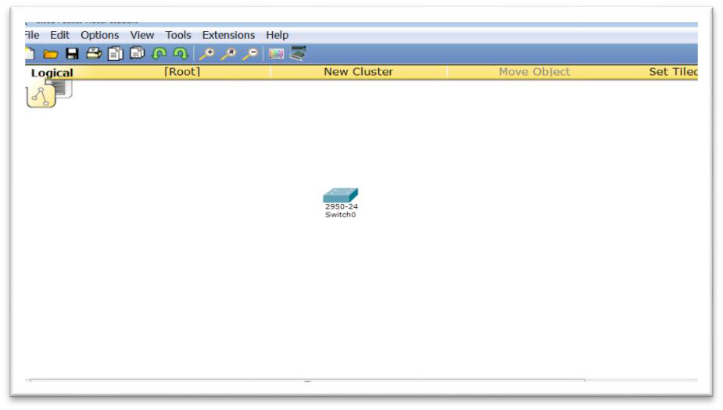
4. Using the mouse, select a PC type device and drag
and drop it to the right of the switch. Repeat the same process to add a second PC, as shown in the figure below:
Select the type of
device End Devices
Select a specific device (model) Generic PC
The result is shown in the figure below:
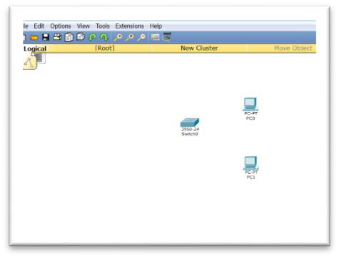
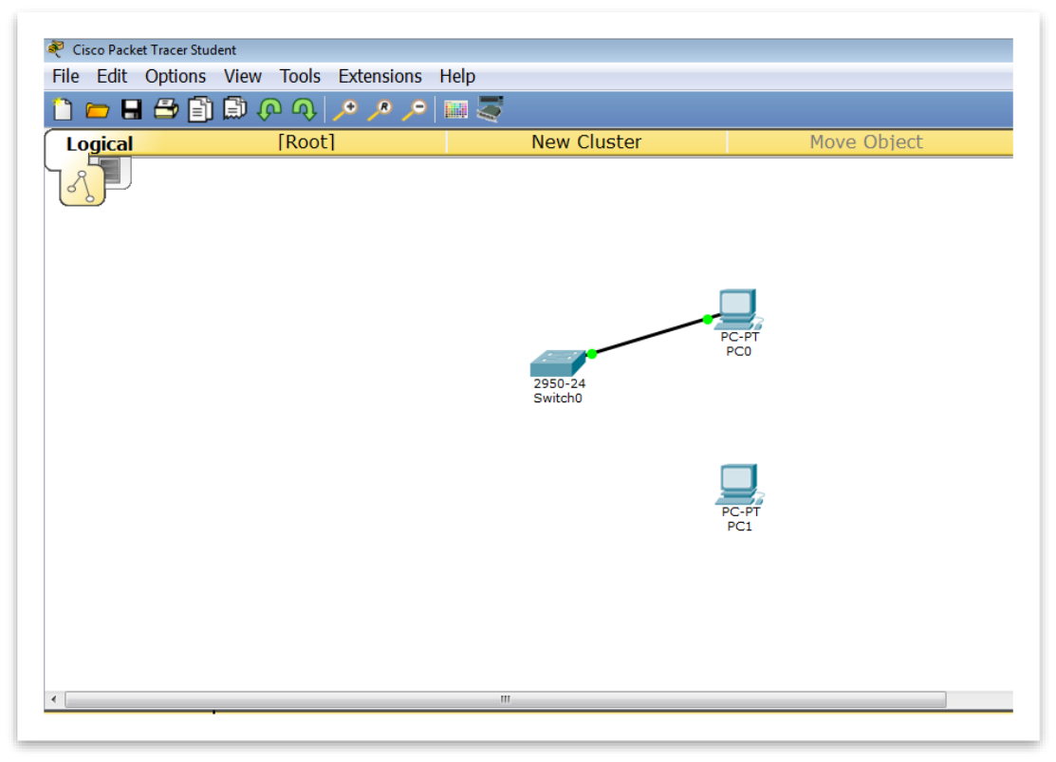
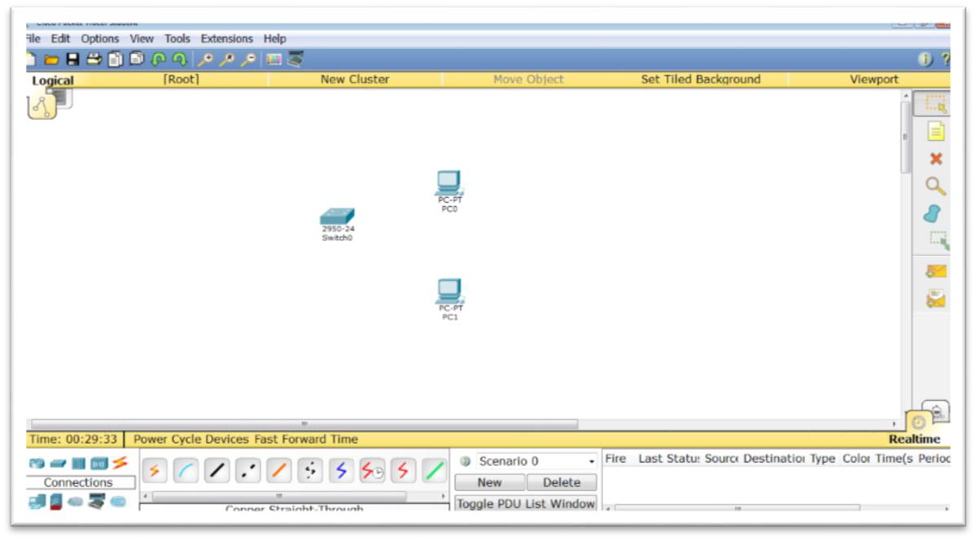


A.5.M3
A.5 Computer Networks and the Internet
5. After placing the devices, you must connect them with cables as shown
in the figure below:
Select the connection
type Connections
Select the specific connection method Copper Straight-Through
(a) Select the Switch and from the menu that appears, select
FastEthernet0/1. Note that this is the first port of the switch.
(b) Then, select PC0 with the mouse and from the menu that appears
select FastEthernet0.
(c) If you followed the instructions correctly, your network diagram should
look like the following screen:
If the lights on the
switch and the PC are orange
instead of green, then wait
2-3 seconds until they turn
green. If the lights are
red
then
either
you
did
not
use
the
correct
cable
or
you
connected
your cable to
the
wrong
port.
(d) Connect the second PC in the same way.

A.5 Computer Networks and the Internet
A.5.M3
6. After the physical connection has been made, we will then need to set the logical
addresses or IP Addresses to the devices.
(a) Select PC0 and then the Desktop tab
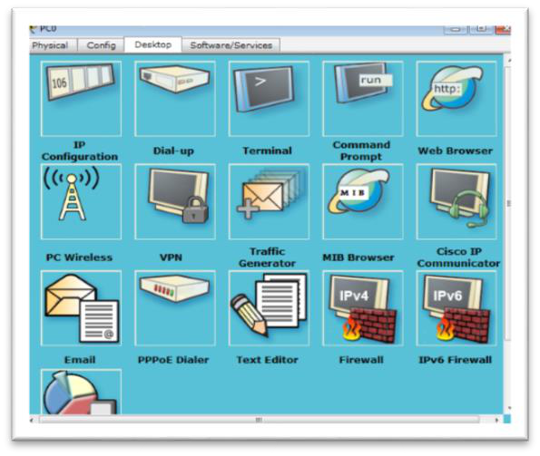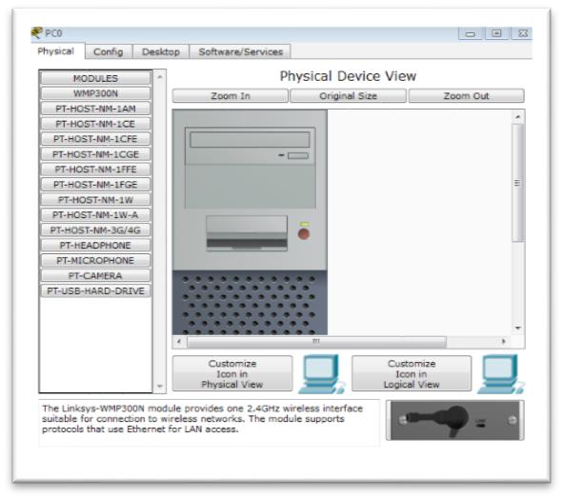
(b) Select IP Configuration and enter:
IP Address: 192.168.1.1
Subnet Mask: 255.255.255.0
(c) Close both windows.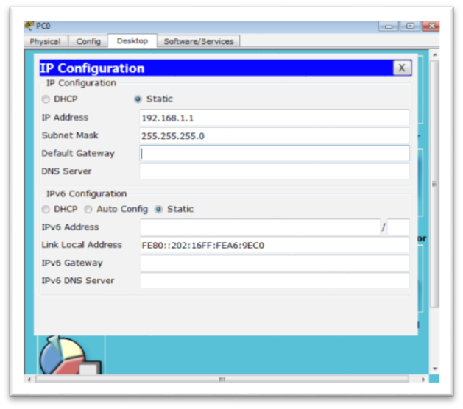
7. Add IP Configuration for PC1:
IP Address: 192.168.1.2
Subnet Mask: 255.255.255.0
The IP Address must be different for each device that we connect to the same network
8. Save the file by selecting FileSave (or the floppy disk icon) with
the name Network1 in the folder that your teacher will indicate to you.
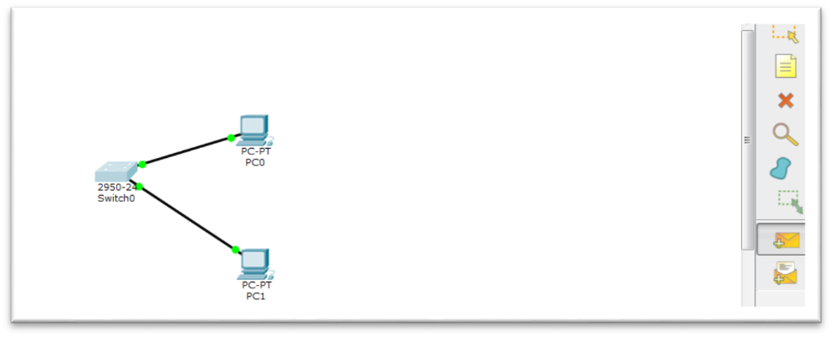

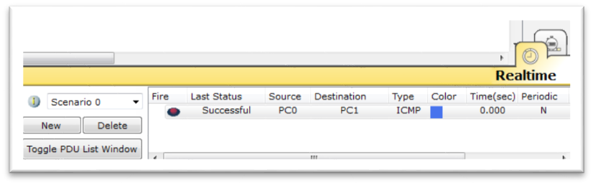

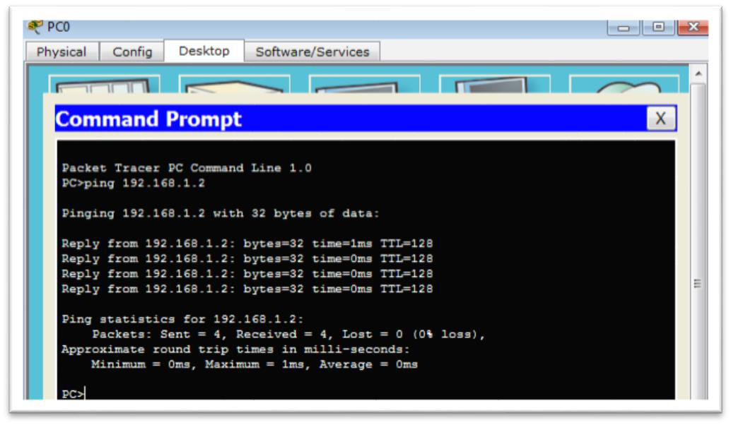

A.5.M3
A.5 Computer Networks and the Internet
9. Your network is ready. To check that it works, use the two
below ways:
(a) Through the command line environment with the ping command:
Select PC0 Dekstop Command Prompt
Type: ping 192.168.1.2
It sent 4 data
packets and
received 4 data
packets
(b) Through the simulator, as shown in the figure below:
Select
Add Simple PDU and
then
PC0 and PC1
If
the message Successful
appears in the lower
right
corner, it means that
+Additional Activities
10. Connect two more PCs and make the appropriate settings (Copper-
Straight Through cable, IP address) so that your network works.

A.5 Computer Networks and the Internet
A.5.M3
11. Add another switch and connect it to the Copper Cross-Over cable. Connect 4 laptops and enter appropriate IP Addresses.
The result is shown in the figure below:
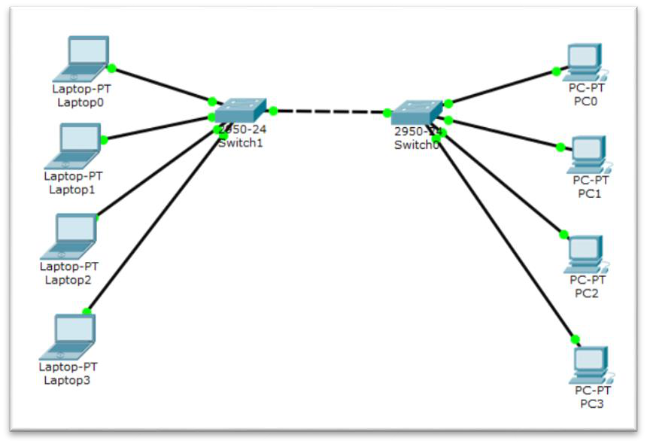
12. Open the Troubleshooting 1.pka activity and find the errors in wireless networking.
13. In collaboration with the teacher, implement this task in a real environment using a small Switch, computers in your
laboratory and straight Ethernet cables.



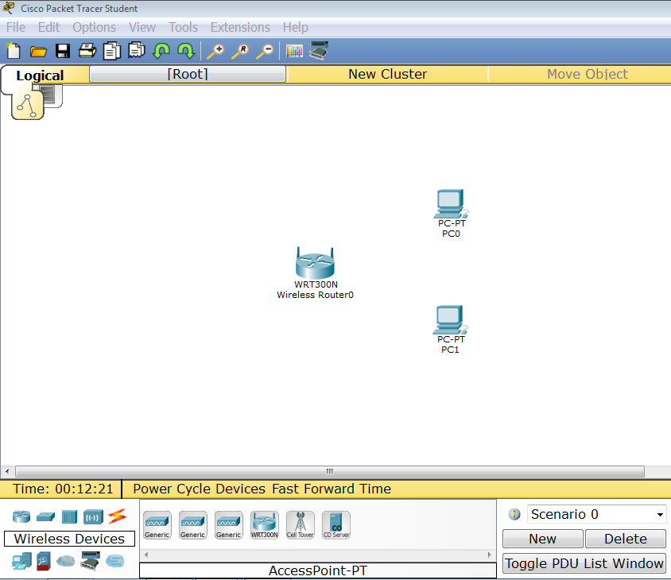
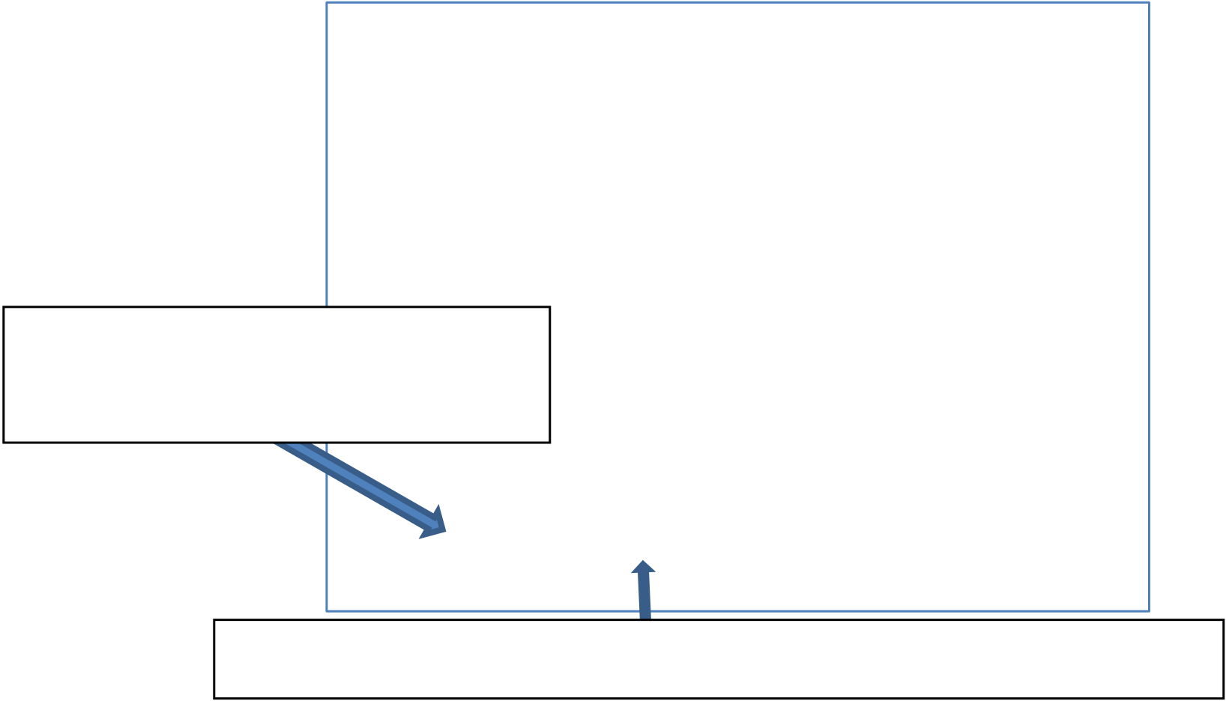
WORKSHEET A.5.M4
Wireless Networks
What we will learn today:
Implement wireless PC networks
Introduce basic wireless network security settings
Identify problems in wireless networks and propose and implement ways
to solve these problems.
Reinforcement Activities
1. Open the Cisco Packet Tracer software.
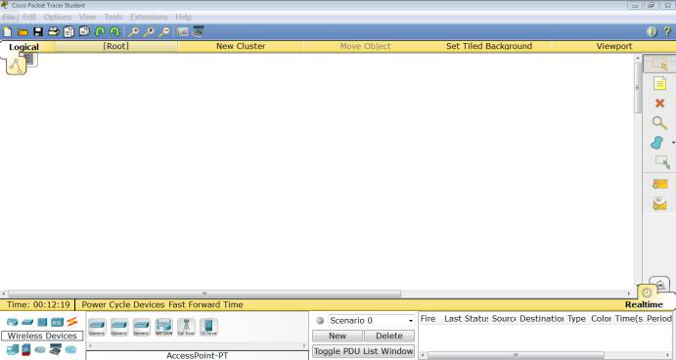
2. Design a wireless network using the following:
(a) A wireless device (wireless router) and
(b) End devices (PC or laptop) suitably equipped with a wireless card
to connect to our wireless device.
3. Using the mouse, drag and drop a Wireless Network Device to the center of the main
workspace as shown in the figure below:
Select the device type
Wireless Devices
Select a specific device (model) WRT300N
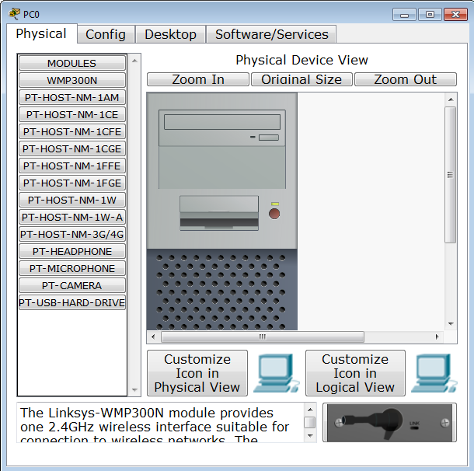

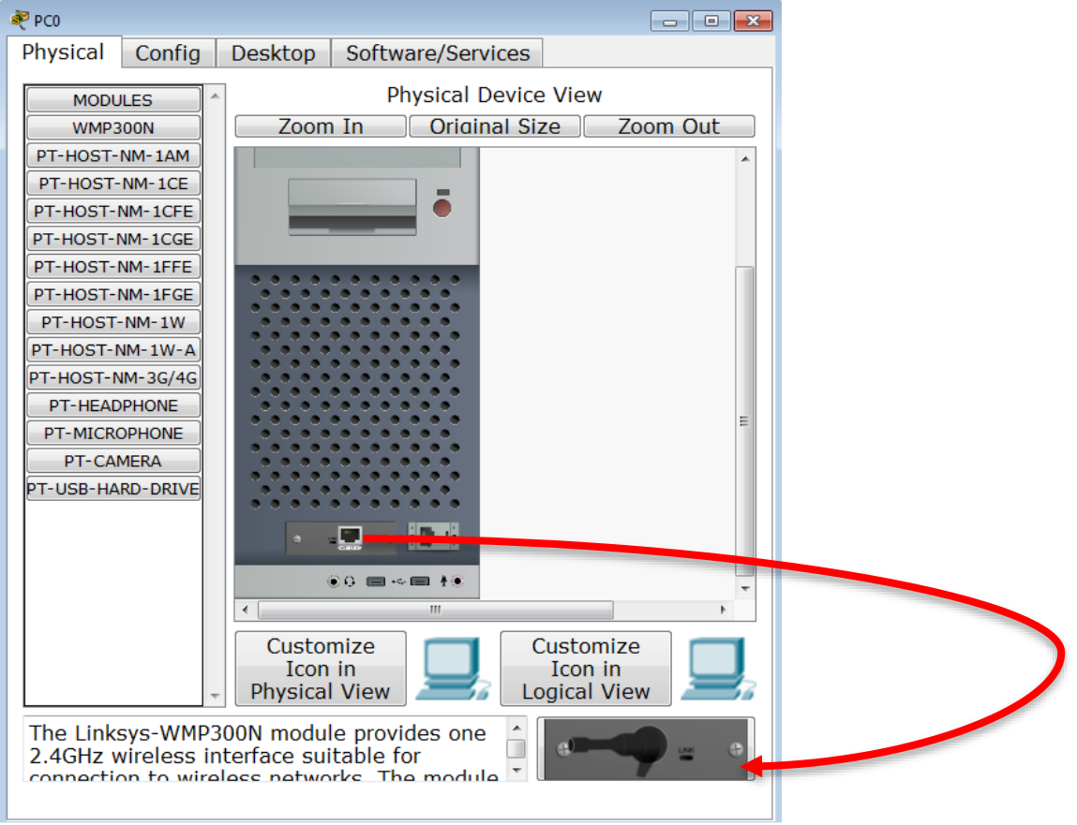

A.5.M4
A.5 Computer Networks and the Internet
4. Using the mouse, add two computers, PC0 and PC1.
5. Equip the computers with wireless network cards, so that they can be connected to the wireless network device:
(a) Select PC0 and turn it off by pressing the ON/OFF switch once.
(b) The following image shows the position of the switch. Make sure that the light (led) located directly above the switch changes color from green to black.
On/Off
Switch
(c) While the PC is off, remove the network card by dragging and dropping
to the bottom right of the window.
(d) Make sure that an
empty black box should appear in the
space where the network card was.
(e) Add the wireless network card located at the bottom right (drag and drop), to the empty space you created previously.

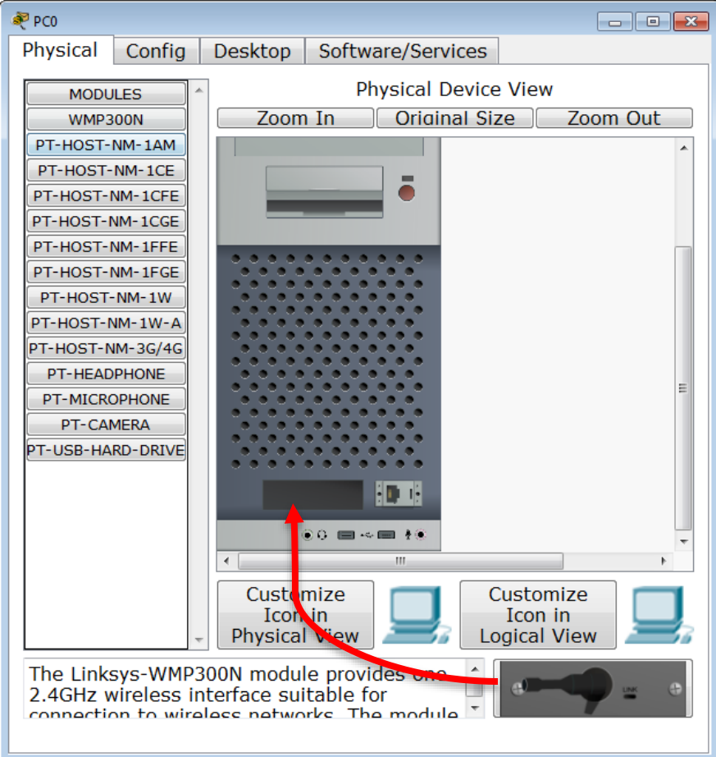
A.5 Computer Networks and the Internet
A.5.M4
(f) Turn on PC0 by pressing the ON/OFF switch once. (g) Close the PC0 window.
(h) Open PC1 and repeat the same process to add a wireless network card to PC1 as well.
The final wireless network should have the following format.
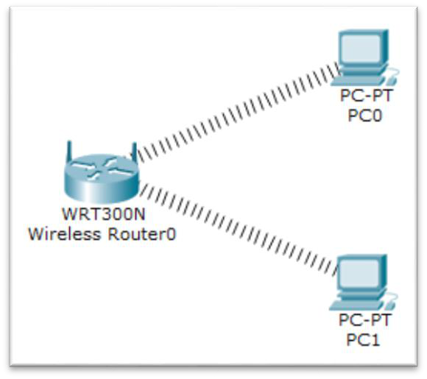
6. Record the IP Address that the Router gave to each of the two PCs.
PC0:
________ . ________ . ________ . ________
PC1:
________ . ________ . ________ . ________ . ________
7. Check if PC0 communicates with PC1 using the ping command. Check for possible problems and solve them.
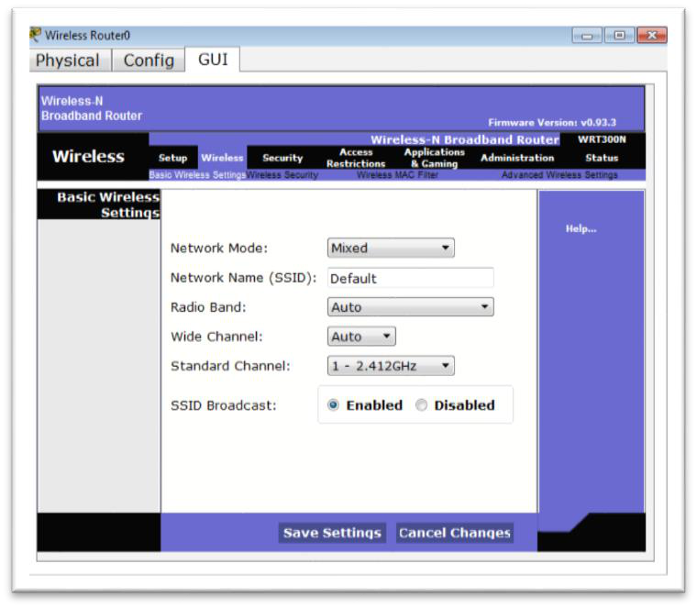

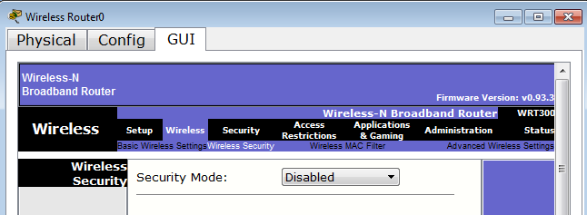
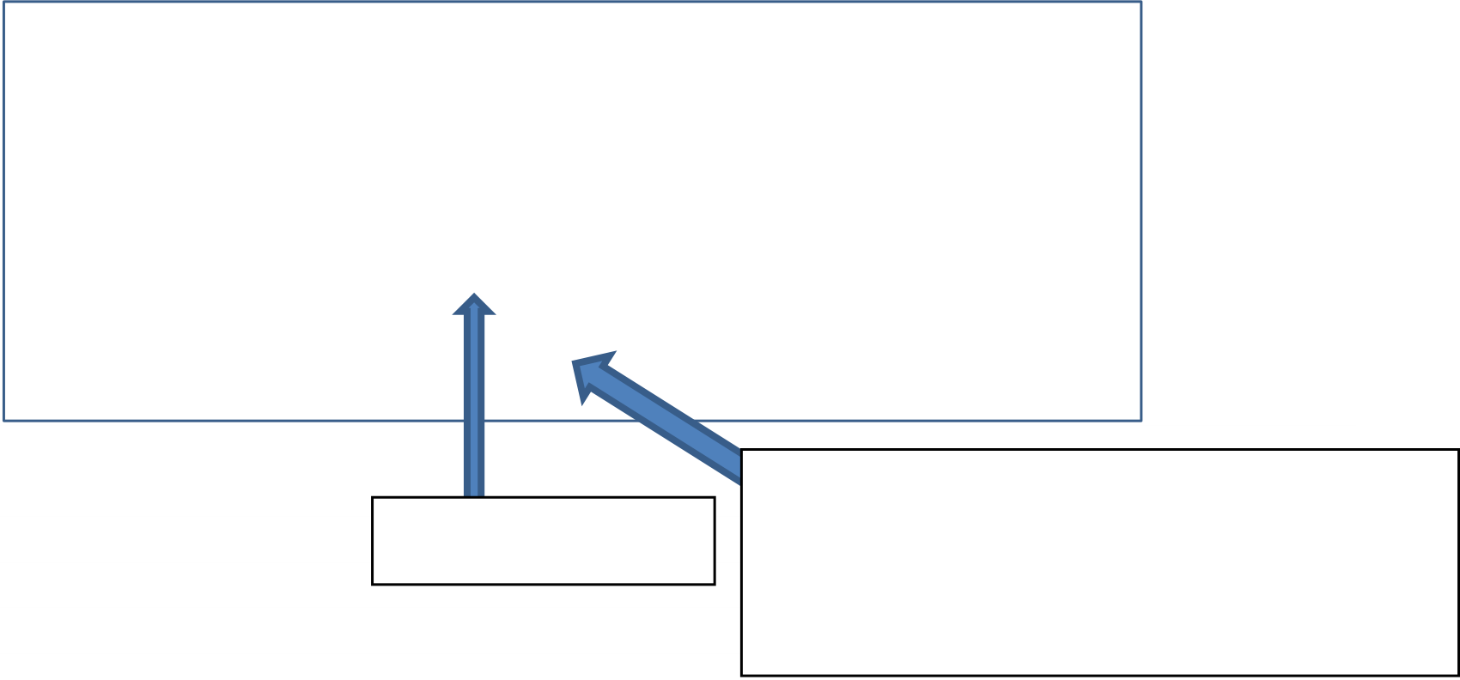
A.5.M4
A.5 Computer Networks and the Internet
WIRELESS NETWORK SECURITY
8. The network you created has a security hole. Any computer you add
will be able to connect without asking you to enter a password. To create a secure and controlled network, you must enter passwords in the Wireless Router, following the instructions below:
(a) Select the WRT300N Router and click on the GUI tab.
(b) Select Wireless and change the Network Name
(SSID) from Default to SCHOOL. Click the Save Settings button.
Wireless Network Name
(c) Select Wireless Security and change the Security mode from Disabled
to WPA2 Personal.
Disabled=Open network without password
Wireless Security
WEP, WPA Personal, WPA2 Personal= Password protected network
(d) In the Passphrase field, you can add the password you want. The
password must be at least 8 characters long.
(e) Enter the password guesswhat and click the Save Settings button.
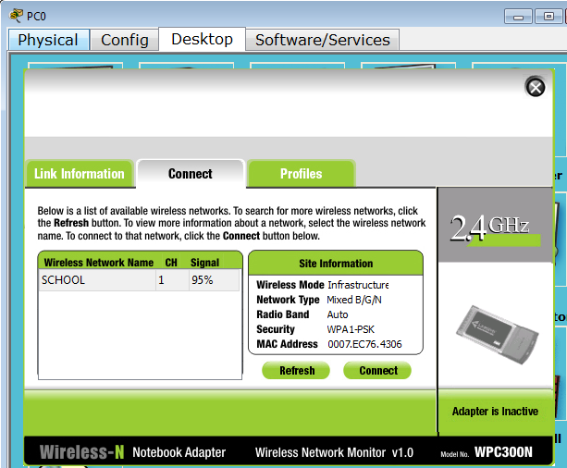


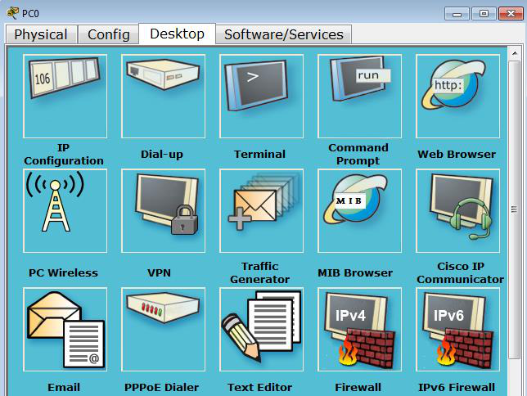

A.5 Computer Networks and the Internet
A.5.M4
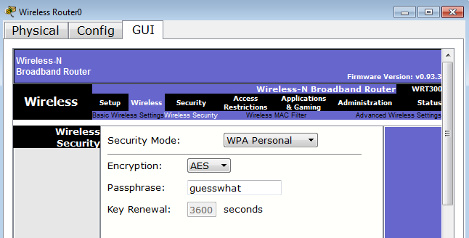
Since you changed the network name (SSID) and password, your network is relatively secure.
9. Now the two computers have lost their connection to the Wireless
Router (and the wireless network) and should be configured with the security parameters we specified:
(a) Select PC0, Desktop tab and click on PC Wireless.
(b) On the next screen, select the Connect tab and press the
Refresh button, until the wireless network named SCHOOL that you defined previously on the router appears.
(c) Select the SCHOOL network and then press the Connect button to
connect.
Select the
SCHOOL
Press the
Connect button to
connect

A.5.M4
A.5 Computer Networks and the Internet
(d) Enter your guesswhat password in the Pre-shared Key box and press the Connect button.
(e) Close the two open windows and check if PC0 has reconnected to the Router.
(f) Repeat the process for PC1.
Your final network should look like this:
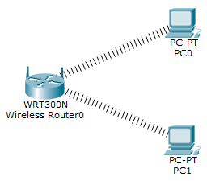
10. Save the file by selecting FileSave (or the floppy disk icon) with the name Network2 in the folder that your teacher will indicate.
+Additional Activities
11. Create the following network.
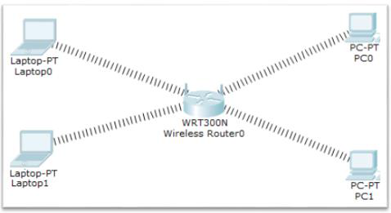
12. Open the Troubleshooting 2.pka activity and find the errors in the wireless networking.
13. Open the Troubleshooting 3.pka activity and follow the instructions that appear.
14. In collaboration with your teacher, implement this task in a real environment using a small Wireless Router and computers of your laboratory after adding usb Wireless adapters.


WORKSHEET A5.M5
Security, Interactive Communication Applications and
Social Networks
What will we learn today:
Explain the role of security programs (antivirus, firewall, antispyware)
Name various interactive communication applications (e.g. Skype, Messenger, Viber) Describe the capabilities and main advantages and disadvantages of
interactive communication applications
Define what a social network is and give examples (e.g. Facebook, Twitter, LinkedIn,
Instagram, TikTok)
Describe the risks arising from the use of interactive
communication applications and social networks (Personal Data Interception–Phishing, Cyber-bullying–Cyberbullying, Seduction of Minors–Grooming)
Explain ways to address the risks arising from the use applications
interactive communication and social networks (Personal Data Interception –Phishing, Cyberbullying, Seduction of Minors – Grooming).
Reinforcement and Evaluation Activities
1. Match the Software with the corresponding Role, by putting the number in
Column B in the empty boxes in Column A:
Column A
Software
Column B ROLE
It is software that allows or rejects
(a) Antivirus 1 data packets passing from one computer network to another.
They detect an attacker's attempt to
(b) Firewall spy on our activity and
2 read our personal data, passwords and files.
(c) Antispyware
3
Protects the computer
from malicious programs.
2. On social networking sites, we usually cannot publish
our photos and videos.
(a) True
(b) False
3. On social networking sites, we usually cannot visit the
pages of other users.
(a) True
(b) False

A.5.M5
A.5 Computer Networks and the Internet
4.
Depending on the interactive communication application you choose to use, you may be able to communicate using:
(a) Voice (audio)
(b) Text
(c) Video
(d) All of the above
5.
Most interactive communication applications also give us the ability to use upgraded forms of communication, such as video-conferencing.
(a) True
(b) False
6.
Which three of the following are Interactive Communication Applications?
(a) Skype
(b) Facebook
(c) Twitter
(d) Viber
(e) Messenger
(f) Instagram
(g) LinkedIn
(h) TikTok
7.
Which five of the following are social networking sites?
(a) Skype
(b) Facebook
(c) Twitter
(d) Viber
(e) Messenger
(f) Instagram
(g) LinkedIn
(h) TikTok
8.
In an interactive communication application, we usually do not have the ability to define our own personal settings.
(a) True
(b) False

A.5 Computer Networks and the Internet
A.5.M5
9. In an interactive communication application, we usually have the ability to add the people we want to communicate with to the contact list.
(a) True
(b) False
10. On social networking sites, we can usually create our own profile.
(a) True
(b) False
11. Interactive communication applications are programs that, using Internet services, allow us to communicate with other
people located anywhere in the world.
(a) True
(b) False
Open the file Phishing.mp4 from your folder, watch it and answer the questions below:
12. What is Phishing and how is it achieved?
................................................................................................................................
................................................................................................................................
13. How can the risk of Phishing be addressed?
(Phishing);
................................................................................................................................ ................................................................................................................................ ................................................................................................................................
Open the file Grooming.mp4 from your folder, watch it and answer the questions below:
14. What is Grooming and how is it achieved?
................................................................................................................................ ................................................................................................................................
15. How can the risk of Grooming be addressed?
................................................................................................................................ ................................................................................................................................

A.5.M5
A.5 Computer Networks and the Internet
Open the files named Cyberbullying1.mp4 and Cyberbullying2.mp4 from your folder, watch them and answer the questions below:
16. What is Cyberbullying and how is it achieved?
...............................................................................................................................
...............................................................................................................................
17. How can the risk of Cyberbullying be addressed?
...............................................................................................................................
...............................................................................................................................
+Additional Activities
18. Go to the website https://sxoleio.eu . Through this website, you can download and install security programs (antivirus,
firewall, antispyware) on your computer.
Note: You must log in as Administrator/Teacher on your laboratory computer.
Homework
19. Using the Internet, locate two more interactive
communication applications that we have not mentioned and list their main features.
............................................................................................................................... ...............................................................................................................................
20. Using the Internet, identify two more social networking websites that we have not mentioned.
............................................................................................................................... ...............................................................................................................................

UNIT A7 Algorithmic Thinking,
Programming and Modern Applications of Computer Science



WORKSHEET A.7.M1
The Application Development Cycle
What will we learn today:
Name and describe the phases of the Application Development Cycle Explain what an Algorithm is and describe the ways of expressing algorithms Describe the geometric shapes used in logic diagrams and the
we use to create a simple logic diagram
Explain what a program is
Explain what programming languages ​are.
Reinforcement / Assessment Activities
1. Fill in the blanks:
(a) To solve a problem on a computer, we break it down into simple ____________ which must be placed in a logical ____________. All of these steps constitute a ________________.
(b) The steps of an algorithm will be converted into instructions of a language ____________________.
(c) Before converting an algorithm into a program, we must always check whether it correctly produces ________________.
2. The three ways (formulas) of formulating / representing an algorithm are: (a) .......................................................................................................................... (b) .......................................................................................................................... (c) ..........................................................................................................................
3. Put the following in the correct order:
(a) We check the algorithm and convert it into a program using a programming language.
(b) We enter the necessary data to see if the program gives us the correct information (output results).
(c) We analyze the problem in simple steps and put them in the correct order. (d) We read the problem given to us carefully.
Answer: 1 ____ 2 ____ 3 ____ 4 ___
4. Write the phases of the application development cycle
(a) .......................................................................................................................... (b) .......................................................................................................................... (c) .......................................................................................................................... (d) ..........................................................................................................................

A.7.M1
A.7 Algorithmic Thinking, Programming and Modern Computer Applications
5. You are given the logic diagram and the corresponding commands in the
Python programming language of the problem that converts euros into dollars and
pounds. Complete the table below by matching the steps of the logic diagram with the program instructions.
euro=float(input())
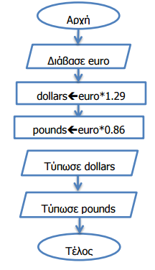
dollars=euro*1.29
pounds=euro*0.86
print('%.2f' % dollars)
print('%.2f' % pounds)
Logic Diagram
Commands
euro=float(input())
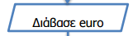

A.7 Algorithmic Thinking, Programming and Modern Computer Applications
A.7.M1
6. Using the ALGO software, draw the logic diagram which
accepts a number and prints its triple. Then, for checking purposes, give the values ​2, 3 and 4 and confirm the correctness of the result. Save the logic diagram in your folder with the name FE1_ask6.xml.
+Additional Activities
7. In the folder FE1_ask7 there are 3 logic diagrams designed in ALGO and 3
programs written in Python. Write the name of the program that corresponds to the logic diagram.
Logic Diagram
Program
LD1.xml
LD2.xml
LD3.xml
8. The Electricity Authority of Cyprus (EAC) charges 15 cents per KWh (kilowatt hour).
Design the logic diagram, using the ALGO software, which
reads the meter reading of the previous bill, as well as the
current meter value. Then, prints the total KWh that have been consumed and the amount that must be paid. For verification purposes, give the
values ​1000 and 1100 and confirm the correctness of the result. Save the logic diagram in your folder with the name FE1_ask8.xml.
Homework
9. The area and circumference of a circle are calculated by the formulas E=πR2 and
P=2πR respectively. Draw the logic diagram that accepts the radius R of a circle and calculates and prints its area and circumference.
10. Draw the logic diagram that accepts two numbers that correspond
to the grades of a student in the A’ and B’ Semester in the Computer Science course. Then, calculate and print the average for the year.



WORKSHEET A.7.M2
Python's Integrated Environment (IDLE)
What we will learn today:
Activate the Python Integrated Environment (IDLE) and become familiar with it Use the application environment
Identify and correct errors in ready-made programs
Save a program in Python.
Consolidation Activity
1. Open the program A7-M2_p1.py located in the M2 folder and save it to your folder.
(a) Check the program for any errors by running it and typing values where necessary. Correct the errors and run the program again.
Repeat the process until you have identified and corrected all the errors.
(b) Add the instruction so that the program accepts a third integer number and stores it in the variable Z.
(c) Modify the instruction to calculate the sum so that it returns sum of all three variables.
(d) Modify the product calculation command to return the product of all three variables.
(e) Run the program again with your own values ​and check the correctness of its results.
(f) Close the program.
Assessment Activity
2. Open the program A7-M2_p2.py located in the M2 folder and save it to your folder.
(a) The program should calculate and print the sum and average of four numbers.
(b) Run the program and correct any errors you find.
(c) Check the correctness of the program with the following input data:
a=5, b=6, c=7, d=8
(d) Close the program.
+Additional Activities
3. Open the program A7-M2_p3.py located in the M2 folder and save it to your folder.
(a) The program corresponds to the logic diagram below.

A.7.M2
A.7 Algorithmic Thinking, Programming and Modern Computer Applications
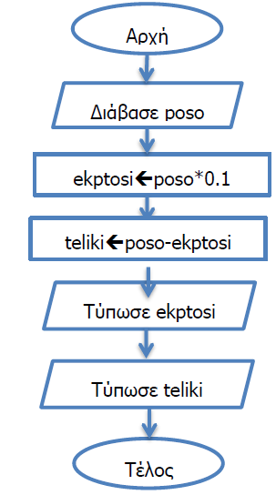
(b) Put the program commands in the correct order so that they correspond to
the order of the steps in the above logic diagram.
(c) Check the correctness of the program with the following input data:
poso = 500
(d) Close the program.
Homework
4.
Open the program A7-M2_p4.py located in the M2 folder and save it to your folder. Complete the preliminary
execution table below based on the program commands.
Variables
Presentation
…………………. …………………. ………………….


WORKSHEET A.7.M3
Variables
What we will learn today:
Explain and use variables
Explain and use variable types
Use variable naming conventions
Use the assignment statement.
Reinforcement Activities
1. Find which of the following identifiers are acceptable. For those that are not
explain the reason.
Identifiers
Acceptable (Yes/No)
MyName
Yes □
No □
2Lessons
Yes □
No □
My Name
Yes □
No □
myName
Yes □
No □
Name-Surname
Yes □
No □
NAME_SURNAME
Yes □
No □
print
Yes □
No □
Print
Yes □
No □
My(Name)
Yes □
No □
float
Yes □
No □
Num1
Yes □
No □
X
Yes □
No □
_number
Yes □
No □

A.7.M3
A.7 Algorithmic Thinking, Programming and Modern Computer Applications
2. Determine the data type for the following variables and write an appropriate identifier for each.
Content
Data Type
Suggested Identifier
School Name
Number of sections in the school
Average student performance
per section
Total number of students in
the school
Gender (boy/girl)
3. Open the program M3_ask3.py, located in the M3 folder and save it to your folder.
(a) Complete the appropriate commands so that it calculates and prints ten times an integer.
(b) Check the correctness of the program.
(c) Close the program.
Assessment Activities
4. Open the program M3_ask4.py, located in the M3 folder and save it in your folder.
(a) Make the necessary changes so that the program calculates and prints except for the area of ​the square and its perimeter.
(b) Check the correctness of the program.
(c) Close the program.
5. Open the program M3_ask5.py, located in the M3 folder, and
save it to your folder. The program accepts the goals scored by 2 teams in a football match and calculates and prints the total number of goals.
(a) There are errors in the program. Identify and correct them. (b) Then, check the correctness of the program.
(c) Close the program.
+Additional Activities
6. Write a program that accepts an integer and a real number
and calculates and prints their product with an accuracy of one decimal place. For example, if the numbers 5 and 6.4 are given, the number 32.0 is printed.

A.7 Algorithmic Thinking, Programming and Modern Computer Applications
A.7.M3
Home Activities
7. The cost of transporting a large parcel from the post office is calculated based on
its weight. If its weight is between 1 and 10 kilos, inclusive, the
customer is charged 5.5 euros per kilo, otherwise 7 euros are charged. Identify the formula and specify identifiers for all variables needed for
the above problem.
8. The area of ​a triangle is calculated with the formula E=(base*height)/2. The following
program contains 3 errors. Find and correct them.
basi=input()
E = basi*ipsos/2
Print('%.2f' % E)



WORKSHEET A.7.M4
Sequential Structure
What we will learn today:
Create a program in the Python integrated environment
Use the development cycle to create simple programs with a sequential
structure.
Reinforcement Activity
1. The computer science teacher at Hogwarts High School has decided that he will evaluate his
students in the following way:
50% Test grade
20% Homework
30% Project
Follow the steps below to write a program that accepts the test grade, the homework grade, and the final
project grade and prints the student's final grade.
(a) Complete the table for the data and information.
Data
Information
(b) Draw the logic diagram for the above problem.
(c) Open Python and create a new program.
(d) Write the commands for the program and save it with the name
M4_ask1.py.
Note: In the space provided, draw the logic diagram and write the program.
Logic Diagram Program

A.7.M4
A.7 Algorithmic Thinking, Programming and Modern Computer Applications
(e) Check the results of your program based on the following preliminary execution.
Variables
Presentation
test hwork project grade
Assessment Activity
2. The area of ​a trapezoid is given by the formula E =(base1+base2)∗height .
(a) Follow the development cycle to write a program that
accepts the bases and height of a trapezoid and calculates and prints the area.
(b) Save the program as M4_ask2.py.
Logic Diagram Program
+Additional Activities
3. Ariadne is a first grader. It is her first day at school and she is still
doesn't know how to subtract. She wants to visit the school canteen, but she is not sure about the change she should get.
(a) Follow the development cycle to write a program that
accepts the amount in euros that Ariadne will give to the canteen as well as the price
of the product she will buy and prints the change that Ariadne should get.
(b) Save the program as M4_ask3.py.
Homework
4. The research ship “Captain Pantelis” is looking for the best spot to set up the natural gas rig. One factor is the depth of the sea in

A.7 Algorithmic Thinking, Programming and Modern Computer Applications
A.7.M4
a specific area. The ship has taken measurements at 3 points. Follow the development cycle to write a program that accepts the measurements and prints their average with one decimal place.
5. Follow the development cycle to write a program that accepts
the sides (X and Y) of 2 squares and calculates and prints the area of the shaded figure Area = X2 −Y2.
Y
Y
X



WORKSHEET A.7.M5
Sequential Structure – Arithmetic Operators
What we will learn today:
Know the precedence of arithmetic operators and be able to find the
result of an arithmetic expression
Use arithmetic expressions and arithmetic operators to solve problems.
Reinforcement Activities
1. Find the results of the following mathematical expressions.
(a) 7*2 +2**3=
(b) 3*4**2=
(c) 4 ** 0.5 - 2=
(d) (15-6)*2=
(e) 4*5-3+2**3=
(f) (40-2**2)**0.5=
2. The kinetic energy of a body is calculated by the formula E = 1 2 mU2.
Write a program that accepts the mass (m) and the velocity (U) and calculates and prints the kinetic energy (E).
Save the program as M5_ask2.py.
Program
Assessment Activities
3. A student will have a test on the Pythagorean theorem next week. To
be sure that he solves his exercises correctly, he asks you to
create a program for him that accepts the two perpendicular sides of a right-angled
triangle and calculates and prints the hypotenuse (= √2 + 2).
Write the program for the above problem and save it as M5_ask3.py.
Program

A.7.M5
A.7 Algorithmic Thinking, Programming and Modern Computer Applications
+Additional Activities
4. The distance between 2 points is given by the formula: d = √(x2 −x1)2 + (y2 −y1)2
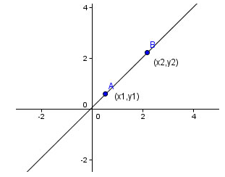
Write a program that accepts the coordinates of 2 points A and B and calculates and
prints the distance d. Save the
program with the name M5_ask4.py.
Homework
5. Find the results of the following mathematical expressions.
(a) 7**2 +10=
(b) 2**(2+2)=
(c) 3+10/4 =
(d) 10-16**0.5=
(e) 2*5**2=
(f) 9/3*3=
6. Write a program that accepts 3 integers x, y and z and
calculates and prints the result of the equation F=x3+2y2+3z.


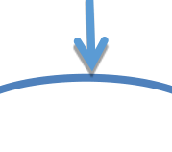
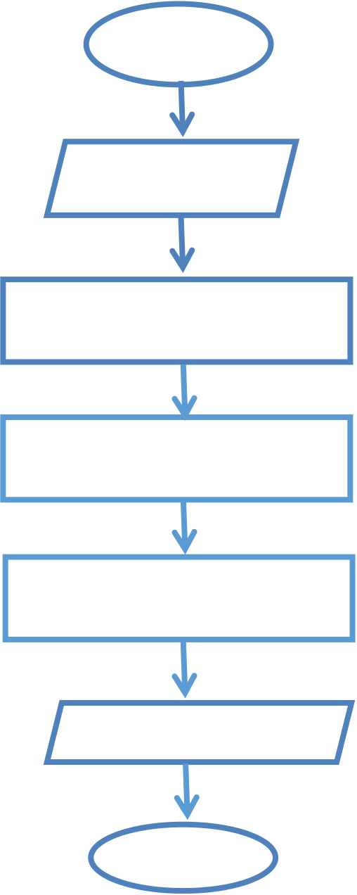

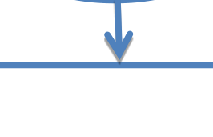



WORKSHEET A.7.M6
Sequential Structure – Arithmetic Operators
What we will learn today:
Know the precedence of arithmetic operators and be able to find the
result of an arithmetic expression
Use the // and % operators to solve problems.
Reinforcement Activities
1. Find the results of the following mathematical expressions.
(a) 5%6=
(b) 5//6=
(c) 6%4%2=
(d) 21//4%3=
(e) 15%6*2=
(f) 4*5//3=
2. The following logic diagram is given which accepts a two-digit number and
calculates and prints the sum of its digits. For example, if the number 15 is given, it will print the number 6 (1+5=6).
Start
Read N
monN % 10
Print ath
End
(a) Complete the above logic diagram.
(b) Write a program that corresponds to the above logic diagram.
(c) Save the program with the name M6_ask2.py.

A.7.M6
A.7 Algorithmic Thinking, Programming and Modern Computer Applications
Program
Assessment Activities
3.
A tank holds N liters of water. To fill it, someone uses a bucket
that holds 4 liters of water. Write a program that accepts the number N and calculates and prints the number of buckets needed to fill the
tank.
Note: Assume that N is an integer multiple of 4.
Save the program as M6_ask3.py.
Program
+Additional Activities
4. Write a program that accepts an integer in seconds and
parses it into hours, minutes, and seconds. For example, the number 5000 corresponds to 1 hour, 23 minutes, and 20 seconds.
Homework
5. Write a program that accepts a four-digit integer and
calculates and prints the result of dividing it by its first digit. For example, if the number 4064 is given, the result will be 4064/4=1016.
6. Find the results of the following mathematical expressions.
(a) 3//6=
(b) 3%6=
(c) 7%2+10=
(d) 10%5*2=
(e) 2*5%3=
(f) 9%6%2=

WORKSHEET A.7.M7
Sequential Structure
What we will learn today:
Follow the stages of the Application Development Cycle to solve problems
sequential structure.
Consolidation and Evaluation Activities
1.
Follow the development cycle to write a program that accepts a four-digit integer and calculates and prints its thousands, hundreds, tens and units digits.
For example, if the number 2475 is given, the program should print the following:
Thousands: 2
Hundreds: 4
Tens: 7
Units: 5
(a) Complete the table for the data and information.
Data
Information
(b) Draw the logic diagram for the above problem.
(c) Write the program that corresponds to the logic diagram and
save it as M7_ask1.py.
Note: In the space provided, draw the logic diagram and write the program.
Logic Diagram Program

A.7.M7
A.7 Algorithmic Thinking, Programming and Modern Computer Applications
(d) Using the pre-run method, present the
results of your program in the table below with an input value of 3851.
Variables
Presentation
+Additional Activities
2.
A contractor can hire workers with contracts of 10, 5, 1 day. Follow the
development cycle to write a program that accepts the days it takes to complete a project and calculates and prints the minimum number of contracts the contractor will need to sign.
For example, if the days are 17, then the minimum number of contracts will be 4 (1 contract of 10 days, 1 contract of 5 days, and 2 contracts of 1 day).
Home Activities
3.
Follow the development cycle to write a program that accepts
a 4-digit number in the octal number system and calculates and prints the resulting number after converting it to the decimal number system.
Input Example Output Example
3714 1996
Explanation: 4*80+1*81+7*82+3*83 =
1996

WORKSHEET A.7.M8
Branching Structure
What we will learn today:
Follow the phases of the Application Development Cycle to solve problems branching structure, using simple conditions.
Reinforcement Activities
1. Open the program M8_ask1.py from the M8 folder and save it in your folder.
(a) Complete the condition in the program which must accept 2 integer numbers A and B and if A is equal to twice B, then print the word «Double», otherwise print the phrase «Not Double». (b) Check the correctness of the program.
(c) Close the program.
2.
The logic diagram below is given.
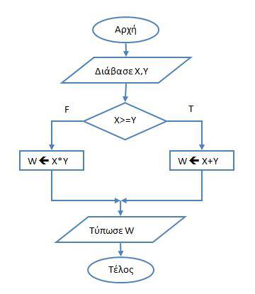
(a) Write a program that corresponds to the logic diagram.
(b) Save the program with the name M8_ask2.py.
(c) Check the correctness of the program and write the preliminary
execution for 1) X=15 and Y=20, 2) X=15 and Y=15, 3) X=25 and Y=20.
3. Write a program that calculates and prints the square root of a
number. If a negative number is given, an error message should be displayed (Error). Save the program as M8_ask3.py.

A.7.M8
A.7 Algorithmic Thinking, Programming and Modern Computer Applications
Program
+Additional Activities
4. Ariadne and Nicole are playing the following game. Ariadne thinks of a number from
1 to 9 and Nicole tries to guess Ariadne's number. If Nicole
guesses Ariadne's number correctly, the word "Win" appears on the screen, otherwise the word "Lose" appears. Write a program that accepts
the two numbers (Ariadne, Nicole) and displays the appropriate message on the screen.
Assume that the input data will be given correctly.
Homework
5. Write a program that accepts the goals scored by the teams in a
football match and prints the message “Tie” or “There is a Winner”.
6. Follow the Application Development Cycle to write a program
that accepts two integers and prints the larger of the two.









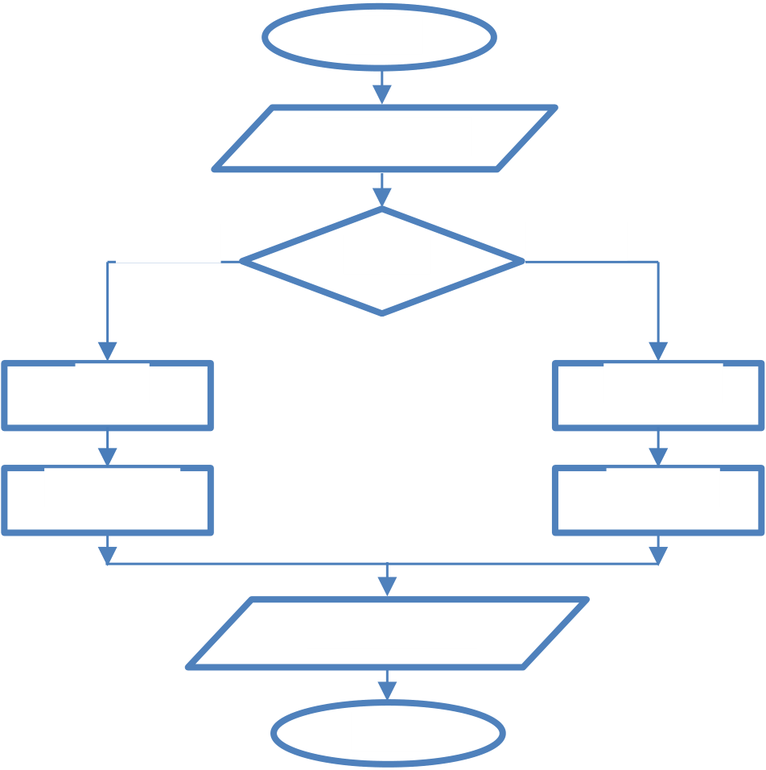
WORKSHEET A.7.M9
Branching Structure
What we will learn today:
Follow the phases of the Application Development Cycle to solve problems
branching structure, using simple conditions.
Reinforcement Activities
1.
The following logic diagram is given.
Start
Read X, Y
True
False X>=Y
XY XX * Y
YX+Y*3 YY - 3
Print X, Y
End
(a) Write a program that corresponds to the logic diagram.
Program
(b) Save the program as M9_ask1.py.

A.7.M9
A.7 Algorithmic Thinking, Programming and Modern Applications Computer Science
(c) Check the correctness of the program and write the preliminary
execution for the following input values:
X=10, Y=4
X= 2, Y=5
X= 3, Y=3
Preliminary Execution
Assessment Activities
2. A tennis club charges its members 10 euros for each hour they use the
courts and 20 euros for every hour for non-members.
(a) Write a program that accepts an integer corresponding to the
hours someone wants to rent a field and a character that specifies
whether they are a member or not. In the case of a member, the character M is given, while any other character indicates a non-member. Then, calculate
and print the amount that must be paid.
(b) Check the correctness of the program and save the program with
the name M9_ask2.py.
+Additional Activities
3. The product of 2 like numbers is always positive, while the product of 2 unlike numbers
is negative. For example (-2)*(-4)=8, while (-2)*4=-8. Follow the
development cycle to write a program that accepts two non-zero numbers (A,B) and prints the message “Like” if the numbers
are like, otherwise it prints the message “Odd”.

A.7 Algorithmic Thinking, Programming and Modern Computer Applications
A.7.M9
Home Activities
4. A store decided to give a discount depending on the amount of each
customer's purchase. If the customer makes purchases over 100 euros, then he gets a 10% discount,
otherwise he gets no discount. Write a program that accepts the customer's purchase amount and then calculates and prints the amount that the customer will pay.
5. Find the result of the program below using a table
of preliminary execution with initial values ​a) misthos = 1000, b) misthos = 3000 and c) misthos = 2000.
misthos=float(input())
if misthos >= 2000:
foros = misthos * 20 / 100
else:
foros = misthos * 10 /100
kath_misthos = misthos - foros
print(kath_misthos)


WORKSHEET A.7.M10
Structure Branching
What we will learn today:
Follow the phases of the Application Development Cycle to solve problems
with a branching structure, using simple conditions.
Reinforcement Activities
1.
Theseus works for a software company. For every hour he works,
up to 40 hours a week, he is paid 15 euros per hour. However,
there are weeks in which he has to work overtime, for which he is paid 20 euros per
hour. Write a program that accepts the hours Theseus worked in a week and calculates and prints his salary. Save the
program with the name M10_ask1.py.
Program
Assessment Activities
2.
Write a program that accepts the price of a product. If the price is
greater than 100 euros, then a 10% discount is applied, otherwise a 5% discount is applied.
The program should calculate and print the discount amount and the final price of the product. Save the program with the name M10_ask2.py.
Program

A.7.M10
A.7 Algorithmic Thinking, Programming and Modern Computer Applications
+Additional Activities
3. Your high school has a complex system to distinguish male and female students.
Each student has a four-digit registration number. If the product of their digits is exactly divisible by 3, then they are male, otherwise they are female. Write a program that accepts the registration number and prints the appropriate message.
Homework
4. Follow the Application Development Cycle to write a program
that accepts an integer and prints the message “Even” or“Odd” accordingly.

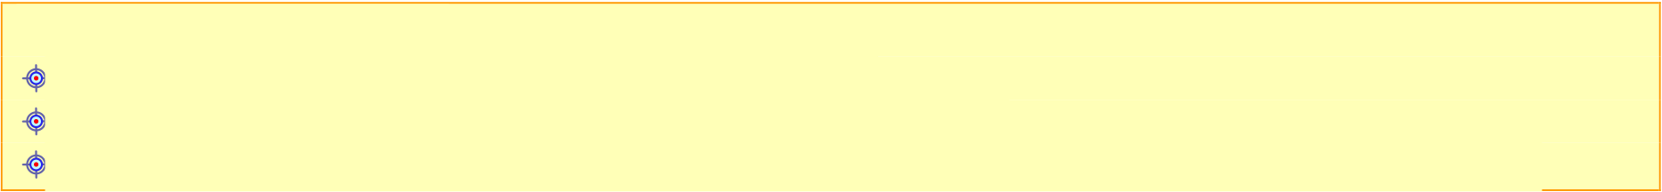
WORKSHEET A.7.M11
Branch Structure – Logical Operators
What we will learn today:
Find the result of logical expressions
Convert verbal sentences into logical sentences
Create programs for branch structure problems with complex conditions.
Consolidation Activities
1. Suppose we have the variables A=10, B=20, C=30. Write the results of
the following logical expressions.
Logical Expression
Result
(A>B) or (A>C)
(B<C) and (B>A)
(B>A) or (B>C)
(A==B) or (C==30)
(A>0) and (C>0)
not (A>B)
(A<C) or (A==B) and (B<C)
(B==(A*2)) and (B<C) and (B>20)
(A==B) and (A>0) or not (B>C)
not ((A==10) and (B==20))
2. Assume that the areas of 3 countries correspond to the variables ekA, ekB, ekC.
convert the following verbal sentences into logical expressions using the operators not, and and or.
Verbal Sentence
Logical Expression
The area of ​country A is greater than (ekA>ekB) and (ekA>ekC) the area of ​countries B and C
The area of ​country A is less than
the area of ​countries B and C
The area of ​country A is equal to the sum
of the areas of countries B and C or is
greater than 10000
The area of ​country B is unequal to
the area of ​country C or is equal to
the area of ​country A
The area of ​country A is less than
the area of ​country C and equal to twice
the area of B

A.7.M11
A.7 Algorithmic Thinking, Programming and Modern Computer Applications
3. A student remains stagnant after the end of the school year if the total
absences are more than 134, or the absences of the 2nd Semester are more than 67. Write a program that accepts the total absences
and the absences of the 2nd Semester of a student and prints the corresponding message
"Remains Stagnant" or "Participates in the exams".
Program
Assessment Activities
4. A triangle is called a right triangle if it has one right angle (90 degrees).
Furthermore, the sum of the angles of a triangle must be 180.
(a) Write a program that accepts the size of the three angles of
a triangle and prints “Right Triangle” if the triangle is right, otherwise prints “Not a Right Triangle”.
(b) Check the correctness of the program and save it with the name
M11_ask4.py.
Program

A.7 Algorithmic Thinking, Programming and Modern Computer Applications
A.7.M11
+Additional Activities
5.
A museum sells its tickets for 10 euros each. The museum gives a 2 euros discount on each ticket every Saturday and Sunday. Write a program that
accepts the number of people who want to buy a ticket as well as the day (1-Monday, 2-Tuesday, 3-Wednesday, 4-Thursday, 5-Friday, 6-Saturday, 7-Sunday) and calculates and prints the amount to be paid.
Write a program for the above problem.
Homework
6. The variables X, Y, Z are given with values ​X=False, Y=True, Z=True. Write the
result of the following logical expressions.
(a) X or Y
(b) Y and Z
(c) X and Z
(d) not Y and X
(e) X or Y or Z and Y
(f) not X and Y or Z and not X
(g) Y or not Z and not X
7.
Given the variables A, B, and C which correspond to 3 integers.
Convert the following verbal sentences into logical expressions using the operators not, and and or.
Word Sentences
Logical Expression
The number A is greater than B and C
The number B is equal to either A or C The number C is not equal to the sum of A
and B
8.
A year is called a leap year if it is exactly divisible by 4 but not divisible by
100 or if it is exactly divisible by
400. Write a program that accepts
the year and prints the word «Yes» if the year is a leap year, otherwise prints the word «No».
Input Example 1 Input Example 2 2000 1900
Output Example 1 Output Example 2 1 0



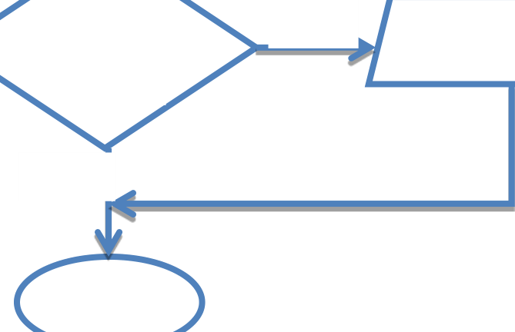
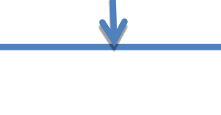





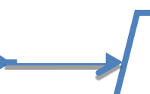
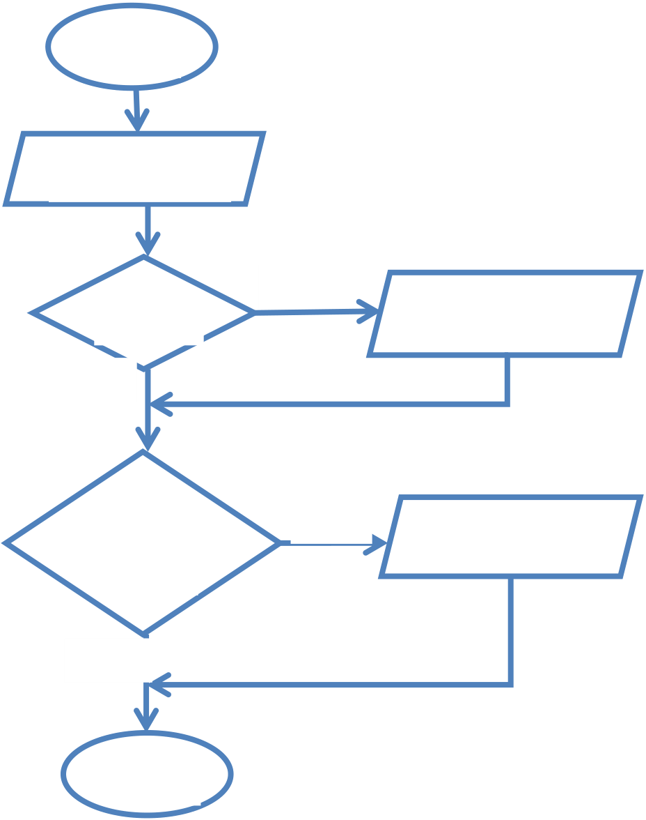
WORKSHEET A.7.M12
Branch Structure – Independent Conditions
What we will learn today:
Follow the Application Development Cycle to write programs with
more than one independent condition.
Reinforcement Activities
1. The logic diagram below is given.
Start
Read X,Y
True
X>100 Print X
False
(X=Y) or True Print Y
(Y>0)
False
End
(a) Write a program that corresponds to the logic diagram.
Program
(b) Save the program as M12_ask1.py.

A.7.M12
A.7 Algorithmic Thinking, Programming and Modern Applications Computer Science
(c) Write the preliminary execution and check the correctness of the
program for the following input values:
X=200, Y=-1
X=100, Y=10
X=-10, Y=-10
X= 20, Y=-10
Preliminary Execution
Assessment Activities
2. A mobile phone factory uses a four-digit integer (N)
for each mobile phone it manufactures. The last digit X (units digit) indicates the following:
(a) If X is greater than 5, then the mobile phone will be installed
Android operating system, otherwise Windows Mobile will be installed.
(b) If X is an even number, then it will have 2GB of memory, otherwise it will have 4GB of memory.
Write a program that accepts a four-digit integer (N) and prints the corresponding messages. Save the program as M12_ask2.py.
Program

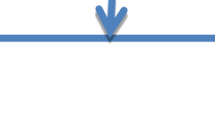

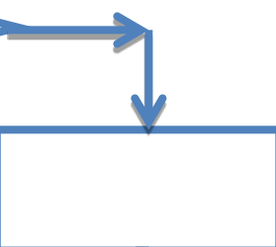
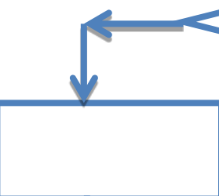
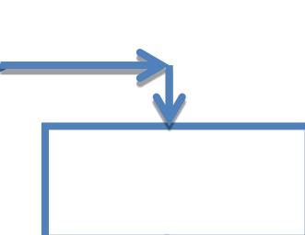
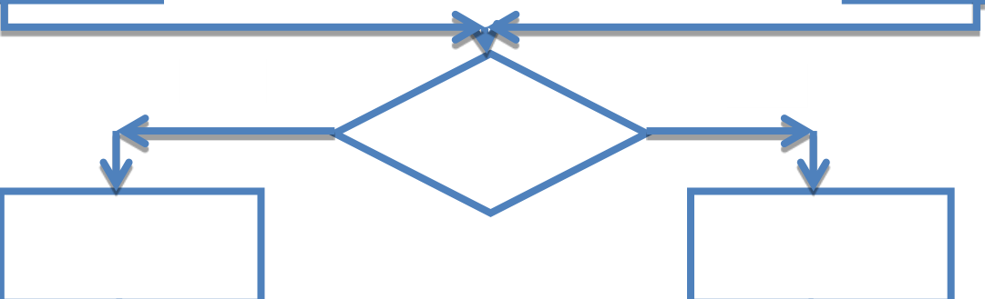


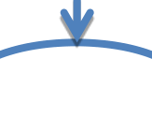



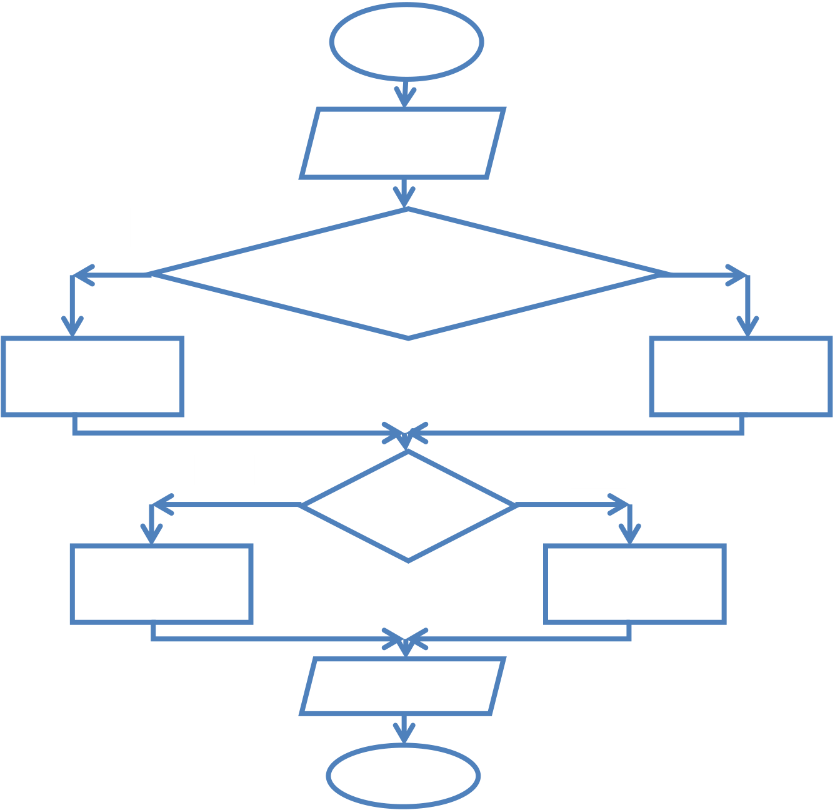
A.7 Algorithmic Thinking, Programming and Modern Informatics Applications A.7.M12
+Additional Activities
3. The charge in a hotel is as follows:
(a) If the room is single the price is 30 euros per day, otherwise it is 45
euro.
(b) If it has a sea view there is an additional charge of 5 euros per day.
Write a program that accepts the days, the room type and the view and calculates and prints the total amount that the customer must pay.
Home Activities
4. Write a program that corresponds to the logic diagram below and
create a pre-execution table using the following initial values:
a) X=5, b) X=13, c) X=-1 and d) X=40
Start
Read X
False True
(X>=1) and (X<=20)
Y2*X
YX
False True
Y>20
YY+1
YY+2
Print Y
End



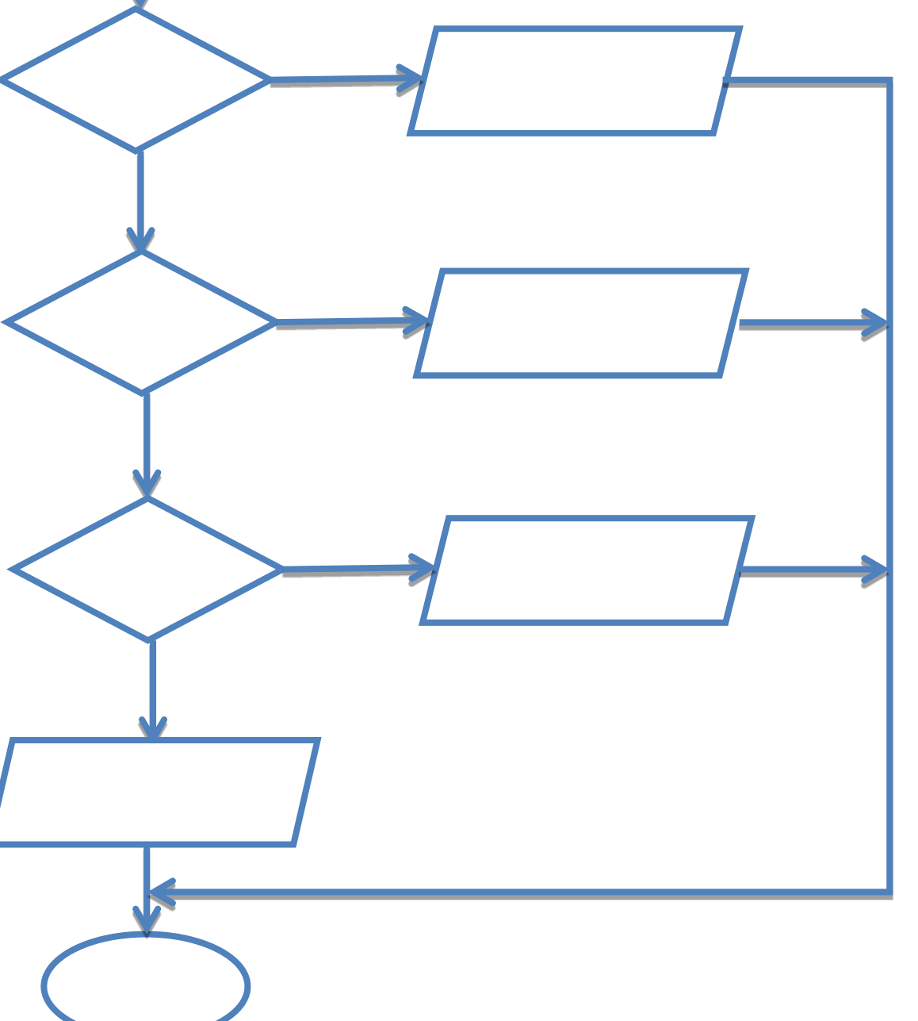
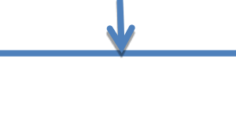

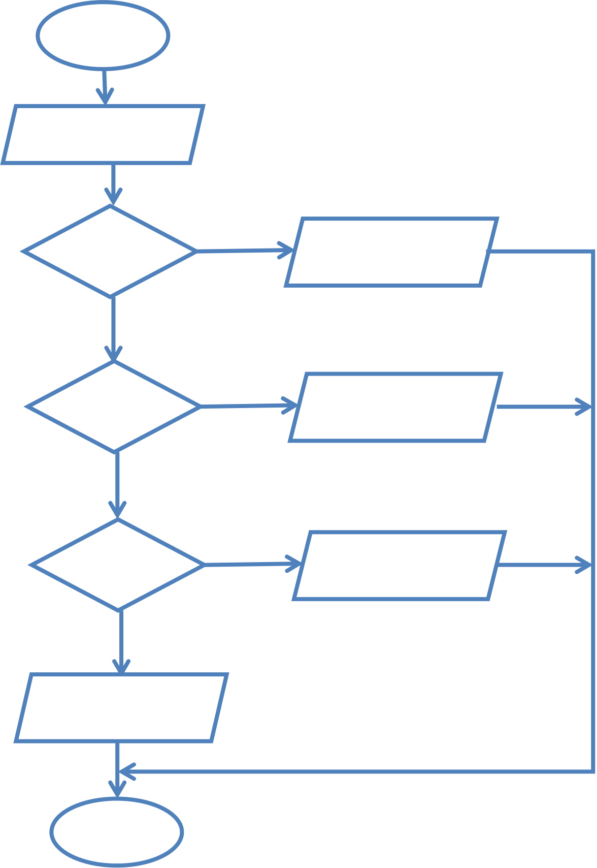
WORKSHEET A.7.M13
Branching Structure – if…elif…else
What will we learn today:
Follow the Application Development Cycle to write programs with the
if…elif...else statement.
Reinforcement Activities
1. Complete the logic diagram below which accepts an integer
N (0<=N<=9999) and prints one of the messages “Four-digit”,“Three-digit”, “Two-digit” or “Single-digit”.

A.7.M13
A.7 Algorithmic Thinking, Programming and Modern Computer Applications
2. Create a preliminary execution table for initial values ​a) N=5 b) N=159,
c) N=1290 and d) N=20
Preliminary Execution
3. Write a program that corresponds to the logic diagram and
save it as M13_ask3.py.
Program

A.7 Algorithmic Thinking, Programming and Modern Computer Applications
A.7.M13
Assessment Activities
4. The body mass index (BMI) of an individual is given by the formula BMI =Weight
height2. Depending on the
value of BMI, we have the following characterizations.
BMI
Characterization
<19
Underweight
19-25 Normal Weight
26-29 Overweight
30-34 Obese
>34
Severely Obese
Write a program that accepts the weight (W) and height (H) of a person and prints the appropriate message. Save the program with the name M13_ask4.py.
Program
Additional Activities
5. A printing house charges its customers in stages as follows:
The first 100 books [1-100] at 8 euros each.
The next 400 books [101-500] at 6.40 euros each.
The remaining books (more than 500) at 3.50 euros each.
Write a program that accepts the number of books and calculates and prints the cost.

A.7.M13
A.7 Algorithmic Thinking, Programming and Modern Computer Applications
Homework
6. Follow the development cycle to write a program that accepts
the goals scored by each team in a football match and prints the
result (1 – Home team win, X - Draw, 2 – Away team win).
Input Example 1 Input Example 2 Input Example 3
2 2 2 1 1 2
Output Example 1 Output Example 2 Output Example 3
X 1 2
7. A company provides high-quality audio and video services. One of the
services it provides is product photography and charges as follows:
Quantity
Price per Piece
1 – 25
13.49 €
26 - 50
12.74 €
More than 50
11.99 €
Follow the development cycle to write a program that accepts
quantity and calculates and prints the total price.

WORKSHEET A.7.M14
Branching Structure – if…elif…else
What we will learn today:
Follow the Application Development Cycle to write programs with the if…elif...else statement.
Reinforcement Activities
1. The table below shows the number of satellites that the planets in our solar system have.
Category - Number of Satellites Planets
A - 0
Mercury, Venus
B - 1,2
Earth, Mars
C- more than 2
Jupiter, Saturn, Uranus, Neptune
(a) Write a program that accepts the name of the planet and prints
the category to which it belongs. In case an incorrect name is given, the program prints the message «Wrong input».
(b) Save your program with the name M14_ask1.py.
Syllabus

A.7.M14
A.7 Algorithmic Thinking, Programming and Modern Computer Applications
Assessment Activities
2. The table below shows some important sights and the dates
of their creation.
Select Attraction
Chronology
1
Petra
1200 BC
2
Statue of Christ 1931
3
Colosseum
70 BC
4
Great Wall
220 BC
5
Matzu Picchu
15th century
(a) Write a program that accepts a choice (1-5) and prints the
corresponding attraction and the date of creation. For example, for choice 4 it will print: Great Wall - 220 BC. In case an incorrect choice is given, the program will print the message "Incorrect choice".
(b) Save the program as M14_ask2.py.
Program













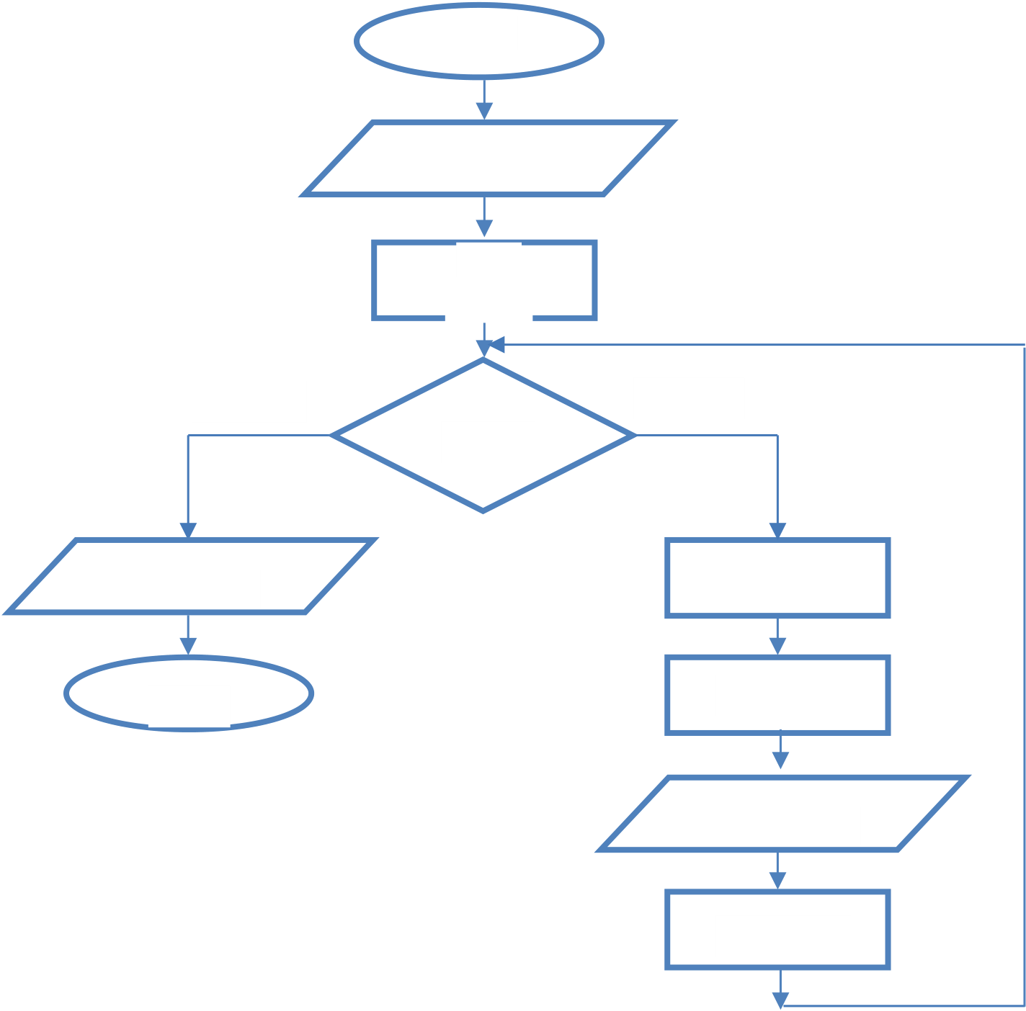
WORKSHEET A.7.M15
Repetition Structure
What will we learn today:
Follow the phases of the Application Development Cycle to solve problems with an iterative structure.
Reinforcement / Evaluation Activities
1. Find the result of the logic diagram below using the table
of preliminary execution with initial values ​a) X=5, Y=5 and b) X= -2, Y=7.
Start
Read X, Y
Z0
YY-3
True
False
X<=Y
Print G XX + 4
End ZZ + X
Print X, Y
YY + 1
Preliminary Execution

A.7.M15
A.7 Algorithmic Thinking, Programming and Modern Computer Applications
2. For the above logic diagram, write the corresponding program and save it as M15_ask2.py.
Program
3. Write a program that prints all numbers from 100 up to 1, inclusive. Save the program as M15_ask3.py.
Program
4. Write a program that:
(a) Calculates and prints the sum of the numbers from 1 to 10.
(b) Calculates and prints the sum of the even numbers from 1 to 10.
Save your program as M15_ask4.py.










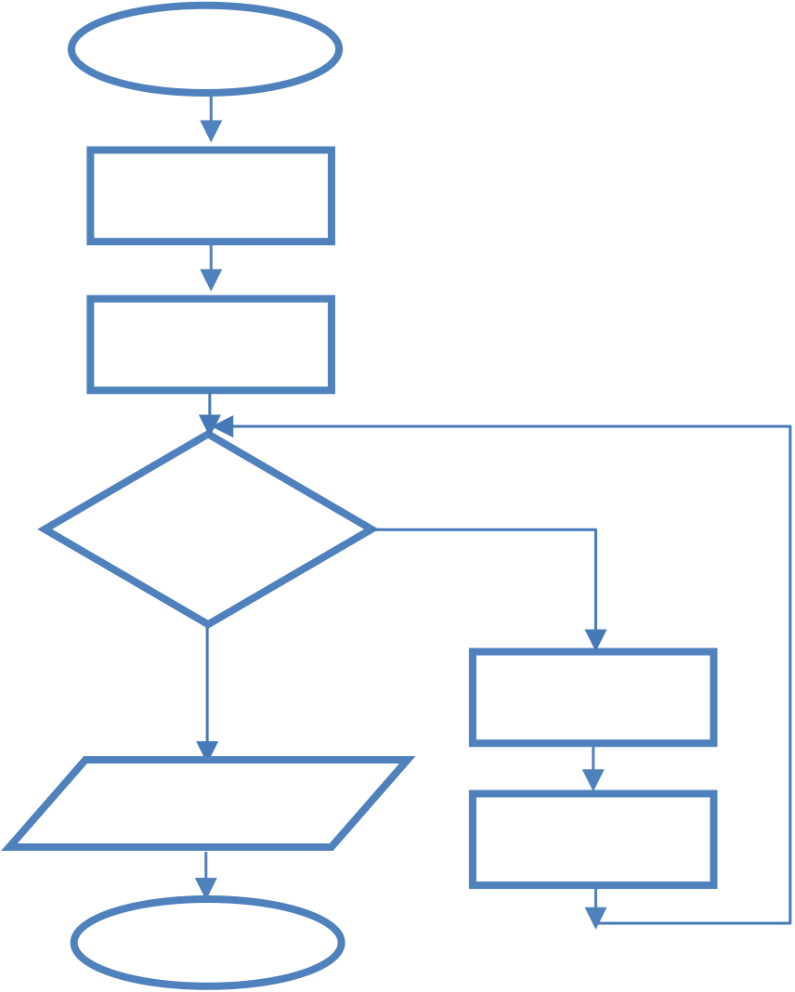
A.7 Algorithmic Thinking, Programming and Modern Computer Applications A.7.M15
Program
+Additional Activities
5. Write a program that accepts two integers X1 and X2 and prints all multiples of
4, between the numbers X1 and X2,
inclusive.
6. Write a program that prints all three-digit integers
for which the first digit is an even number and the third digit is an odd number.
Homework
7. Find the result of the logic diagram below using a table
of preliminary execution. Then, convert the logic diagram into a program.
Start
X1
Y3
True
X<=8
False
YY + 1
XY + 3
Print X
End
8. Write a program that prints all two-digit integers.


WORKSHEET A.7.M16
Repetition Structure
What will we learn today:
Follow the phases of the Application Development Cycle to solve problems
with an iterative structure.
Consolidation / Assessment Activities
1. Find the result of the following program (code) using a table
of preliminary execution with initial values:
a) onoma = Andreas, misthos = 1000 b) onoma = Costas, misthos = 3000 and c) onoma = Maria, misthos = 2000
counter = 1
while counter <= 3:
onoma=input('Enter employee name: ')
misthos=float(input('Enter Salary: '))
if misthos >= 2000:
foros = misthos * 20 / 100
else:
foros = misthos * 10 / 100
kath_misthos = misthos - foros
print('His net salary',onoma,'is:',kath_misthos) counter = counter + 1
Preliminary Execution

A.7.M16
A.7 Algorithmic Thinking, Programming and Modern Computer Applications
2. Write a program that accepts the grades of 15 students in a class
for the Computer Science course and calculates and prints the average of the class. Save your program as M16_ask2.py.
Program
3. Write a program that accepts 20 positive integers and
prints the largest one. Save the program in the folder M16_ask3.py.
Program

A.7 Algorithmic Thinking, Programming and Modern Computer Applications
A.7.M17
4. Write a program that accepts 100 integers. Then
calculates and prints the number of numbers that are multiples of 8 and the
number of numbers that are multiples of 12. Save the program
in the folder M16_ask4.py.
Program
+Additional Activities
5. The factorial of an integer is calculated using the
following formula: n! = 1*2*3*...*n. For example, if we want to calculate the factorial of the number 4 then: 4! = 1*2*3*4 = 24. The factorial of 0 and 1 is 1. Write a program that accepts a number and then
calculates and prints the factorial of the number.
Home Activities
6. A plot of land is considered expensive when its selling price per square meter is
greater than 450 euros, cheap when its selling price per square meter is less than 150 euros, and normal in any other case. Write a program that reads for each of the 20 plots, its size in
square meters (Metra) and its selling price per square meter
(Timi_metro). Then, calculate and print the total cost of each
plot and the category to which it belongs (“Expensive”, “Cheap” or
“Normal”).

A.7.M16
A.7 Algorithmic Thinking, Programming and Modern Computer Applications
7. Write a program that:
(a) Accepts the grade ([1..100]) for a class of 50 students.
(b) Calculates and prints the average grade.
(c) Calculates and prints the maximum and minimum grade.
(d) Calculate and print the number of students who received a failing grade (grade <50).
WORKSHEET A.7.M17
Repetition Structure
What we will learn today:
Follow the phases of the Application Development Cycle to solve problems with an iterative structure.
Consolidation / Evaluation Activities
1. Using the preliminary execution method, present the results of the following logic diagram with input values:
A) N=3, 1, 10, -2, 0
B) N=0
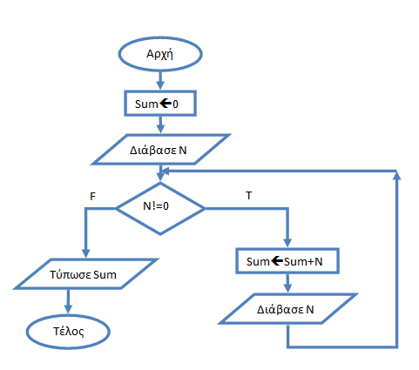
Preliminary Execution

A.7.M17
A.7 Algorithmic Thinking, Programming and Modern Computer Applications
2. Convert the logic diagram of exercise (1) into a program. Save
your program with the name M17_ask2.py.
Program
3. Write a program that accepts an unknown number of integers
numbers from the user. The program should stop accepting numbers when the number 999 is given.
Then, it should calculate and print the average of the numbers given and the largest number. Save the program in the folder M17_ask3.py.
Program
4. The program below is a game. The user tries to
guess an integer number that belongs to the interval 1 to 10,
inclusive and is automatically generated by the program. The program
calculates and prints the number of attempts the user makes until he guesses the correct number, at which point it terminates. The program contains 4 errors.
Locate
them
and correct them.

A.7 Algorithmic Thinking, Programming and Modern Computer Applications
A.7.M17
Note: The first 2 lines of the program that generate the number do not contain any error.
from random import randint
secret=randint(1,10)
num=0
while num==secret:
tries+=1
num=input('Guess the number: ')
print('The number was',secret)
print('You found it after',num,'attempts.')
+Additional Activities
5. Unicellular organisms, such as amoeba, usually reproduce by monogamy.
First, the genetic material of the amoeba is duplicated and then, by division, two new identical amoebas are created. This happens every 30 minutes. Write a program that calculates and prints how many minutes it takes for more than 1000 amoebas to be created from a single amoeba.
Home Activities
6. A 2000 liter water tank contains 1000 liters of water. Every day
the water supply board adds x liters of water to the tank while at the same time on the same day there is a consumption of y liters of water. Write a program that
accepts the values ​of x and y (x>y) for each day and calculates and prints the number of days it will take to completely fill the tank.
7. The population of an ant colony increases by 12% every month. At the same time,
due to unfavorable conditions, about 10,000 ants die during the same period. Write a program that, given that the initial population of the colony was 85,000, calculates and prints in how many months the colony will exceed 200,000.



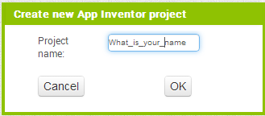
WORKSHEET A.7.M18
Programming with App Inventor–Introduction
What we will learn today:
The App Inventor work environment
Use the controls (graphical objects) button, label and image and change
their properties
Test our application.
Reinforcement Activities
1. We will create an application that translates the question “What
is your name?” into 5
languages
(a) Create a new application called What_is_your_name.
(b) Place 5 buttons and 1 label on the screen. Your screen should look like
the image below.
(c) Load the images Greece, UK, France, Germany and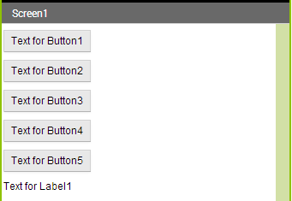
Russia, which are in your folder, into the media window.

A.7.M18
A.7 Algorithmic Thinking, Programming and Modern Computer Applications
(d) Change the properties as shown in the table below
Controller (graphic Property Value
object)
Screen1
Align Horizontal
Center
Screen1
Title
Translator
Screen1
Background Color
Light Gray
Button1
Text
Button1
Image
Greece.png
Button1
Width
50 pixels
Button1
Height
50 pixels
Repeat the same for the other buttons, changing the name and image
Label1
FontBold
True
Label1
Text
(e) Switch to the Blocks view to program the buttons. For each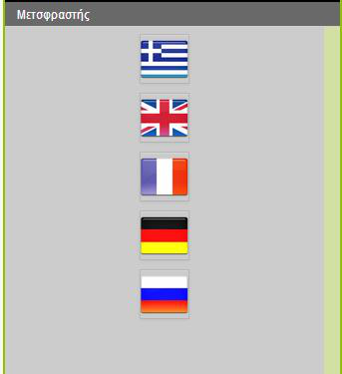
button you will use the click event and change the text property of label1.
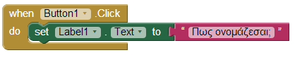

A.7 Algorithmic Thinking, Programming and Modern Computer Applications
A.7.M18
Language
Translation
English
What is your name?
French
Comment vous appelez?
German
Wie ist Ihr Name?
Russian
Как тебя зовут?
You can use Google Translate to find the translations (https://translate.google.com/)
(f) Test your application in one of the following ways:
Installation on mobile.
Using the AI ​Companion.
Using the emulator.
Assessment Activities
2. Create an application called Countries which will give us the following
information about the countries Cyprus, Greece, Italy, Spain.
Country
Capital
Flag
Cyprus Nicosia
Cyprus.png
Greece
Athens
Greece.png
Italy
Rome
Italy.png
Spain Madrid
Spain.png
The user will press the button that will display the name of the country and the information will be displayed.
The flags are located in the flags folder.
+Additional Activities
(a) Create a new project with
(b) Disable the
your drawing by shaking
the
phone.
the name DigitalDoodle. 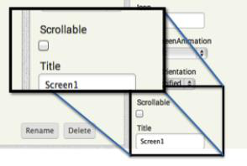
3. Follow the steps
to create an application that
allows you to draw with your
finger
on
the
screen
and
to
erase
Scrollable option from the Screen properties.

A.7.M18
A.7 Algorithmic Thinking, Programming and Modern Computer Applications
4. Place a canvas control and an AcceleratormeterSensor control
on your screen.
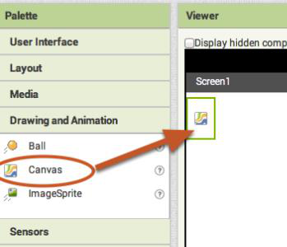
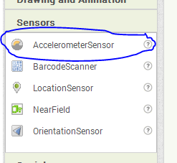
5. Change the height and width of the canvas, so that they cover the entire size of the screen (Fill Parent).
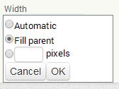
6. Switch to the Blocks view. From the canvas, select the event when canvas1 dragged.
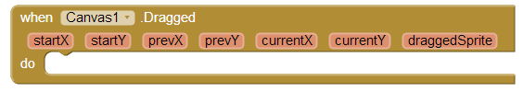
7. Then place the DrawLine procedure inside this event.
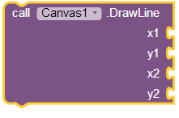
The drawline procedure accepts as arguments the initial (x1,y1) and final (x2, y2) coordinates of your screen. That is, the point at which you click and start the line and the point at which the line ends.

A.7 Algorithmic Thinking, Programming and Modern Computer Applications
A.7.M18
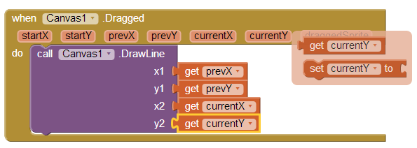
8. To erase the lines by shaking the screen, we need to program the
object
AcceleratormeterSensor.
We will
use
the
event
when
AcceleratormeterSensor Shacking and the Clear procedure from the
canvas object.
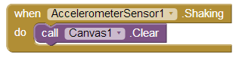
9. The application is ready for testing.


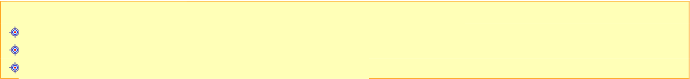
WORKSHEET A.7.M19
Programming with App Inventor–Variables
What we will learn today:
Use the Textbox control
Declare and use variables
Create sequential applications.
Reinforcement Activities
1. The area and circumference of a circle are given by the formulas = 2 and =
2R respectively. Create the application that accepts the radius R of a circle and calculates its area and circumference.
(a) Identify the data and information
Data
Information
(b) Draw the logic diagram for the above problem
(c) Note what the variables of the application are?
Variables

A.7.M19
A.7 Algorithmic Thinking, Programming and Modern Computer Applications
(d) Draw the controls you will need on the screen below:
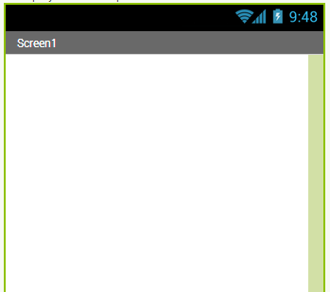
(e) Write the properties of the controls and their properties that need to
change:
Control Property Value
(graphic object)

A.7 Algorithmic Thinking, Programming and Modern Computer Applications Computer Science
A.7.M19
(f) Connect to App Inventor and create a new project named Circle.
(g) Create the screen as you designed it with all the controls (graphic objects) and change the values ​of their properties, as you specified them.
(h) Switch to the Blocks view.
(i) Define the variables and initialize them with 0
e.g. 
(j) Program your application according to the logic diagram you have
designed. For the power (R2) you can use the following block located in the math category.
(k) Test your application.
Assessment Activities
2. The grade in the subjects examined in high school is obtained as follows:
Final grade =
(Grade A of the semester + Grade B of the semester)*0.7
+ (Exam grade)*0.3
Create the FinalGrade application that accepts the grades of the semesters and the exams and calculates the final grade.
+Additional Activities
3. Follow the steps below to create a
Text – to – speech application, that is, an application that will convert the content of a Textbox into sound.
(a) Create a new project named TextToSpeech.
(b) Place a Textbox, a Button, and a control
(object) TextToSpeech on your screen, as shown in the diagram on the next page.
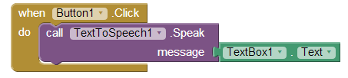
A.7.M19
A.7 Algorithmic Thinking, Programming and Modern Computer Applications
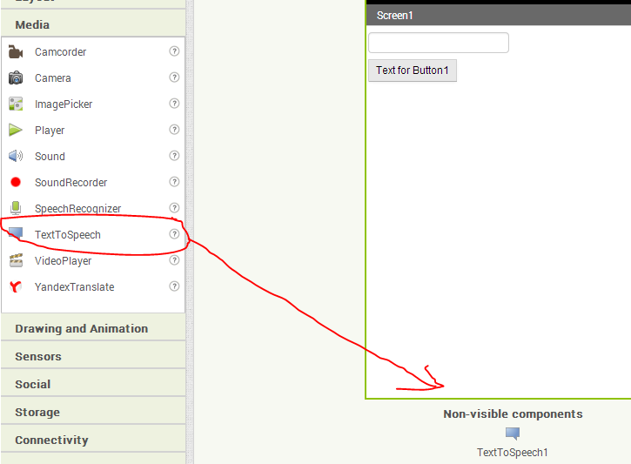
(c) Program Button1 as shown below.
(d) Before testing your application, make sure that Voice Data is
installed on your mobile phone (Settings Voice input and output Text-to-speech settings).

WORKSHEET A.7.M20
Programming with App Inventor–Branching Structure
What we will learn today:
Create applications that include a branching structure.
Reinforcement Activities
1. Create an application that accepts a number and calculates its
square root. If the number is less than 0, it prints the message«Error».
(a) Identify the data and information:
Data
Information
(b) Draw the logic diagram for the above problem
(c) List the variables of the application:
Variables

A.7.M20
A.7 Algorithmic Thinking, Programming and Modern Computer Applications
(d) Draw the controls you will need on the screen below:
(e) Write the properties of the controls and their their properties that need to
change:
Control Property Value
(graphic object)

A.7 Algorithmic Thinking, Programming and Modern Computer Applications
A.7.M20
(f) Connect to App Inventor and create a new project named
SQRT.
(g) Draw the controls (graphic objects) on the screen and change the
values ​of their properties.
(h) Go to the Blocks view.
(i) Define the variables and initialize them with 0.
(j) Program your application according to the logic diagram that you have
designed. For the square root, you can use the following block found in the math category:
(k) Test your application. 
Assessment Activities
2. A printing house charges for printing books based on their pages. For books
with more than 500 pages the charge is 30 cents per page otherwise it is 35 cents per page. Design an application called Books, which accepts the number of pages in the book (P) and calculates the charge (T).
+Additional Activities
3. Follow the steps below to
create an application that can
call or send a message (SMS) to a number that we write in a textbox.
The user will be able to make a phone call or send a message or both. The selection will be made using the
Checkbox object.
(a) Create a new project with
name Call
(b) Place the
controls (graphical objects) on the screen as shown in the figure below.
(c) The final form of the screen is shown
below.
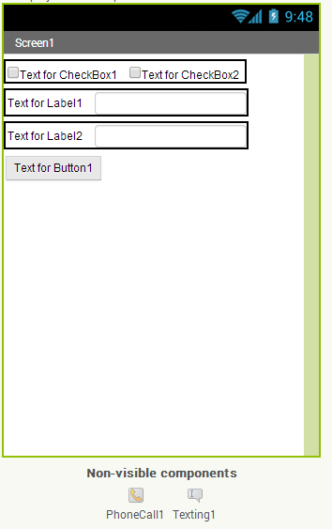
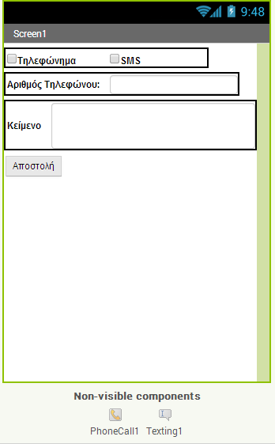
A.7.M20
A.7 Algorithmic Thinking, Programming and Modern Computer Applications
(d) Program your objects as shown below:
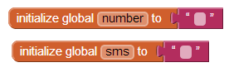
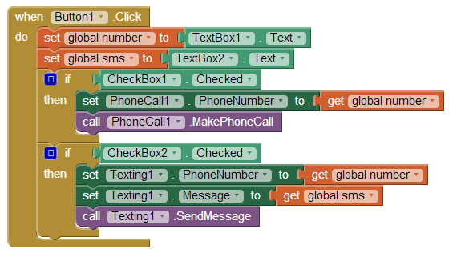

WORKSHEET A.7.M21
Programming with App Inventor–Nested Structure
Branching
What will we learn today:
To create applications that use nested branching structures.
Reinforcement Activities
1. The mass index (BMI) of an individual is given by the formula BMI=Weight Height². Depending on the
BMI we have the following characterizations.
BMI
Characterization
<19
Underweight
19-25 Normal Weight
26-29 Overweight
30-34 Obese
>34
Severely Obese
Create an application that accepts the weight (W) and height (H) of a person and prints the appropriate message.
(a) Identify data and information:
Data
Information

A.7.M21
A.7 Algorithmic Thinking, Programming and Modern Computer Applications
(b) Draw the logic diagram for the above problem:
(c) What are the variables of the application?
Variables

A.7 Algorithmic Thinking, Programming and Modern Computer Applications
A.7.M21
(d) Draw the controls you will need on the following screen:
(e) Write the properties of the controls and their properties that need to
change:
Control Property Value
(graphic object)
(f) Connect to App Inventor and create a new project with name
BMI.
(g) Draw the controls on the screen and change the values ​of their
properti
es.
(h) Switch to the Blocks view.
(i) Define the variables and initialize them with 0.
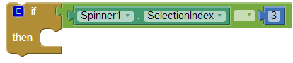
A.7.M21
A.7 Algorithmic Thinking, Programming and Modern Computer Applications
(j) Program your application according to the logic diagram you have
designed.
(k) Test your application.
Assessment Activities
2. A company provides high-fidelity audio and video services. One of the
services it provides is product photography and charges as follows:
Quantity
Price per Piece
1 – 25
13.49 €
26 – 50
12.74 €
More than 50
11.99 €
Create an application called Photos that accepts the quantity (P) and prints the total price (T).
Example: P=30, T=25*13.49+(30-25)*12.74
+Additional Activities
3. Create the Planets application that will give you information about the
planets of our solar system. For each planet, present the following information:
Image
Number of Satellites
Orbital Period
To find the information, use the internet.
The selection of the planets will be done using the spinner object. The selections are entered using the ElementsFromString property. Write the names of the planets in the field of the above property, separated by commas (Mercury, Venus, Earth, Mars, Jupiter, Saturn, Uranus, Neptune).
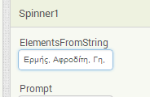
Checking which planet has been selected can be done in 2 ways
(a) Checking the position. The example below checks if you have selected the 3rd option.
(b) Checking the name. The example below checks if you have selected the
option named "Earth".
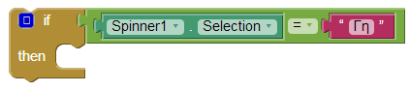

Notes
...................................................................................................................................... ...................................................................................................................................... ...................................................................................................................................... ...................................................................................................................................... ...................................................................................................................................... ...................................................................................................................................... ...................................................................................................................................... ...................................................................................................................................... ...................................................................................................................................... ...................................................................................................................................... ...................................................................................................................................... ...................................................................................................................................... ...................................................................................................................................... ...................................................................................................................................... ...................................................................................................................................... ...................................................................................................................................... ...................................................................................................................................... ...................................................................................................................................... ...................................................................................................................................... ...................................................................................................................................... ...................................................................................................................................... ...................................................................................................................................... ...................................................................................................................................... ...................................................................................................................................... ...................................................................................................................................... ...................................................................................................................................... ......................................................................................................................................

Notes
...................................................................................................................................... ...................................................................................................................................... ...................................................................................................................................... ...................................................................................................................................... ...................................................................................................................................... ...................................................................................................................................... ...................................................................................................................................... ...................................................................................................................................... ...................................................................................................................................... ...................................................................................................................................... ...................................................................................................................................... ...................................................................................................................................... ...................................................................................................................................... ...................................................................................................................................... ...................................................................................................................................... ...................................................................................................................................... ...................................................................................................................................... ...................................................................................................................................... ...................................................................................................................................... ...................................................................................................................................... ...................................................................................................................................... ...................................................................................................................................... ...................................................................................................................................... ...................................................................................................................................... ...................................................................................................................................... ...................................................................................................................................... ...................................................................................................................................... ......................................................................................................................................

Notes ...................................................................................................................................... ...................................................................................................................................... ...................................................................................................................................... ...................................................................................................................................... ...................................................................................................................................... ...................................................................................................................................... ...................................................................................................................................... ...................................................................................................................................... ...................................................................................................................................... ...................................................................................................................................... ...................................................................................................................................... ...................................................................................................................................... ...................................................................................................................................... ...................................................................................................................................... ...................................................................................................................................... ...................................................................................................................................... ...................................................................................................................................... ...................................................................................................................................... ...................................................................................................................................... ...................................................................................................................................... ...................................................................................................................................... ...................................................................................................................................... ...................................................................................................................................... ...................................................................................................................................... ...................................................................................................................................... ...................................................................................................................................... ...................................................................................................................................... ......................................................................................................................................

Notes
...................................................................................................................................... ...................................................................................................................................... ...................................................................................................................................... ...................................................................................................................................... ...................................................................................................................................... ...................................................................................................................................... ...................................................................................................................................... ...................................................................................................................................... ...................................................................................................................................... ...................................................................................................................................... ...................................................................................................................................... ...................................................................................................................................... ...................................................................................................................................... ...................................................................................................................................... ...................................................................................................................................... ...................................................................................................................................... ...................................................................................................................................... ...................................................................................................................................... ...................................................................................................................................... ...................................................................................................................................... ...................................................................................................................................... ...................................................................................................................................... ...................................................................................................................................... ...................................................................................................................................... ...................................................................................................................................... ...................................................................................................................................... ...................................................................................................................................... ......................................................................................................................................

Notes ...................................................................................................................................... ...................................................................................................................................... ...................................................................................................................................... ...................................................................................................................................... ...................................................................................................................................... ...................................................................................................................................... ...................................................................................................................................... ...................................................................................................................................... ...................................................................................................................................... ...................................................................................................................................... ...................................................................................................................................... ...................................................................................................................................... ...................................................................................................................................... ...................................................................................................................................... ...................................................................................................................................... ...................................................................................................................................... ...................................................................................................................................... ...................................................................................................................................... ...................................................................................................................................... ...................................................................................................................................... ...................................................................................................................................... ...................................................................................................................................... ...................................................................................................................................... ...................................................................................................................................... ...................................................................................................................................... ...................................................................................................................................... ...................................................................................................................................... ......................................................................................................................................

Notes
...................................................................................................................................... ...................................................................................................................................... ...................................................................................................................................... ...................................................................................................................................... ...................................................................................................................................... ...................................................................................................................................... ...................................................................................................................................... ...................................................................................................................................... ...................................................................................................................................... ...................................................................................................................................... ...................................................................................................................................... ...................................................................................................................................... ...................................................................................................................................... ...................................................................................................................................... ...................................................................................................................................... ...................................................................................................................................... ...................................................................................................................................... ...................................................................................................................................... ...................................................................................................................................... ...................................................................................................................................... ...................................................................................................................................... ...................................................................................................................................... ...................................................................................................................................... ...................................................................................................................................... ...................................................................................................................................... ...................................................................................................................................... ...................................................................................................................................... ......................................................................................................................................

Notes ...................................................................................................................................... ...................................................................................................................................... ...................................................................................................................................... ...................................................................................................................................... ...................................................................................................................................... ...................................................................................................................................... ...................................................................................................................................... ...................................................................................................................................... ...................................................................................................................................... ...................................................................................................................................... ...................................................................................................................................... ...................................................................................................................................... ...................................................................................................................................... ...................................................................................................................................... ...................................................................................................................................... ...................................................................................................................................... ...................................................................................................................................... ...................................................................................................................................... ...................................................................................................................................... ...................................................................................................................................... ...................................................................................................................................... ...................................................................................................................................... ...................................................................................................................................... ...................................................................................................................................... ...................................................................................................................................... ...................................................................................................................................... ...................................................................................................................................... ......................................................................................................................................
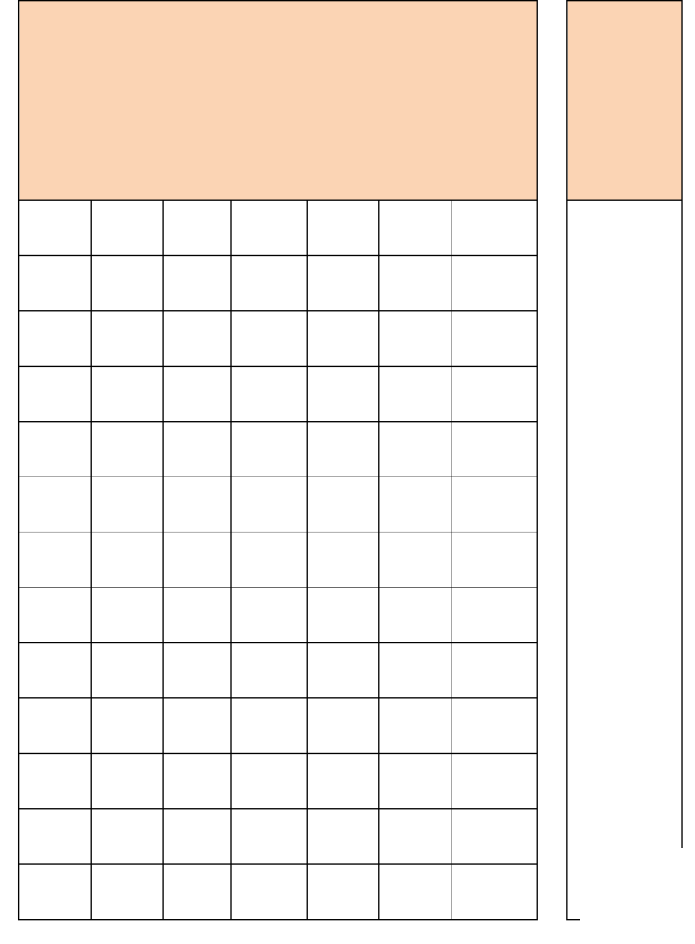



A.7 Algorithmic Thinking, Programming and Modern Applications
Worksheet: _______ Page No.: _______ Exercise: ____
Phase 1: Data/Information: Phase 3: Program
Data
Information
Additional Variables
Phase 4: Control Coding Phase 4: Check
Pr
es
en
ta
Variables/Conditions ti
on
… ….
190
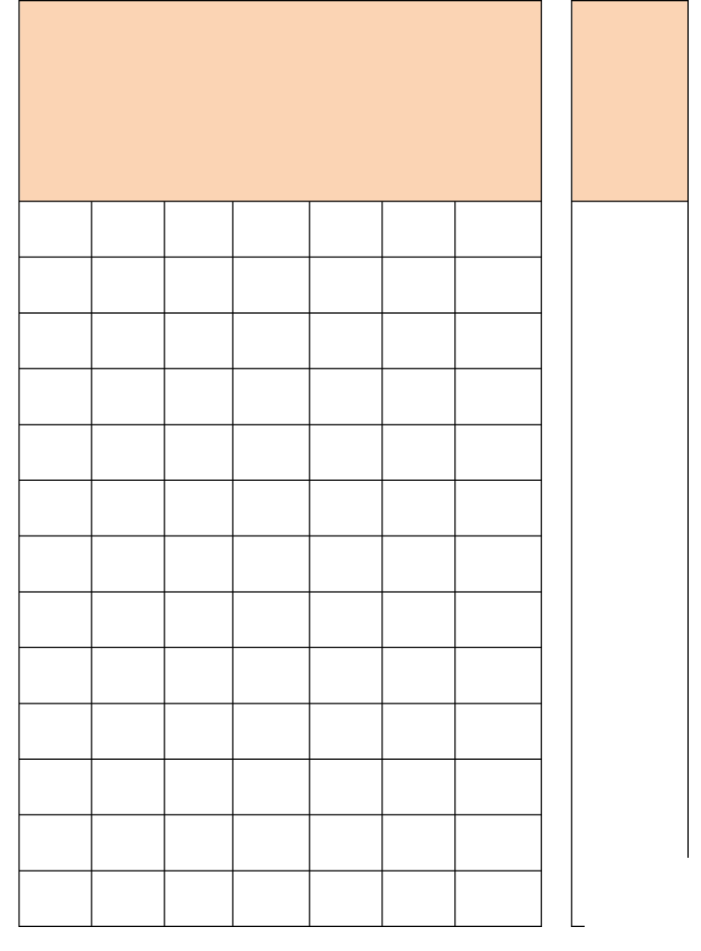
Worksheet: _______ No. Page: _______ Algorithmic Thinking, Programming and Modern Applications Exercise: ____
Phase 3: Program
Phase 1: Data/Information:
Data
Information
Additional Variables
Phase 4: Verification
 191 Pr es en ta Variables/Conditions
ti on
… ….
A.7 Algorithmic Thinking, Programming and Modern Applications
Worksheet: _______ No. Page: _______ Exercise: ____
Phase 3: Program
Phase 1: Data/Information:
Data
Information
Additional Variables
Phase 4: Check Coding
Pr
es
en
ta
Variables/Conditions ti
on
… ….
192

